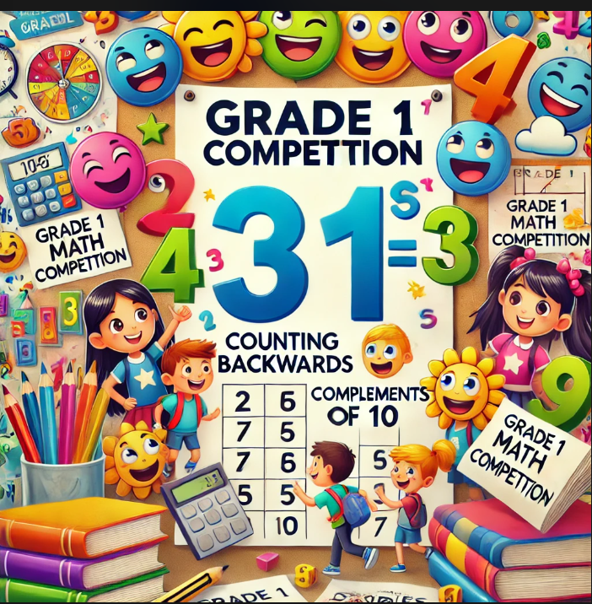
Dear first graders,
Do you love math challenges?
We are excited to announce the upcoming
Grade1 Maths Competition, which will
take place from March/2025 to May/2025.
Don’t Miss out !
This fun and educational competition is
designed to enhance your skills in key mathematical areas, where everyone is encouraged to participate. Be well prepared by practising whenever you can.
"Double the effort, double the fun!"

The competition aims to boost confidence, promote a love for math, and provide a supportive environment for students to apply what they have learned in class.
Effective participants and winners will receive a certificate of achievement, and special prizes will be awarded to top performers!
Competition Details:
- Our March ORAL competitions include:
- COUNTING ON in 1s, 2s and 10s up to 20
- COUNTING BACK in 1s, 2s and 10s from 20
- *COMPLEMENTS of 10 [number pairs]
- *DOUBLES of 1 to 10 up to double 10
* Complements and doubles will be learnt in February.

- Our May ORAL competitions include: [Higher Level]

- COUNTING ON in 1s, 2s and 10s up to 100
- COUNTING BACK in 1s, 2s and 10s from 100
Let’s make math magical together!

