Both paper 1 and paper 2 of the Cambridge Checkpoint Exam have comprehension questions. You will need to get lots of practice reading and completing comprehension questions.

When you are answering comprehension questions remember:
- Some questions want you to answer with your own words.
- Some questions want you to use evidence/quotes from the text.
- Some questions want you to use both.
- Use full sentences where necessary.​ ​​

Showing the Correct Order
You will often be asked to arrange things from a text in the order in which they happened. See the example below from an actual exam:
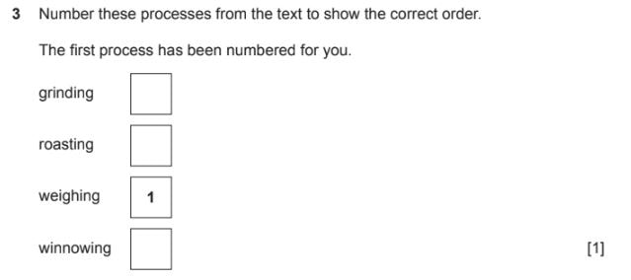

Writer’s Effect
​You may be asked a question about writer’s effect like the question below.
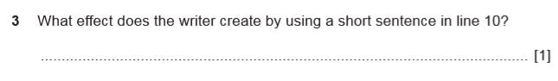
Some possible answers maybe something like the following:

- It introduces a surprising/shocking fact.
- It emphasizes the idea of the danger.

The above answers had to be related to the actual text in the test.
Other questions may ask you for a more general meaning of why writers use short sentences. Possible answers could be:
​
- to make the sentences clear
- to make it easier to read
- to make it easier to understand
- to add a dramatic effect
- to build up tension

Active and Passive Sentence
There is usually a question about passive sentences (and sometimes active sentences) in the non-fiction part of the test. See the example below:
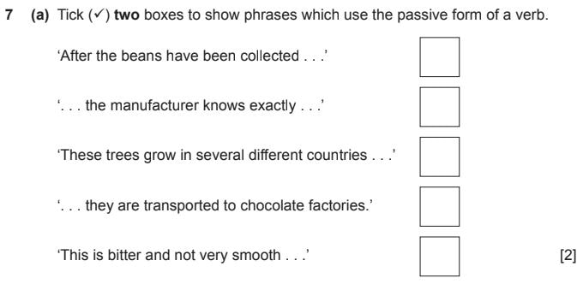

The opposite of a passive sentence is an active sentence so let’s look at what an active sentence is first:
A sentence using the active verb is one where the subject of the sentence carries out the action described by the verb and the object of the sentence has the action done to it.

The cat frightened the mouse.

A sentence using the passive verb is one where the subject of the sentence has the action described done to it. The passive voice usually has a form of the verb to be plus the past participle of the main verb e.g. was frightened. If the object is included in the sentence, it is usually at the end with the word by used before it.

The mouse was frightened by the cat.

Sometimes the agent can be left out completely.

The mouse was frightened.

You could be asked why the passive form is generally used in a text?
An acceptable answer would be one that recognizes that using the passive verb focuses on the process (rather than the subject doing the process).
Other possible answers could be:
​
- to describe the process
- the process is more important than who is doing it
- it doesn’t matter who is doing the process
- the object is more important than the subject
- the topic is about chocolate, not who is making the chocolate

Connectives
You may be asked to identify connectives and why they are used in a text.

For example: You might be asked about time connectives so you must identify them and explain that in the text they are being used to put processes into chronological order.

Other possible answers could be:
​
- to sequence events
- to show the order in which things happen.

Synonyms
In an exam you will often be asked to give synonyms for a word or words from the text. Make sure you know what a synonym is.

Definition: Synonyms are words that are similar, or have a related meaning to another word.

Some examples:
​
- Baffle: confuse, deceive.
- Beautiful: attractive, pretty, lovely.
- Bossy: controlling, tyrannical.
- Fair: just, objective, impartial, unbiased.

Figurative Language
During a test you will more than likely be given a phrase from one of the comprehension texts in the exam and asked what technique/figurative language is used? Also, you will often be asked what the phrase means in your own words?

Make yourself familiar with the figurative speech below.
​
Simile: A figure of speech which involves a direct comparison between 2 unlike things, usually with the words like or as.
Example: The muscles on his brawny arms are as strong as iron bands.
Other examples that begin with “as”:
- As big as an elephant
- As black as coal
- As blind as a bat
- As boring as watching paint dry
- As brave as a lion
- As bright as a button
- As busy as a bee
- As cheap as dirt

Other examples of similes that use “like”:
- They fought like cats and dogs.
- Watching the show was like watching grass grow.
- Don’t just sit there like a bump on a log.
- Well, that went over like a lead balloon.
- Last night, I slept like a log.
- This dress is perfect because it fits like a glove.

Metaphor: A figure of speech which involves a comparison between two relatively unlike things using a form of the verb ‘to be’ (am, is, are, was, were) The comparison does not use the words like or as to introduce the figurative speech.

Example: The road was a ribbon wrapped through the desert.
Examples of metaphors. Look for the comparison being made:
- The snow is a white blanket.
- The classroom was a zoo.
- America is a melting pot.
- Her lovely voice was music to his ears.
- Life is a rollercoaster.
- The alligator’s teeth are white daggers.
- Their home was a prison.
- His heart is a cold iron.

Alliteration: Repeated consonant sounds occurring at the beginning of words or within words.
Example: She was wide – eyed and wondering while she waited for Walter to waken.

Personification: A figure of speech which gives the qualities of a person to an animal, an object, or an idea.
Example: The wind yells while blowing.
​
Exaggeration: A statement that represents something as better, bigger, worse etc than it really is.
Example: I’ve heard that a thousand times.

Onomatopoeia: The use of words that mimic sounds.
Example: The firecracker made a loud ka-boom!

Irony: An outcome of events opposite to what was, or might have been expected.
Example: A protestor is holding up a sign calling the president stupid but he has a spelling mistake on his sign.

Sarcasm: Words that mean the opposite of their usual meaning. Usually spoken with a mocking tone.
Example: A sick person said he felt, "just great."

Explaining Differences Between Paragraphs
You could be asked to explain the difference between one paragraph compared to other paragraphs in a text.

Here is an example from an exam:
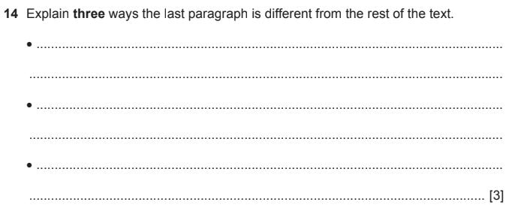
Answers might be something like the following differences in relation to purpose, audience or style:

• The first three paragraphs use very descriptive, powerful words and are full of opinions. / The last paragraph uses factual language.

• The first three paragraphs use descriptive language but the last paragraph doesn’t use descriptive language.

• The author is persuading the target audience to have a chocolate party in the first three paragraphs.

• The author is giving details (information/facts) about the parties/ appropriate age group and party times in the last paragraph.

• The first three paragraphs are directed towards the children.

• The last paragraph is giving information directed to parents.

Similarities With Sentences
You may be asked to look at two sentences and write down the similarities.

Here is an example from an exam:
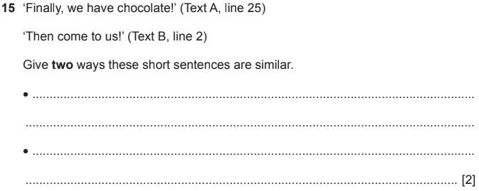
Below are some acceptable answers to the above question.

• They both use exclamation marks.
• They both use the first person plural we/us.
• They are both simple sentences.

The Purpose of a Text
You may be asked to explain the purposes of the comprehension texts in paper 1.

Here is an example from an exam:
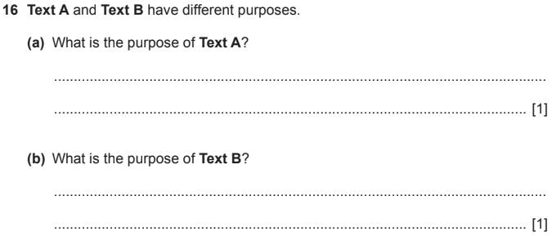

Text A in the above exam was an explanation text.
The answer must recognize the purpose of the first text as explanatory e.g:

• Text A is used to explain.
or
• Text A’s purpose is to describe the process of making chocolate.

Text B in the above exam was a persuasion text.
The answer must recognize the purpose of the second text as persuasive e.g:
​
• Text B is used to persuade.
or
• Text B’s purpose is to draw people into having a chocolate party / to make
people want to have a chocolate party.

Language Features
You may sometimes be asked to give features (usually two) of one of the comprehension texts. For example, if it is a persuasive text you could write two of the following:

- Usually written in present tense or future tense if appropriate.
- Written in chronological order.
- Contains mostly facts.
- The title describes the contents.
- Written in third person.
- Uses connectives of cause and effect e.g. because, therefore, etc.
- Contains technical vocabulary e.g. battery, bulb, stock etc.
- Contains passive sentences e.g. Blood is pumped around the body by the heart.
Make sure you study the features of the different text types.

Purpose of Subheadings
You will often be asked what is the purpose of sub-headings? Possible answers could be:
To draw attention to or highlight specific information in a text.
So the text is easier to follow.
They divide information into parts so it is easier to see.
So it is easier to find specific information in a text.
They tell the reader the main topic of the following paragraph or paragraphs.

Grammar
Make sure you know the different word classes such as: nouns, verbs, adjectives, adverbs, prepositions, pronouns, prepositional phrases, relative clauses etc.

You will need to understand the different forms of verbs as you might be asked to change a sentence from one tense to another.

Punctuation and Their Functions
You should study these:
- SCARY Capital Letters (The whole word) – Are used to emphasize a point.
- … Ellipsis – Are used to make the reader continue reading; the intentional omission of words; a pause in speech; an unfinished thought; a sentence that trails into silence.
- ! Exclamation Mark – Used to express joy, surprise etc; to generally show emotion; to show a raised voice; to issue a command.
- : Colon – Is used to make the reader pause or start a list. It is also used for relating to or expanding on information before it.
- ; Semicolon – can join two clauses so they replace the conjunction e.g. and, but, yet etc. They are used to separate items into a list.
- – Dash – a dash is considered less formal than brackets. A dash can be used to create emphasis in a sentence or adding extra information that stands out.
- () Brackets – used to give additional information that stands out.
- “ “ Speech marks – used to show speech.
- , Commas – they are used in lists; they are used to mark clause divisions etc.

