Dear Students,
Scan the QR code below to watch a short video [https://youtu.be/J9Pjit4kU6Q?si=KgYj0lXiiagKhdnH] (around 3 minutes) about vertebrate and invertebrate animals.
After watching, complete the mind map chart on the back of the paper using the information from the video.
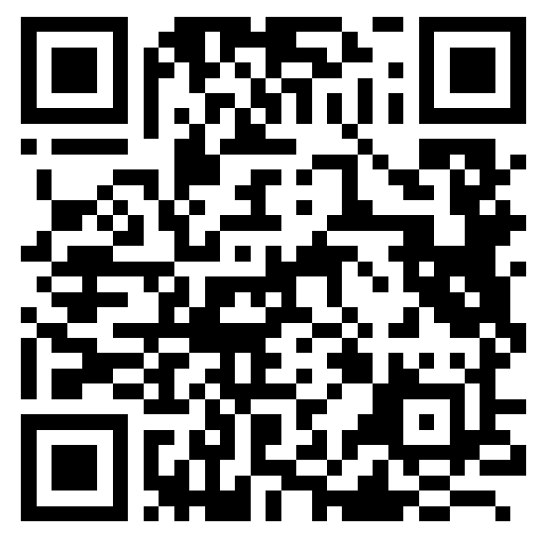
Submission date: from 11th – 16th October.

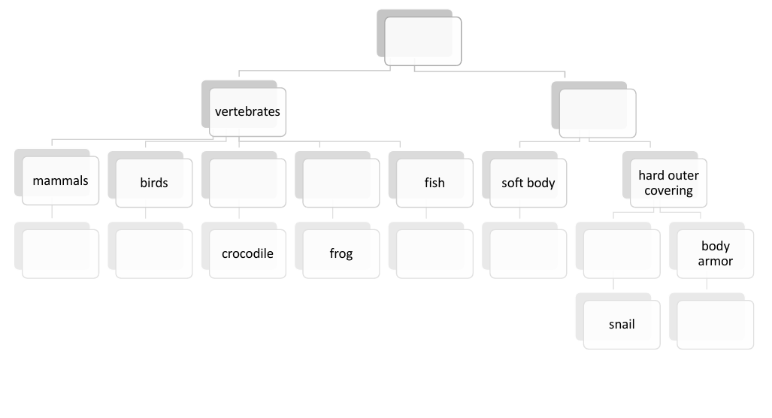
Name: _____________________ Class: _______

