Past Paper Questions
Q1. Eva has some $2 notes and some $5 notes.

She keeps them in two separate envelopes.

$2 notes
$5 notes
A represents the total amount in the envelope that contains the $2 notes.

B represents the total amount in the envelope that contains the $5 notes.

A + B = $25

Write a possible pair of values for A and B.

A = $

B = $

[1]

Q25, 0096/02/A/M/25

Q2. The perimeter, 𝑝, of an equilateral triangle with side length, s, is written as

𝑝 = 𝑠 + 𝑠 + 𝑠
- Find the value of 𝑝 if s = 12 cm.

cm [1]

- Two identical equilateral triangles are joined together to make a new shape.
𝑠
Draw a ring around the correct expression for the perimeter, d, of the new shape.

d = s + s + s d = s + s + s + s

d = s + s + s + s + s d = s + s + s + s + s + s

[1]

Q13 ,0096/01/O/N/23

Q3. Pierre has some $1 notes and some $2 notes.
The total value of the notes is $50

g represents the number of $1 notes Pierre has.
h represents the number of $2 notes Pierre has.
- Write the value of g when h is 10

[1]

- Write the largest possible value of h.

Q4.
Ahmed and Yuri have some pencils.
Ahmed has more pencils than Yuri. Yuri has an even number of pencils.
[1]

Q27, 0096/02/O/N/24

The number of pencils Ahmed has is represented by  The number of pencils Yuri has is represented by 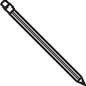

+ 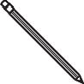 is greater than 60


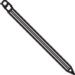
If is 45 write two possible values for

or [1]

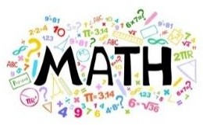
Teachers: Eman Nabas, Qusie Hijazeen

