“How to Make a Fruit Salad”

Hello everyone! Today I’m going to show you how to make a simple and delicious fruit salad.

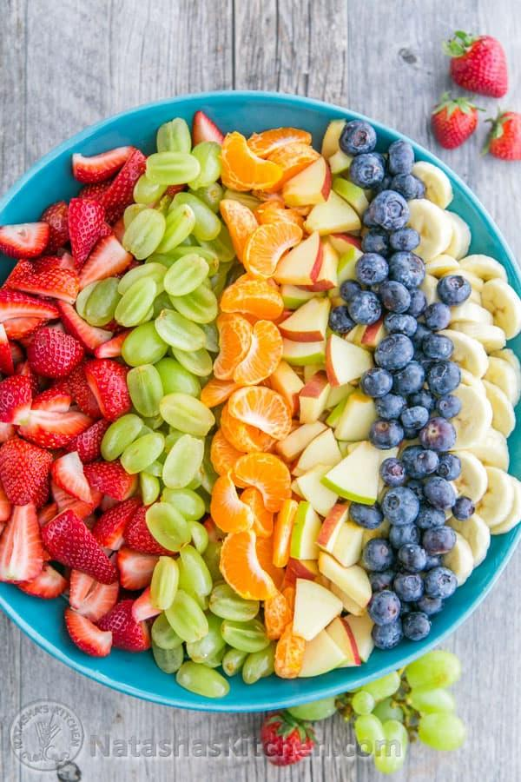

Done by Issa Haddaden
1E

Ingredients and Tools
First, let’s look at the ingredients and tools we need.

You will need:
• 1 banana
• 1 apple
• A handful of grapes
• 1 orange
• Some strawberries

And the tools:
• A chopping board
• A knife
• A bowl
• A spoon

Instructions :
First, wash all the fruits carefully.
Second , peel the banana and the orange.
Next, cut the banana, apple, and strawberries into small pieces.
cut the grapes in half and add all the fruits into the bowl.
Then, gently mix everything with a spoon.
Finally, your fruit salad is ready to eat!

