Step 1 – EVIDENCE 1 here:
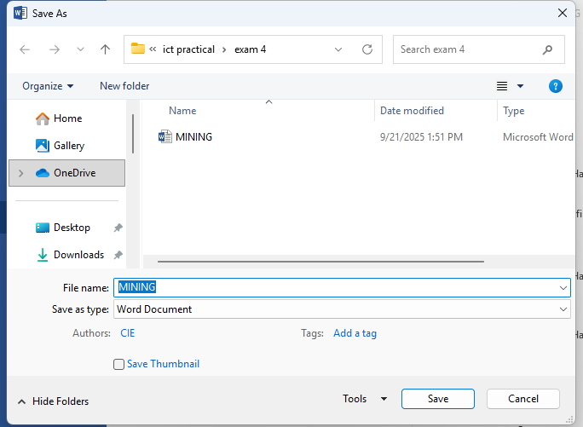

Step 4 – EVIDENCE 2 here:
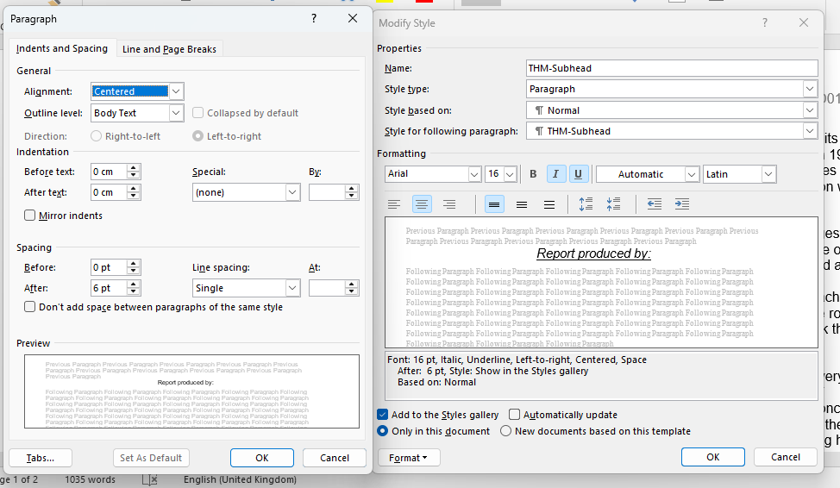

Step 5 – EVIDENCE 3 here:
