Step 2 - EVIDENCE 1 - File saved showing the file type here:

Step 4 - EVIDENCE 2 – Style definition here:

Step 23 - EVIDENCE 3 – Evaluation and recommendation here:

Step 24 – EVIDENCE 4 – Database field structure screenshot here:

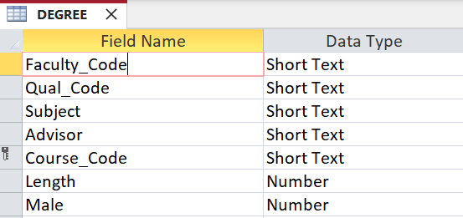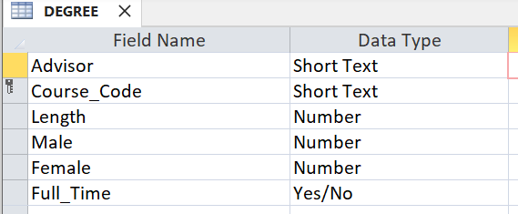

Step 25 - EVIDENCE 5 – Restriction screenshot here:

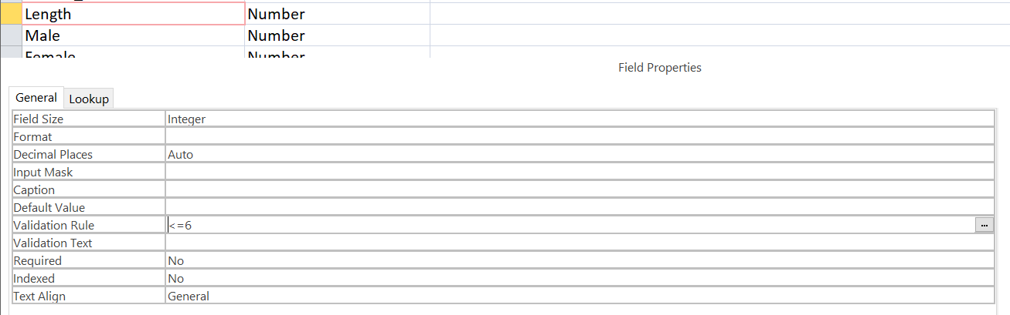

Step 27 - EVIDENCE 6 – Relationship screenshot here

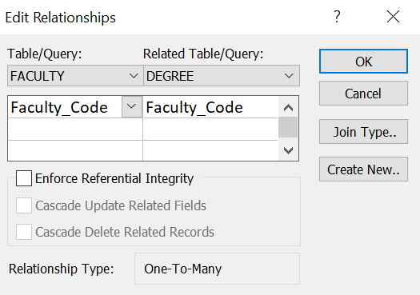

Step 28 - EVIDENCE 7 – Calculated control formula screenshot here

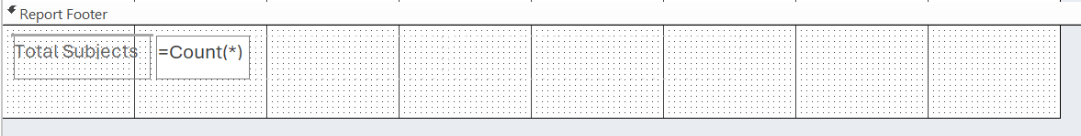

Step 30 – EVIDENCE 8 – Date field screenshot here:

Step 31 – EVIDENCE 9 – Mail merge selection method screenshot here:

