Step 2 - EVIDENCE 1 - File saved showing the file type here:
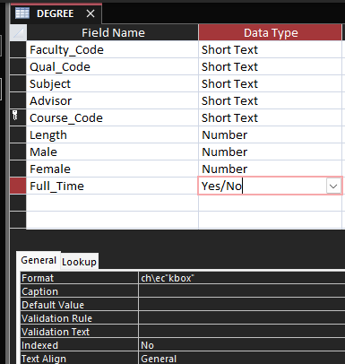

Step 4 - EVIDENCE 2 – Style definition here:

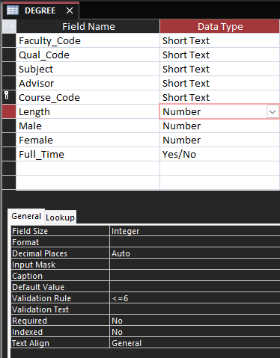

Step 23 - EVIDENCE 3 – Evaluation and recommendation here:

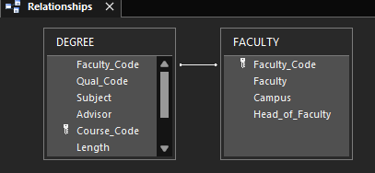

Step 24 – EVIDENCE 4 – Database field structure screenshot here:

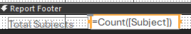

Step 25 - EVIDENCE 5 – Restriction screenshot here:

Step 27 - EVIDENCE 6 – Relationship screenshot here

Step 28 - EVIDENCE 7 – Calculated control formula screenshot here

Step 30 – EVIDENCE 8 – Date field screenshot here:

Step 31 – EVIDENCE 9 – Mail merge selection method screenshot here:

