Step 1 – EVIDENCE 1

Step 3 – EVIDENCE 2
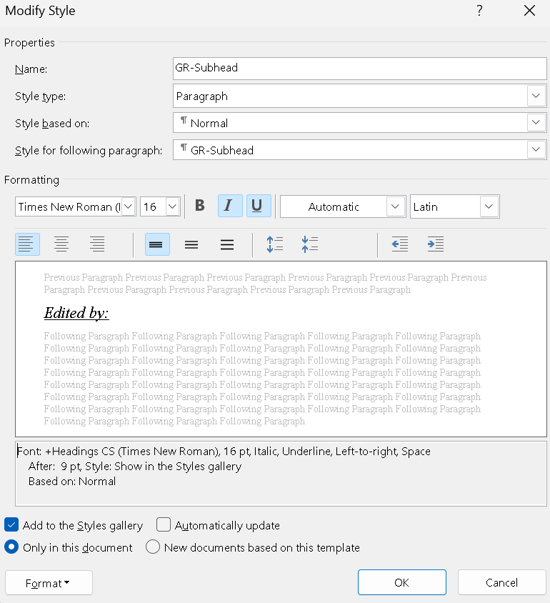

Step 4 – EVIDENCE 3

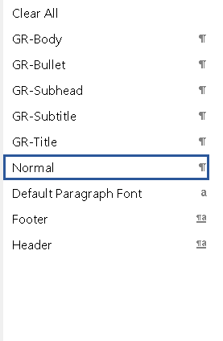

Step 21 – EVIDENCE 4

Step 22 – EVIDENCE 5

Step 24 – EVIDENCE 6

Step 25 – EVIDENCE 7

Step 27 – EVIDENCE 8:

Answer a)

Answer b)

Answer c)

Answer d)

Step 28 – EVIDENCE 9

Step 30 – EVIDENCE 10

Step 32 – EVIDENCE 11

