Step 24 – EVIDENCE 4 – Database field structure screenshot here:

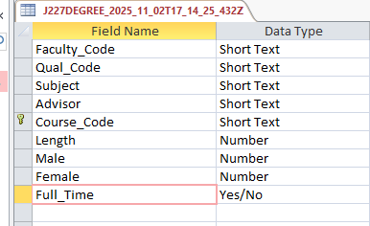

Step 25 - EVIDENCE 5 – Restriction screenshot here:

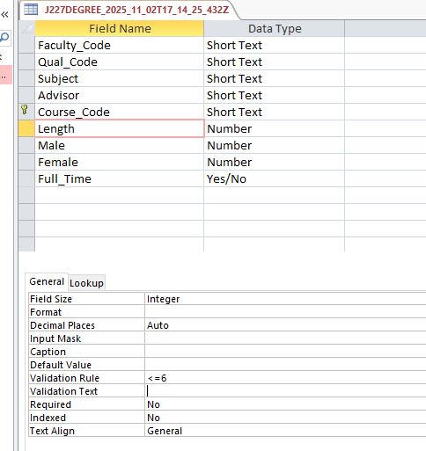

Step 27 - EVIDENCE 6 – Relationship screenshot here

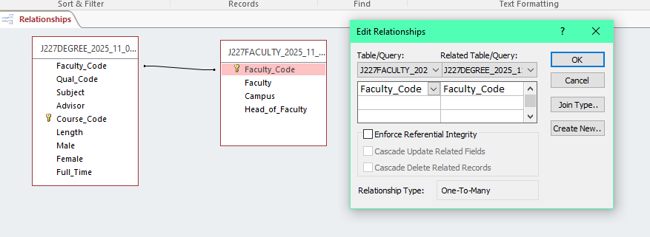

Step 28 - EVIDENCE 7 – Calculated control formula screenshot here

