Business project
McDonalds

Report by:Faisal Ghanma, Karam Alafnan

The history

McDonalds is a worldwide fast food chain, Serving over 69 million customers daily in many countries around the world. It was founded in 1940 by brothers Richard and Maurice McDonald in California. Famous for its speed and quality without sacrificing taste. In 1955 Ray Kroc joined the McDonald brothers and expanded it to nationwide fast food restaurants.

Business side

McDonalds satisfies the need of nutrition however there are much healthier options, and it is usually bought for its cheap prices. The company operates in the private sector as it is not government owned and the main goal is to make profits, it's also a limited company which means that it has limited liability and its shares are traded publicly.

Marketing And Branding

McDonalds is one of the most recognizable brands in the world. Due to its strategies,marketing and consistent collaborations with multiple types of products that entertain and attract customers from different fan bases.

Its golden M logo also known as the “golden arches” symbolizes fast and straightforward service while being basic so that it is recognised instantly.

Collaborations

McDonalds keeps their collaborations constant so that they can attract more customers. They collaborate with celebrities from the music industry, or the fashion industry such as Adidas and crocs, this attracts audiences from all ages and keeps them coming back.

Sales
Mcdonalds displays its quarterly sales every year on their corporate website Corprate.McDonalds.COM ,they do this to encourage investors to buy shares, if the investors see positive sales and revenue, they will be more willing to invest.
Here are some examples of revenue in recent years.

- In 2024, McDonald’s annual revenue was $25.92 billion, up 1.67% from the year before.
- In 2024, net income was $8.223 billion, a decrease of 2.9% from 2023.
- For the first quarter of 2025, global sales declined by 1 percent. U.S. stores saw a drop of 3.6 %, Most likely as a reason of international controversy and boycott

Economic problems and inflation have resulted to higher-priced items.
McDonald’s response has included highlighting value menus and promotions to stimulate traffic.
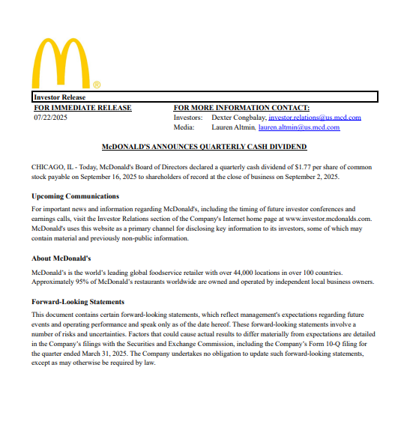
This information is publicly shared on their website as a .pdf file and contains all needed information for shareholders to be able to buy shares,in this photo released on 7/22/2025
which has the most recent quarter (quarter 3) of 2025.

The Self-Checkout scheme
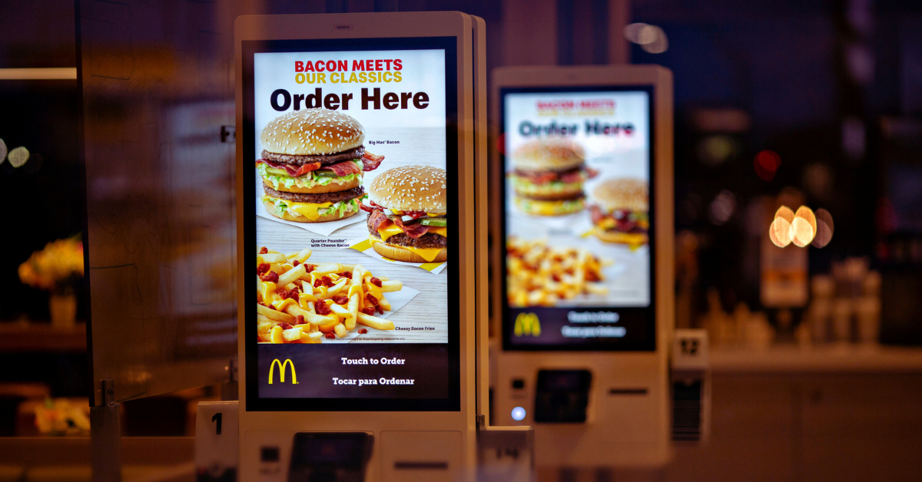
Mcdonalds uses self ordering kiosks which may seem as a useful problem solver for long lines or people who take a long time to order however it is all part of a giant marketing scheme, combining many tricks to get customers to pay more. And it gained them 2.1 billion dollars in revenue.

They used visual tricks to keep customers ordering such as pictures where the food looks higher quality than it actually is and bigger in proportion size, they would also use a method called “bundle framing” or “Bundling” where it convinces the customer to buy the entire meal with fries and a drink than just the burger to show that buying the bundle is cheaper than buying all items separately.

Conclusion

To conclude, McDonald’s seems to be a simple company, with not much controversy and problems that make it have a negative description. However, it uses many business techniques and schemes that trick customers into spending more; which might show that they care more about money than customers.

References:
https://corporate.mcdonalds.com/corpmcd/investors/financial-information.html#accordion-317079a844-item-9b66363394

https://youtu.be/BKX6EhDrgqQ?si=iPtIho6WTwjfLUlo

https://www.mcdonalds.com/us/en-us/about-us.html

https://corporate.mcdonalds.com/corpmcd/investors.html

