Business Project: Abdulhadi hospital

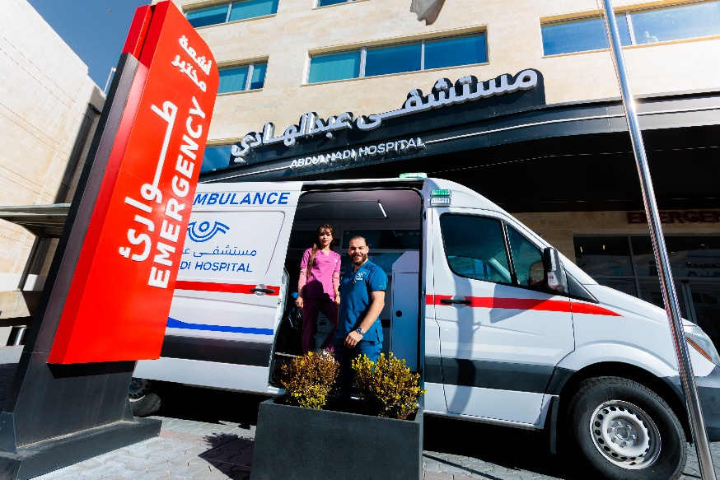

Zeina Habaybeh, Wafa’ Ibrahim
Grade 9D

Achieving excellence in providing comprehensive medical care has been one of the fundamental pillars on which Abdulhadi Hospital for Comprehensive Care was built. Since 2002, under the patronage of Her Majesty Queen Rania Al Abdullah, Abdulhadi Hospital has been founded by Dr. Samer Abdulhadi, and with steady and studied steps, Abdulhadi Hospital was opened, which at that time included many different medical and surgical departments, and also contained the most modern department of ophthalmology and eye surgery at that time. Within a short period, the hospital gained the trust of patients and visitors from all over the Arab world for the comprehensive and distinguished medical services it provided.
The hospital continued to excel year after year, and its journey was full of medical achievements in various fields, which gave rise to the idea of ​​expanding the hospital and increasing its capacity to meet the growing need for comprehensive medical services in one place. This was achieved through the second expansion of the hospital in 2015, so that the hospital includes all medical specialties and delicate surgeries. The bed capacity was increased to more than one hundred beds, and the building was equipped with the latest scientific medical equipment, a comprehensive laboratory, and the creation of a modern and advanced radiology department.
Today, to meet the continuous increase in the number of patients and visitors who are confident in receiving medical services within the highest international standards, the third expansion of Abdulhadi Comprehensive Hospital has been completed, making it a medical edifice recognized globally with a total capacity of more than 200 beds, supported by various supporting medical departments that have been designed according to the latest international standards to ensure that our patients receive a unique medical experience.
- There are now over 180 doctors working with the hospital
- The hospital now has over 12 departments
Departments:
- LAB
- Radiology
- Cardiac Catheterization and CCU
- Intensive care unit (ICU)
- Newborns and NICU
- Dental Care
- Operating Theaters
- Royal Suites & Patient Rooms
- Endoscopy
- Anesthesia and Pain Management Department
- Ophthalmology Department
- Obstetrics & gynecology
- Emergency Department
- Pediatrics Department
- IVF Department

Introduction and History:
In 2002, the hospital originally functioned as an ophthalmology clinic. Over the following years, it underwent multiple phases of expansion in order to introduce additional medical specialties and to increase the number of patient rooms, responding to the growing demand in the healthcare market. Subsequently, the hospital continued to develop by establishing new facilities such as an emergency department, a pharmacy, and other essential services.

Products and Services:
The hospital offers five main medical specialties: Obstetrics and Gynecology, Pediatric Surgery and Pediatrics, General Surgery, Internal Medicine, and Ophthalmology. In addition, the hospital has a Continuous Medical Education Department, which is responsible for training new staff members—including nurses, physicians, and support personnel—on professional conduct, proper procedures, and patient care standards. The hospital also provides a range of additional services. Some of these, such as the pharmacy and medical laboratories, are essential services that fulfill necessary patient needs. Others, such as the cafeteria and valet parking, are optional services that accommodate patient and visitor comfort rather than medical necessity.

Factors of Production:
The hospital utilizes a range of advanced medical equipment and technologies to support specialized treatment. These include the Vaser machine used in cosmetic procedures such as liposuction, the CTANGO cardiac assessment device which helps predict the risk of heart attacks, and the Excimer Laser for correcting vision and reducing dependency on glasses. The hospital also employs bronchoscopy equipment to safely examine airways in pediatric cases, particularly when foreign objects have been swallowed, as well as a surgical microscope used in delicate brain and spinal cord operations. The workforce consists of approximately 500 medical staff—including physicians, nurses, and technical specialists—and around 200 administrative employees who support hospital operations. While the hospital currently relies primarily on its physical location for delivering services, it plans to expand into telemedicine, allowing for remote consultations and online patient follow-ups. As part of its ongoing development strategy, the administration is investing in improved budgeting processes, enhancing continuous medical education, strengthening training and development to promote more patient-centered care, and acquiring more modern medical technology to advance service quality.
Employee Motivation Strategies:

Abdulhadi Hospital in Amman motivates its employees by recognizing and rewarding excellence, investing in their wellbeing, and promoting professional growth. For instance, the hospital holds regular ceremonies to honor outstanding staff, such as “Employee of the Month” awards. They also have health initiatives: they partnered with DHL Jordan to offer comprehensive medical check-ups for their employees. Through collaboration with academic institutions like the Amman Arab University, they provide real-world clinical training, which helps staff build skills and feel part of a larger mission. Moreover, the hospital emphasizes quality and continuous development, aiming to foster a culture where safety, innovation, and high professional standards are central.

Entrepreneur / Leadership and Characteristics:
The founder demonstrated strong leadership abilities, confidence, and courage. As a medical professional, he possessed the expertise necessary to establish and manage a hospital effectively. His first notable success was the eye hospital, where he treated many international patients and achieved recognition as one of the top four hospitals in the country. Driven by a clear vision to expand and develop, he successfully grew the hospital over time.
The hospital benefits from a Continuous Medical Education Department (CMED) that meets daily and maintains open communication with the administration to convey staff complaints and suggestions. This approach helps create a clear roadmap for the hospital’s success by facilitating improvements in service quality and employee treatment.
What distinguishes this hospital is its commitment to ethical and honest medical practice, placing patient welfare at the forefront. Its consistently successful medical outcomes further reinforce its reputation. Strategically located within a prominent medical district surrounded by numerous clinics and healthcare services, the hospital enjoys a competitive advantage. Additional distinguishing features include a team of doctors available 24/7, a large-capacity emergency section, and a strong focus on employing skilled nursing staff, all of which enhance patient loyalty. The hospital also emphasizes service quality through a dedicated Quality Inspection and Control Department that utilizes key performance indicators (KPIs) to ensure optimal patient care.
The hospital was designed to maximize patient comfort, safety, and satisfaction, implementing features such as handrails on beds, which reduced fall risks by 90%. Improvements in staffing, including servers, dieticians, and chefs, enhanced both food quality and employee satisfaction, leading to an approximately 80% increase in customer approval. Additionally, the hospital actively seeks accreditation and awards from international associations, further strengthening its reputation among other healthcare institutions.

Ownership:
The hospital is a privately owned, family-operated business, with shares held exclusively by family members. It is registered as a private limited company (LTD).

Business Activity:
The hospital operates within the tertiary sector and engages in community-oriented activities. It organizes free medical days at schools, universities, and charitable organizations, setting up stations or booths where patients can receive complimentary medical consultations through joint ventures.

Business Size:
The hospital has 152 officially registered beds, with the capacity to accommodate approximately 200 patients at a time, including unofficial beds. In terms of staffing, the hospital employs around 500 medical professionals and 200 administrative personnel. Based on international standards, the hospital is classified as medium-sized, whereas according to national standards, it is considered large.

Business Organization:
The hospital has a defined administrative structure within its Human Resources department. This organizational framework clearly outlines the job descriptions of each employee, as well as the roles and responsibilities of various departments and staff members.

Business Objectives:
The hospital has established objectives across short-term, medium-term, and long-term horizons. Short-term objectives focus on human resources recruitment and training, as well as initiatives led by the Continuous Medical Education Department (CMED). Medium- to long-term objectives aim to enhance marketing, advertising, and the hospital’s brand image, with the goal of developing into a multi-specialty facility and increasing recognition within the community. Long-term objectives target attracting a larger number of both local and international patients, thereby achieving a reputation at the international level.
Although there are no plans for physical expansion due to limited land availability, the hospital intends to pursue internal growth strategies. The administration conducts monthly meetings to establish SMART objectives—specific, measurable, achievable (/agreed upon), relevant (/realistic), and time-bound. Progress is monitored using key performance indicators (KPIs) to ensure objectives are effectively implemented. Proper staffing, employee training, and business development initiatives support the successful achievement of these objectives.
Hospital Website
Hospital YouTube Channel

The findings and content of this document rely exclusively on primary data gathered firsthand.

