1-Write one meaningful word that rhymes with each of the given words below .

Wave ______
Skate______
Vake_______
Lane________
Mate________
Cane________
Cake_______
Cave________
Gate________
Mane________
Lake_________
Game___________
Take_________
Name____________
Make___________
Cape__________
Same__________
Bake__________
Tape__________

2-read the words below and circle the word that have the long vowel a sound .

Are _ mane_ have
Skate _ can__cake
The –wave _ take
Bake – nine –cave
Kid – gate –man
Cave –lake –cap
Name – sam- cane
Lane –late-some
Take –tap-game
Same-mate-cap
Bake – five – bake

3-write the name of each of the following pictures.

____________ ___________________

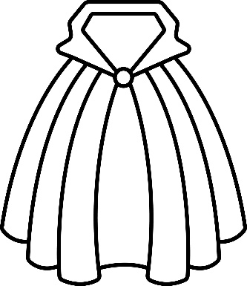 ___________ 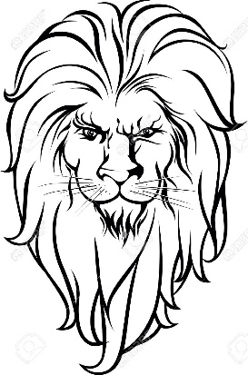
_________________
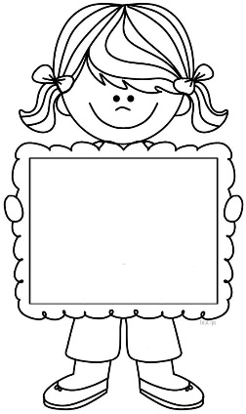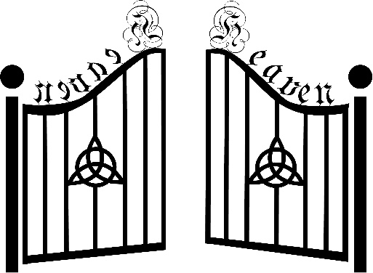
_________________ _______________________

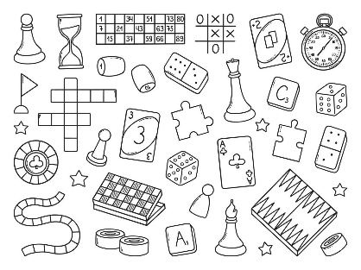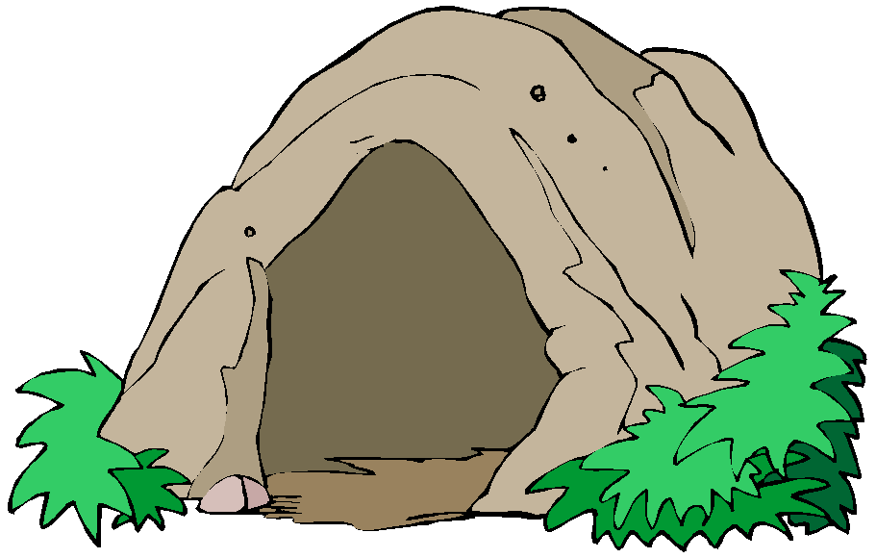
______________ _______________________

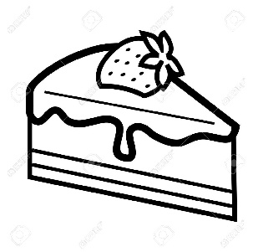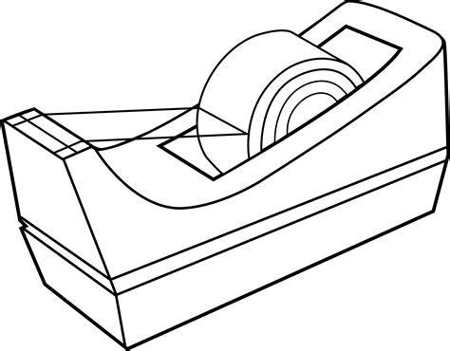
_______________ _________________

________________ ______________________

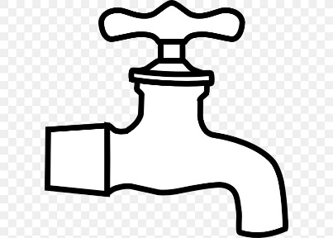
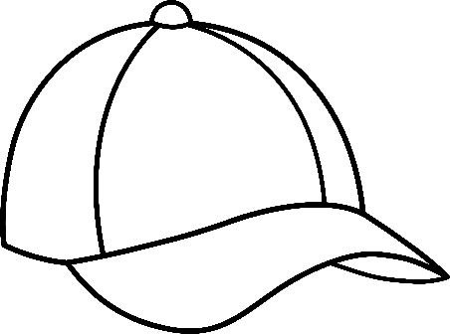
______________
_________

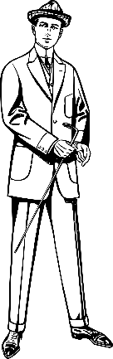
______________ ____________

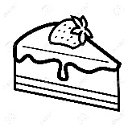
4-
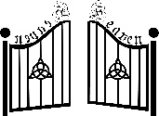
Cane
Cape
Tape
Wave
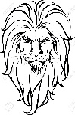
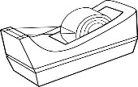
Cave
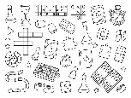
Lake
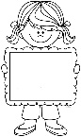
Mane
Cake
Name
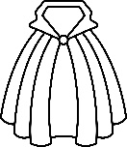
Game
Gate
Skate

5-

Can
Man
Tap
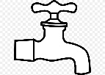
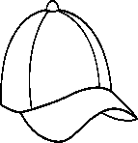
Cap

