Dear teacher
I’m fine thank you.
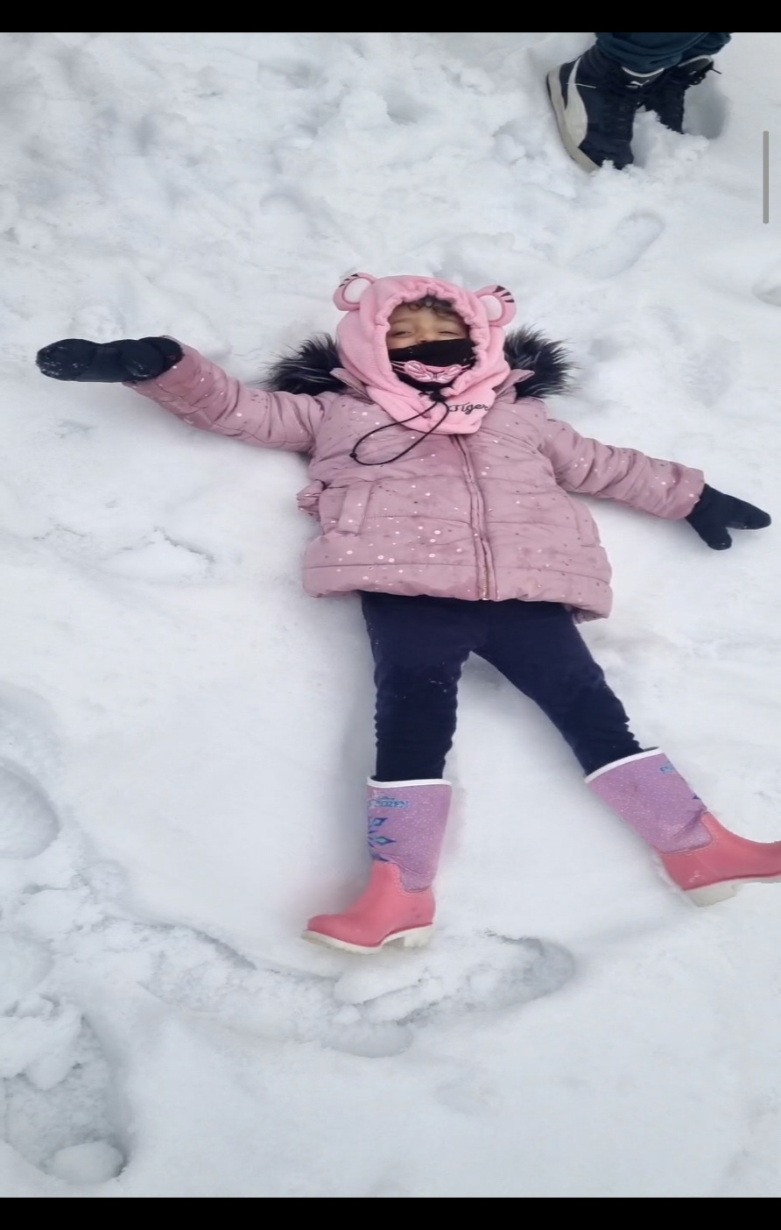
My favourite season is winter
Julia Muammar
3-F

