1-Write the Rhyme:
Vote _________
Home________
Pine__________
Lime__________
Hike__________
Five_________
Nine_________
Dive________
Bike__________
Time__________
Fine_________
Dome_________
Note________
Cone_______
Rope_________
Mute__________
Cube_________
Hope__________
Bone__________
Cute___________
Mule_________
June________
Rule__________
Tube___________
Tune______________
Vine______________
Line___________
June_____________
Hive__________
Like_______________
Ripe______________
Stone__________

2- m-e-i-d v-i-h-e
_________ _________
k-i-l-e n-v-i-e
_________ ____________

3-circle the word that is spelled correctly;

*My sister has a tooth paste
(Tube ) (tupe)
*what is the first (rule) (rulle)
*I hope over the
(rope) (robe)
*I like my
(hume) (home)
*cute (mole) (mule) walk on the sand
* it is a big (pone) (bone)
*the bone on the (kube) (cube)
*I (vot) (vote) for Ghalia and alma .
*I (hobe) (hope) you have a nice Day

4- circle the words don’t have the sound of long vowel (O)

Sock – joke - nose- come-huge
5- circle the words don’t have the sound of long vowel (u)

Home –cube -Kite-June-rope
6- circle the words don’t have the sound of long vowel (i)

Cube-like-mute-bone-fine

7- write words that have the sound of:
Long o-e
7- write words that have the sound of:
Long o-e
1-
2-
3-
4-
Long u-e
1-
2-
3-
4-
Long i-e
1-
2-
3-
4-
8- circle the words have the sound of long vowel (i)
Home – pine – cute
9- circle the words have the sound of long vowel (o)
Rope-rule-kite
10- circle the words have the sound of long vowel (u)
Stone –June-bike
11-write the name of each picture under the right column.

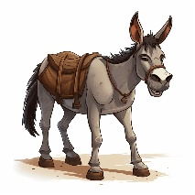

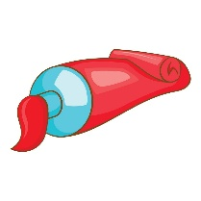



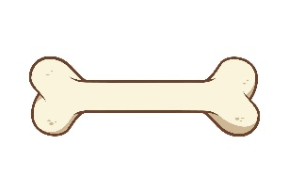



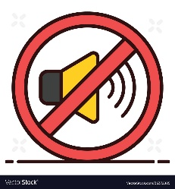

Long (o) long (u)

12-write the name of picture:

