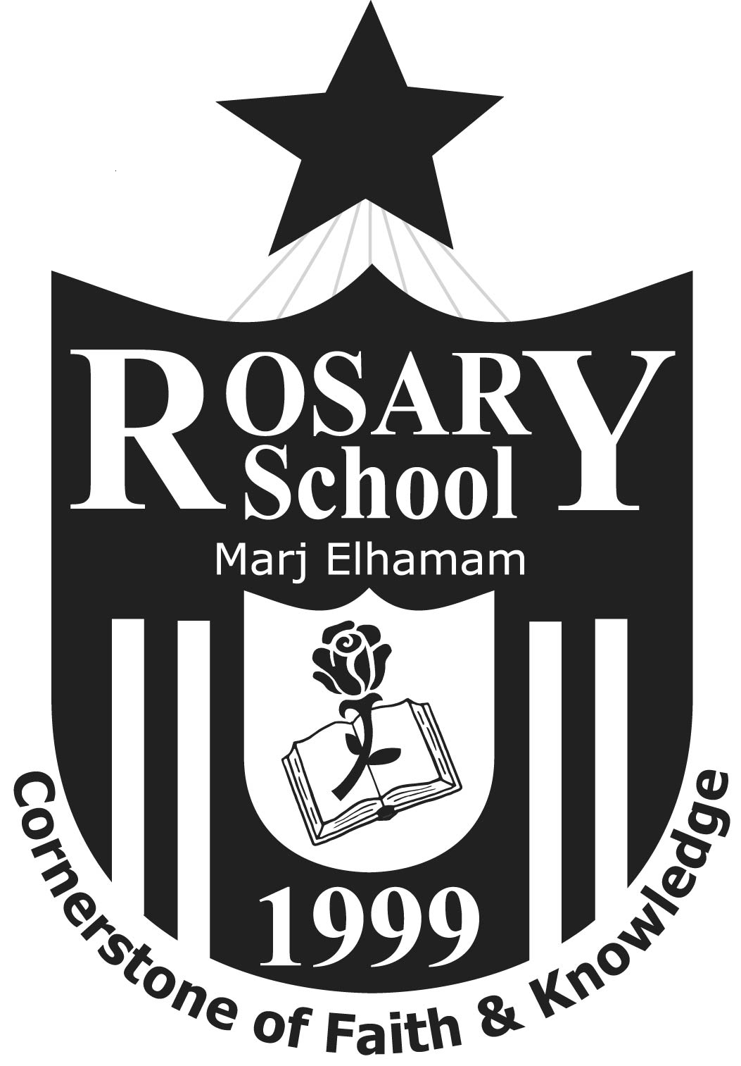

Rosary School – Marj Elhamam
Receiving Mock – Exam Papers 2025-2026
Date | Time | 12 A | 12 B | 12 C
Thursday  18/12/2025 | 8:20 – 9:05 | Biology | Biology | Biology
Thursday  18/12/2025 | 9:05 – 9:30 | Math | ----- | -----
Thursday  18/12/2025 | 9:30 – 10:00 | ---- | Math | -----
Thursday  18/12/2025 | 10:00 – 11:00 | Physics | Physics | Physics
Thursday  18/12/2025 | 11:00 – 12:00 | Chemistry | ----- | -----
‘‘12 A-Level ‘‘

Rosary School – Marj Elhamam
Receiving Mock – Exam Papers 2025-2026
‘‘11 AS-Level ‘‘
Date | Time | 11 A | 11 B | 11 C | 11 D
Saturday  20/12/2025 | 8:20 – 9:00 | Chemistry | Chemistry | Chemistry | ----------
Saturday  20/12/2025 | 9:00 – 9:40 | Biology | ---------- | Math | ----------
Saturday  20/12/2025 | 9:40 – 10:10 | Math | Biology | Biology | Biology
Saturday  20/12/2025 | 10:10- 10:40 | ---- | Math | ---- | Math
Saturday  20/12/2025 | 10:40-11:40 | Physics | Physics | Physics | ----

