GBU is a public limited company. It makes a range of beauty products including shampoo and soaps for the mass market. Last year GBU’s revenue fell. The Marketing Director has been looking at the results from its primary market research based on a sample of 2000 consumers. An extract is shown in Fig. 1. She believes maintaining customer loyalty is more important than attracting new customers.

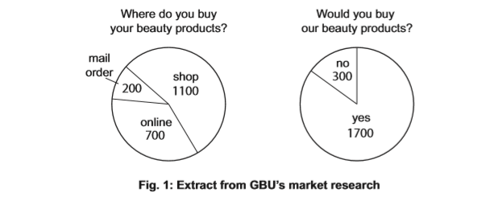

- What is meant by ‘mass market’?
is where there is a very large number of sales of a product[2]

- Calculate the percentage (%) of consumers who buy beauty products online.
35% [2]

(c)Identify and explain two possible reasons why GBU's market research might not be useful to the Marketing Director.
Reason 1:.......................................................................................................................... ........................................................................................................................................... Explanation:....................................................................................................................... ...........................................................................................................................................
Reason 2:.......................................................................................................................... ........................................................................................................................................... Explanation:....................................................................................................................... ........................................................................................................................................... [4]
(d) Do you think maintaining customer loyalty should be more important to GBU than attracting new customers? Justify your answer
Maintaining customer loyalty can be beneficial for GBU by allowing them to get better than their competitors which will increase their profit for their beauty products shop however, maintaining customer loyalty rather than getting new customers wouldn’t get them more customers which will lead them to not get popular .
GBU should attract more customers because it could increase the number of customers allowing him to get [6]

