GBU is a public limited company. It makes a range of beauty products including shampoo and soaps for the mass market. Last year GBU’s revenue fell. The Marketing Director has been looking at the results from its primary market research based on a sample of 2000 consumers. An extract is shown in Fig. 1. She believes maintaining customer loyalty is more important than attracting new customers.

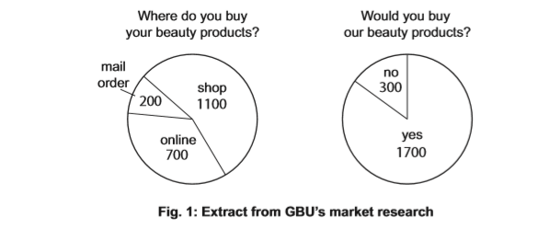

(a) What is meant by ‘mass market’? ........................................................................................................................................... ........................................................................................................................................... ........................................................................................................................................... [2]

(b) Calculate the percentage (%) of consumers who buy beauty products online. ........................................................................................................................................... ........................................................................................................................................... [2]

(c)Identify and explain two possible reasons why GBU's market research might not be useful to the Marketing Director.
Reason 1:.......................................................................................................................... ........................................................................................................................................... Explanation:....................................................................................................................... ...........................................................................................................................................
Reason 2:.......................................................................................................................... ........................................................................................................................................... Explanation:....................................................................................................................... ........................................................................................................................................... [4]
(d) Do you think maintaining customer loyalty should be more important to GBU than attracting new customers? Justify your answer
............................................................................................................................................ ........................................................................................................................................... ........................................................................................................................................... ........................................................................................................................................... ........................................................................................................................................... ........................................................................................................................................... ........................................................................................................................................... ........................................................................................................................................... ........................................................................................................................................... ........................................................................................................................................... ........................................................................................................................................... ........................................................................................................................................... [6]

