Chapter 13: Finding Halves and Quarters
Worksheet A: Find $\frac{1}{4}$ of a Shape

1. A square is folded into halves, then into quarters.
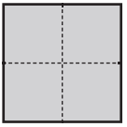
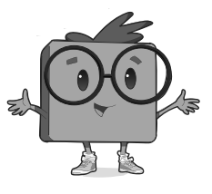
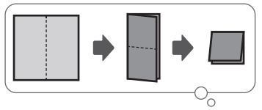

(a) The square shows _________ equal parts.

(b) Each part is called a ______________.

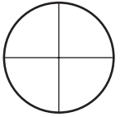
2.

(a) The circle shows _________ equal parts.

(b) Each part is _________ of a circle.
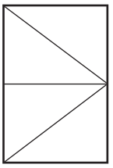
3.

(a) The rectangle shows _________ equal parts.

(b) Each part is _________ of a rectangle.

4. The squares show quarters in different ways.
Colour a quarter of each square.
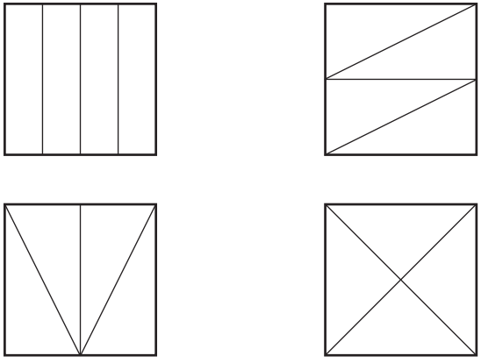

5. Which square is split into unequal parts? Cross it out.
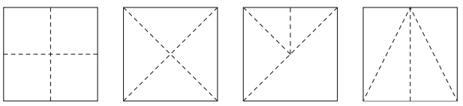

6. Draw lines in each shape to show 4 quarters.
(a)

(b)

(c)

Worksheet B: Find $\frac{1}{4}$ of a Set

1. Complete.
(a) What is $\frac{1}{4}$ of 8? _________

Divide the 8 basketballs equally into 4 groups.


(b) What is $\frac{1}{4}$ of 12? _________



(c) What is $\frac{1}{4}$ of 20? _________
2. What is $\frac{1}{4}$ of 32? _________
Draw circles around the triangles to help you.

3. What is $\frac{1}{4}$ of 16? _________
Draw circles around the circles to help you.

4. What is $\frac{1}{4}$ of 24? _________
Draw circles around the stars to help you.

5. The picture shows $\frac{1}{4}$ of the oranges that Irwan buys.
How many oranges does Irwan buy in total?

Since $\frac{1}{4}$ of the total oranges is 4 oranges, multiply 4 oranges by 4 to find the total number of oranges.
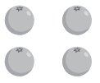

Irwan buys _________ oranges.

6. The picture shows $\frac{1}{4}$ of the fruit tarts that Miss Lim bakes.
How many fruit tarts does Miss Lim bake in all?


Miss Lim bakes _________ fruit tarts in all.

7. The picture shows $\frac{1}{4}$ of the tomatoes in a kitchen.
How many tomatoes are there altogether?


There are _________ tomatoes in all.
Worksheet C: Find $\frac{1}{2}$ and $\frac{1}{4}$ by Dividing

1. (a) A box has 10 crayons.
Michael uses $\frac{1}{2}$ of the crayons for art.
How many crayons does he use?


$\frac{1}{2}$ of 10 = 10 ÷ 2
= _________

Michael uses _________ crayons.

(b) A store has 16 baseballs.
It sells $\frac{1}{2}$ of them to a customer.
How many baseballs does the store sell?


$\frac{1}{2}$ of 16 = 16 ÷ _________
= _________

The store sells _________ baseballs.

(c) There are 14 ants.
$\frac{1}{2}$ of the ants crawl away.
How many ants crawl away?
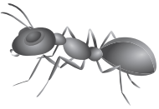

$\frac{1}{2}$ of 14 = _________ ÷ _________
= _________

_________ ants crawl away.

(d) There are 20 bananas.
Some monkeys eat $\frac{1}{2}$ of the bananas.
How many bananas do the monkeys eat?


$\frac{1}{2}$ of 20 = _________ ÷ _________
= _________

The monkeys eat _________ bananas.
2. (a) Enzo folds 28 paper cranes.
He gives $\frac{1}{4}$ of it to his sister.
How many paper cranes does Enzo give to his sister?
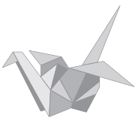
$\frac{1}{4}$ of 28 = 28 ÷ 4
= _________

Enzo gives _________ paper cranes to his sister.

(b) There are 24 carrots.
Glenn cooks $\frac{1}{4}$ of the carrots.
How many carrots does Glenn cook?


$\frac{1}{4}$ of 24 = 24 ÷ _________
= _________

Glenn cooks _________ carrots.
(c) Ian has 20 marbles.
$\frac{1}{4}$ of them are red.
How many marbles are red?


$\frac{1}{4}$ of 20 = _________ ÷ _________
= _________

_________ marbles are red.

(d) There are 32 seashells on a beach.
Tiffany picks $\frac{1}{4}$ of them.
How many seashells does Tiffany pick?


$\frac{1}{4}$ of 32 = _________ ÷ _________
= _________

Tiffany picks _________ seashells.
3. (a) There are 8 cups on a tray.

Finding $\frac{1}{2}$ of 8 is the same as finding 8 ÷ 2.
Mary uses $\frac{1}{2}$ of the cups.
How many cups does Mary use?

Mary uses _________ of the cups.

(b) Kamil has 12 maths questions for homework.
He finishes $\frac{1}{2}$ of them in the morning.
How many maths questions does Kamil finish?

Kamil finishes _________ maths questions.

(c) There are 18 children at a playground.
$\frac{1}{2}$ of them are boys.
How many boys are there?

There are _________ boys.

4. (a) There are 8 cars on a road.
$\frac{1}{4}$ of the cars are blue.

Finding $\frac{1}{4}$ of 8 is the same as finding 8 ÷ 4.
How many cars are blue?

_________ cars are blue.

(b) A football team scores 16 goals.
Ikhsan scores $\frac{1}{4}$ of his team’s goals.
How many goals does Ikhsan score?

Ikhsan scores _________ goals.

(b) A bookcase has 40 books.
$\frac{1}{4}$ of the books are non-fiction.
How many books are non-fiction?

_________ books are non-fiction.

Worksheet D: Find Three Quarters of a Shape and a Set

1. Colour $\frac{3}{4}$ of each shape.
(a) (b)

(c) (d)

2. Colour $\frac{3}{4}$ of the shapes.
(a)

(b)

3. Fill in the blanks.
(a)

$\frac{1}{4}$ of 12 = ________

$\frac{3}{4}$ of 12 = ________ + ________ + ________

= ________

(b)

$\frac{1}{4}$ of 24 = ________

$\frac{3}{4}$ of 24 = ________

4. What is $\frac{3}{4}$ of 20? _________
Draw circles around the shapes to help you.

5. What is $\frac{3}{4}$ of 40? _________
Draw circles around the shapes to help you.

6. What is $\frac{3}{4}$ of 28? _________
Draw circles around the shapes to help you.

7. $\frac{3}{4}$ of a number is 12.
What is the number? _________

8. $\frac{3}{4}$ of a number is 21.
What is the number? _________
Draw circles around the shapes to help you.

9. $\frac{3}{4}$ of a number is 27.
What is the number? _________
Draw circles around the shapes to help you.

