

International GCSE Business studies Cambridge code: (0450)
Teacher: Mr. Mohammad Salim
Section (4): Nature of production/Operations

Disclaimer: this is only a summarization; use both the notes & the book

Production is the process where inputs (components/raw materials) are converted to saleable outputs (finished goods) for the end user (customer)
Products are produced using the factors of productions (capital, enterprise, land, labor)
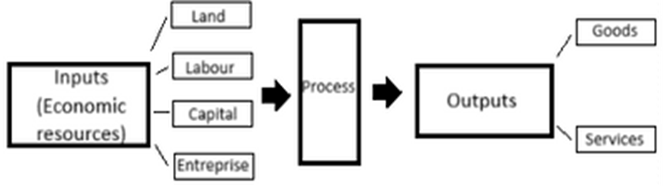
- Do not confuse production with productivity (number of units produced per input)
- production is the process, while productivity is a measure of efficiency of inputs used in production, meaning the quantity produced per resource (capital/machinery or labor)

It can be calculated by the formula below
$productivity= \frac{output}{inputs}$
- Added value is the difference between the cost of materials (direct costs) and the final price, it is not the profit, because the indirect costs have not yet been deducted, increasing added value is either done by reducing direct costs, or increasing selling price.
- Improvements in the product, advertising can be used to increase product value, and make it easy to attract consumers.

Production can be done by human labor, or by capital machinery, we can divide them as followed.

Labor intensive: this occurs when the company hires and operates using large amounts of labor, technology is limited or unused, advantages for that is that the company can benefit from the ideas of workers, and production can have special features for jobs that require creativity such as design and tailoring
However, workers can become tired, so production and quality can be affected, motivating workers can also be difficult so it is possible that workers could be lazy and dishonest, sick days and vacations can also hinder and delay production unlike machinery which can be operated overnight or for longer periods than legal requirements permit.

Capital intensive: The term "capital intensive" refers to business processes or industries that require large amounts of investment to produce a good or service, labor is only used to operate machinery and can be much less than in comparison to labor intensive, the company relies on technology heavily, this can be beneficial because large amount can be produced in shorter periods, this can allow technical economies of scale which reduces the average unit cost, furthermore, labor is less so labor and training costs are reduced.
However very experienced workers are needed to run the machinery and may require high salaries, in addition to the fact that technology is expensive and can require bank loans or payments that can damage the company’s cash flow forecasts.

Types of production.
- Job production: when a single product is produced at a time, the workers usually perform all the tasks involved in producing a unit, meaning it is labor intensive, workers are highly skilled and can do many tasks.

Advantages: products are more specialized to consumer needs, they are not identical and adapted to consumers wants, customer satisfaction is high, relation with consumers can improve.

Disadvantages: labor intensive means high labor costs, production takes longer than by using other methods that require technology, if demand increases, the company may not be able to keep up with demand.

- Batch production: occurs when a specific number of goods and services is produced because demand is constant and regular, one step is completed before the other begins.

Advantages: large amounts can be produced, economies of scale occur, employees have variety so motivation is high, there is flexibility because demand is constant and production has many tasks, the company can also fill in last minute orders rather than lose the chance of more money.
Disadvantages of batch production: high output means more storage space is needed, which is costly, inventory control becomes a priority, machinery cleaning and maintaining is crucial,

- Flow (Mass) production: this is when large amounts are produced using a lot of machinery and equipment in a continuously moving process.

Advantages: purchasing and technical economies of scale reduces average unit cost, production is automated and requires less labor, higher quality occurs with machinery, and no need to stockpile goods and risk damage, they can produce quickly so why store products?

Disadvantages of mass production: machine malfunction and breakdown can be catastrophic, costs are high for machinery as well, worker motivation can be low because their job is not interesting, also the company should maintain a stock of raw materials so an inventory is needed and it can be costly.

Job Production:
Features | Benefits | Limitations
Products are made specifically for the customer’s order | Good for ‘one-off’ products | Often labour-intensive, expensive as highly skilled workers are needed
Each order is different | Meets the exact requirements of the customer | Production takes longer
E.g. bridges, ships, cakes, cinema, films, suits | Varied work increases employee motivation | Any errors made are expensive to fix
 | Ability to charge higher prices | Materials are more expensive.
 |  | No possibility of purchasing economies of scale

Batch Production:
Features | Benefits | Limitations
A similar range of products is made in batches | Flexible work can change products easily | Machines must be reset to do different batches
Ex. bakery: makes one type of bread, then one type of cake and each product is produced in stages or batches. | Gives some variety to worker’s jobs | Semifinished products may need to be transported around (+ cost)
 | More variety, more consumer choice | Need space for stocks of raw material (high storage costs)
 | Production may not be affected to any grant extent if the machine breaks down. | High work-in-progress inventory
 |  | Expensive and time-taking

Flow Production:
Features | Benefits | Limitations
Large quantities of a product are produced. | High output, capital intensive, more efficient. | It is very boring for employees, leading to decreased motivation over time.
Cars, drinks, electronics, and mass-made products are made this way. | Costs are low, therefore low prices, leading to high sales. | High cost of inventory of output & raw materials.
 | It requires only relatively unskilled workers and some training, maybe needed. | Capital costs for setting up production are very high.
 | There is no need for moving goods around (all made in the same place). | If one machine breaks down, the whole production stops.
 | Automated production lines can operate 24*7.
 | Benefit from economies of scale.

Which factors should we consider when deciding type of production.
- Type and nature of product
- Market size
- Competition
- Available technology
- Available finance/cash flow
- Direct and indirect cost
- Size of company
- Available labor and its labor pool

Classification of costs (types of costs)

- Fixed costs: remain constant, does not vary with the level of output (unrelated to output), it includes rent/salaries
- Variable cost: varies directly with level of output, such as raw materials and piece rate wages, it can be given or calculated by (Variable cost per unit * output)
- Total cost: all costs involved in business operations, it can be calculated: (fixed + total variable costs)
- Average unit cost: cost per producing 1 unit, (total cost/no. units)

Why do we need to know cost info?
- Pricing decisions
- To make operating decisions such as taking in new orders or not
- Make comparisons and set trend
- Set targets
Using an example to help us understand the difference between fixed and variable cost, and how they effect total cost and revenue

assuming that fixed costs are 5000$, and variable cost per unit is 3$, and price is 8
 | Sales($)= 0 units | Sales($)= 1000 units | Sales($)= 2000 units
Fixed costs | 5000 | 5000 | 5000
Variable | 0 | 3000 (1000x$3) | 6000 (2000x$3)
Total costs | 5000 | 8000 (3000+5000) | 11000 (5000+6000)
Revenue | 0 | 8000 (1000x8) | 16000 (2000x8)

A breakeven point analysis refers to the level of output that is necessary to be sold in order to recover the cost where the total revenue equals total cost.

Steps of calculating breakeven point:
- Calculate contribution= price per unit – variable cost per unit
- Fixed costs/contribution to find the breakeven output (X axis)
- Multiply by price to find breakeven point in terms of revenue (Y axis)

***keep in mind that step 3 is not always required in the breakeven questions, sometimes you are only required to calculate the breakeven output.
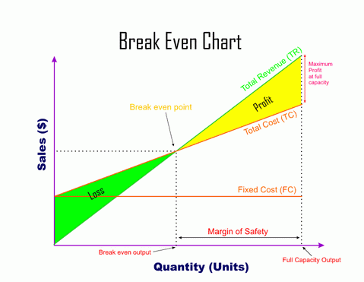

The margin of safety: the difference between current level of profitable output and breakeven point, it can determine how much demand should fall before a loss occurs.
Advantages of BEP
- Easily to calculate
- The chart provides a visual representation
- It can be used to show targets and trends
- It can determine costs/price/sales needed to maintain or improve results
Disadvantages of BEP (breakeven point)
- It assumes all products will be sold
- It assumes demand is constant
- It can only be used temporarily (unpredictable factors/consumer behavior)
- Many companies have a wide product portfolio, a BEP may be time consuming and costly

Stock control (inventory management)
- Raw materials
- Work in progress
- Finished goods

Effects of holding too much stock
- High storage cost
- Opportunity cost, finance and storage can have other uses
- If demand falls, the company is stuck with unneeded stock/products
- Risk of spoiled products, for perishables, and damage for non-perishables (shrinkage cost)
- Risk of theft or stealing as a small amount can go unnoticed for theft

Effects of holding too little stock.
- If demand rises you can’t satisfy them
- Deliveries may get delayed and risk loss or customers
- Regular deliveries are costly
- You can’t take advantage of economies of scale
- All point above are disadvantages, you can deduce the advantages by switching each argument.

Considerations of costs involved in holding inventory includes:
  - Warehousing storage costs
  - Handling cost and transportation
  - Shrinkage costs
  - Insurance costs
  - Obsolescence cost
  - Opportunity costs

Terms to know
- Buffer stock: the minimum stock that needs to be maintained at all times, it ensures the company has enough materials to keep production constant and prevent delays.
- Re-order level: the fixed quantity that is typically ordered at time intervals
- Lead time: the time between when I place the order and till, I receive it, the longer it takes this means I should have a higher re-order amount.
- Inventory: stock of raw materials, work in progress, and finished goods held by a business.

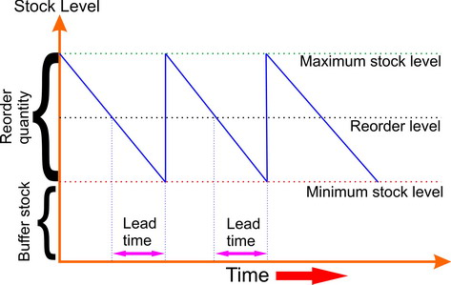
Economies of scale: factors that allow the company to decrease its average unit cost as it grows in size, it includes 6 internal types and 3 external types
Internal economies of scale
- Purchasing: larger companies gain discounts by buying in bulk
- Marketing: larger companies benefit from better marketing opportunities
- Technical: larger companies can afford technology improving efficiency
- Financial: larger companies are more likely to get approved for finance
- Managerial: larger companies can attract more skilled managers
- Risk-bearing: larger companies are at lower risk of failure.

External economies of scale:
- Labor benefit by earning opportunities for employment & at prestige firms
- Commercial services benefit from transactions such as banks
- Cooperation companies cooperate with large companies such as joint ventures, earning higher chances for success.

Dis-economies of scale: are factors that increase average unit cost on the company as it grows in size
- Business communication and bureaucracy can be difficult, large companies have many workers
- Motivation is difficult since managers can’t personally care for large quantities of workers.
- Monitoring is hard when you have so many workers.
- Technical diseconomies (breakdowns and malfunctions)

Factors that affect choice of where to locate your company
- Cost of rent/buying land
- Availability and cost of labor
- Cost and ease of transportation
- Government policies and restrictions
- Government incentives and subsidies
- Location of market
- Location of competition
- Availability of raw materials
- Nature of product
- Availability of customers and target market.
- Trade barriers (for abroad) tariffs/quota
- Exchange rate (for abroad)

Approaches to inventory management

Just in time manufacturing (JIT): it is a key part of inventory management, the materials needed for production are ordered in advance to be delivered just before the current stock is used up
Advantages
- Less money is tied to stocks/inventory improving cash flow
- Reduces cost of renting storage
- More space in inventory/ can be used for other objectives
- Good relation with suppliers
- It can be used to motivate and delegate/empower workers

Disadvantages
- Suppliers might be late, if not reliable, all delays occur causes a delay in production and higher cost.
- Customer satisfaction can fall if delays occur, loyalty and sales can fall
- No purchasing economies of scale, due to no bulk buying
- Delivery and orders increase, their costs increase as well
- Increased demand will be hard to adapt, quantity used is a prediction

Quality
Importance of maintaining and having good quality, as quality can be defined as the standard by which a product meets or exceeds customer’s expectations.
Importance
- Customer satisfaction/brand image and loyalty
- High Competitiveness (same market/similar products) increases market share
- Charging premium prices (Inelasticity)
- Reputation
- Safety/legal actions
- Sales/profits
- Reduces costs/less recall needed

Quality ensuring methods
- Quality control: inspectors checking the product after the production occurs, before they are sent to consumer markets, faulty/poor quality goods are replaced, this reduces complaints and poor satisfaction, but costs are high because the product is already produced and must be fixed or thrown away.

- Quality assurance: the production is monitored during the production process, faulty and poor-quality goods are prevented and stopped before the production is complete, so we can know where the problems occur, it reduces inspection cost, and waste of time and materials, encourages team work.

Advantages of Quality Control | Drawbacks of Quality Control
Eliminates faults/errors before the customer receives a product or service. | It is expensive, as employees need to be paid to check the product or service.
Less training is required for the workers. | Identifies the fault but not how and why it occurred, so it is difficult to remove the problem.
 | Increased costs if products have to be scrapped or reworked or service repeated.

Advantages of Quality Assurance | Drawbacks of Quality Assurance
Eliminates faults/errors before the customer receives a product or service. | It is expensive to train employees to check products.
Fewer customer complaints. | Relies on employees following instructions of the standards set by the business.
Reduced costs if products don’t have to be scrapped or reworked or service repeated.

Technology in operations

- primary sector such as agriculture: improved tractors/pesticides

- Technology in secondary sector (manufacturing): robots, computer aided design (CAD) which designs products before production, computer aided manufacturing (CAM) computers manufacturing the good, computer integrated manufacturing (CIM) which combines design and production in one automated process.

- Technology in tertiary sector (services): advertising/surgeries/hotels/banking
Advantages of using technology
- Reduces costs
- Saves time
- Less human errors
- Higher productivity
- More safety
- It can allow higher wages/salaries

Disadvantages of using technology

- Unemployment could rise.
- It is expensive to invest in new technology; this increases the risk as more products would need to be sold to cover the cost.
- Employees may be unhappy with the change.
- New technology is constantly changing and becoming outdated quickly; thus, businesses must replace technology to remain competitive.

Lean production.

It is an approach to manufacturing which focuses on reducing waste, increasing productivity and efficiency by reducing cost and saving time, some of these methods include
- Just in time: timing delivery of raw material to be delivered as soon as the current inventory runs out.

- Kaizen: which is a Japanese word for continuous improvement, aimed at encouraging workers to find solutions that instill the concept aimed by lean production.
- Team work
- Cell production is where the production line is divided into separate, self-contained units (cells), each making an identifiable part of the finished product, instead of having a flow or mass production line. This method of production improves the morale of the employees and makes them work harder so they become more efficient. The employees feel more valued and are less likely to strike or cause disruption

- Efficiency is how well the company uses its resources such as raw materials, labor and capital etc. (cost leadership/cost saving
- Effectiveness measures how organizational tasks and objectives and being met and achieved.

