Check your progress P140-141
1 a Grams (g) and kilograms (kg)
b Newtons (N)
2 a 70 kg
b 700 N
c 70 kg
d 350 N
3 Force has:
• changed the shape of the car – it is crushed
• changed the position of the car – it has overturned
• changed the movement of the car – it has stopped
• changed the direction of movement of the car – the car is on its roof facing the opposite direction.

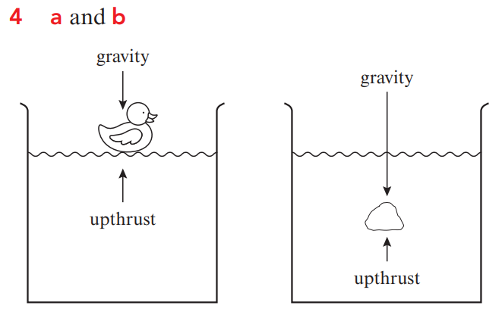
c The duck has a mass equal to or less than the mass of water displaced, so it floats. The stone has a greater mass than the mass of water displaced, so it sinks.

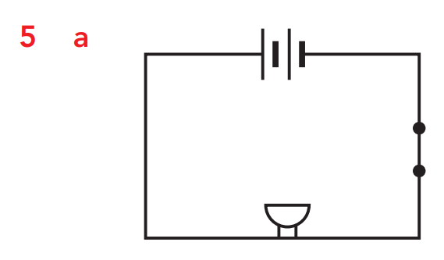
b It is a series circuit because the electric current only has one path.
C They could add another 3 V battery.
d They could make a parallel circuit.

