


Rosary School – Marj El Hammam
Physics 4XPH1

Unit 4 – Energy Resources and Energy Transfers

Chapter 15 – Thermal Energy
 | No. of Pages: 6
Date: ___ / ___ / 2025 |  | Name: __________________ ________…………………………...
Subject : IGCSE Physics |  | Grade: ______ ( A / B / C / D )

Absolute zero is the lowest possible temperature.
Any object whose temperature is above the absolute zero must have a thermal store of energy.
Thermal energy is transferred from hotter objects to cooler ones.
Thermal Energy Transfers
- Conduction
- Convection
- Radiation
A| Conduction
It is the transfer of energy through a substance whose particles vibrate in fixed positions. The substance itself does not move.
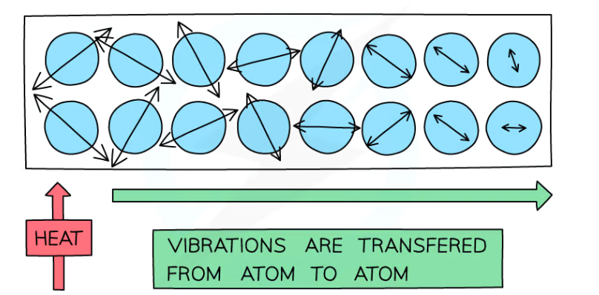
Particles who are directly near the source of heat will have a greater store of kinetic energy (KE) than other neighboring particles. Those particles with a high KE store will transfer some of that store to the neighboring particles, which will move faster and therefore heat up.
Metals are especially good at
conducting heat as the delocalised
electrons can collide with the atoms,
helping to transfer the vibrations
through the material and hence
transfer heat better.
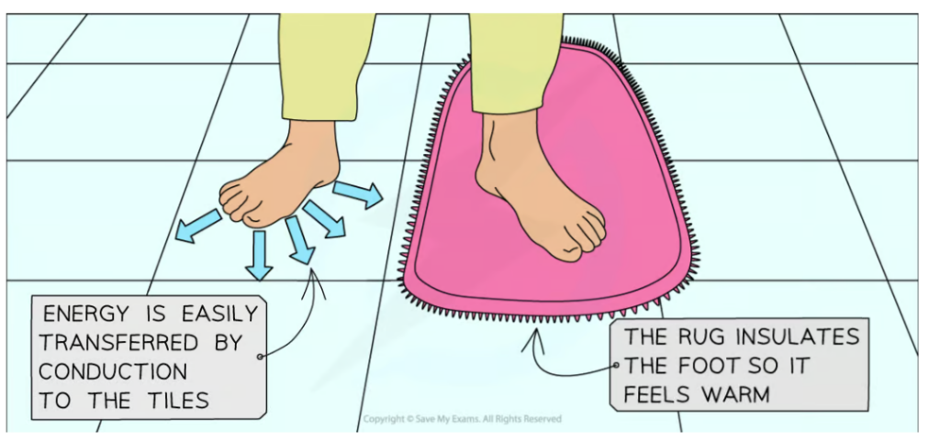
Insulators are used to prevent energy transfer by conduction.

Materials containing small pockets of trapped air are especially good at insulating because air is a gas and hence a poor conductor
The air is trapped, so it cannot move and form a convection current, therefore energy transfer by conduction occurs, but it happens very slowly since air is a gas.
B| Convection
Convection is the transfer of thermal energy through fluids (liquids & gases) by the upward movement of warmer, less dense regions of fluid.
Convection cannot occur in solids.
When a fluid (a liquid or a gas) is heated:
  - The molecules push each other apart, making the fluid expand
  - This makes the hot fluid less dense than the surroundings
  - The hot fluid rises, and the cooler (surrounding) fluid moves in to take its place
  - Eventually, the hot fluid cools, contracts and sinks back down again
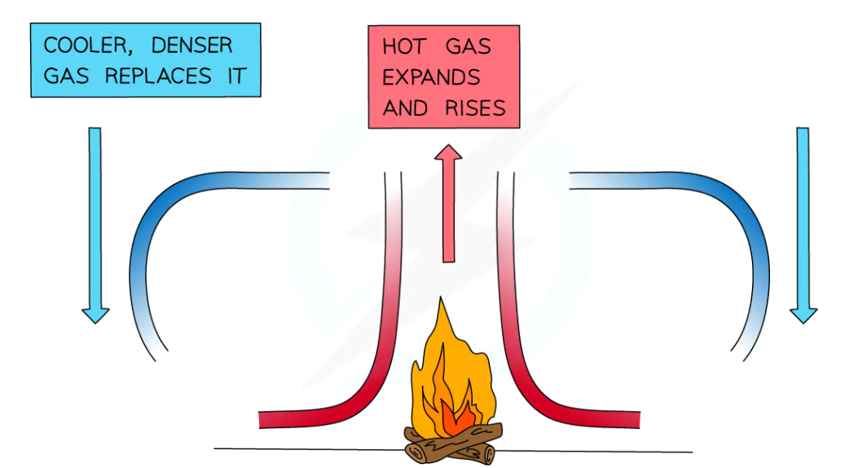
  - The resulting motion is called a convection current.

C| Radiation
Thermal radiation is the transfer of infrared (IR) waves.
Thermal imaging cameras can detect objects that give out IR waves.
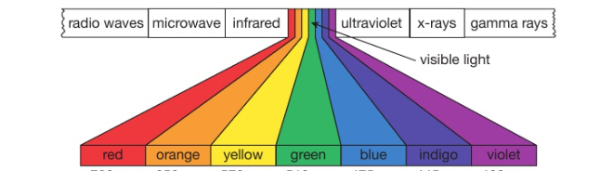
IR waves have the same properties as the other members of the electromagnetic spectrum.

- can travel in a vacuum, which is why we receive IR and UV waves from the sun.
- travels at the speed of light ($3×{10}^{8}$)
IR waves can be absorbed and reflected.
- Highly polished, shiny surfaces are good reflectors of thermal radiation. Shiny surfaces are also good reflectors of IR radiation.
- Black and dark surfaces are poor reflectors of IR radiation, or in other words, are good absorbers of thermal radiation.
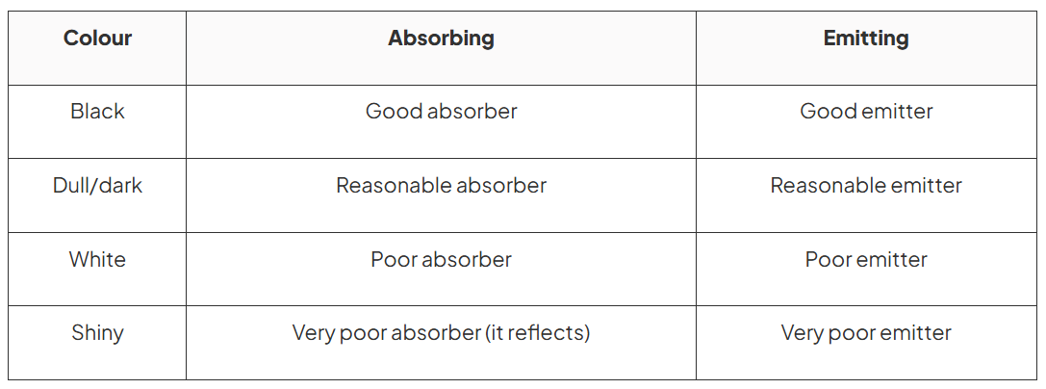

Conduction, Convection & Radiation in a Mug of Coffee
For a mug of hot coffee:
  - Energy is transferred by radiation from the surface to the mug to the surroundings
    - Due to the infrared radiation being emitted from its surface
    - All objects (whose temperature is above the absolute zero) emit infrared radiation, but the hotter an object is, the more IR radiation it emits.
Energy is transferred by heating from the surface of the coffee to the surroundings
  - The most energetic particles of the coffee evaporate setting up a convection current.
Energy is transferred by heating from the bottom of the mug to any surface it is in contact with, such as a table
  - This energy transfer happens by conduction
Objects will continue to lose heat until they reach thermal equilibrium (equal temperature) with their surroundings
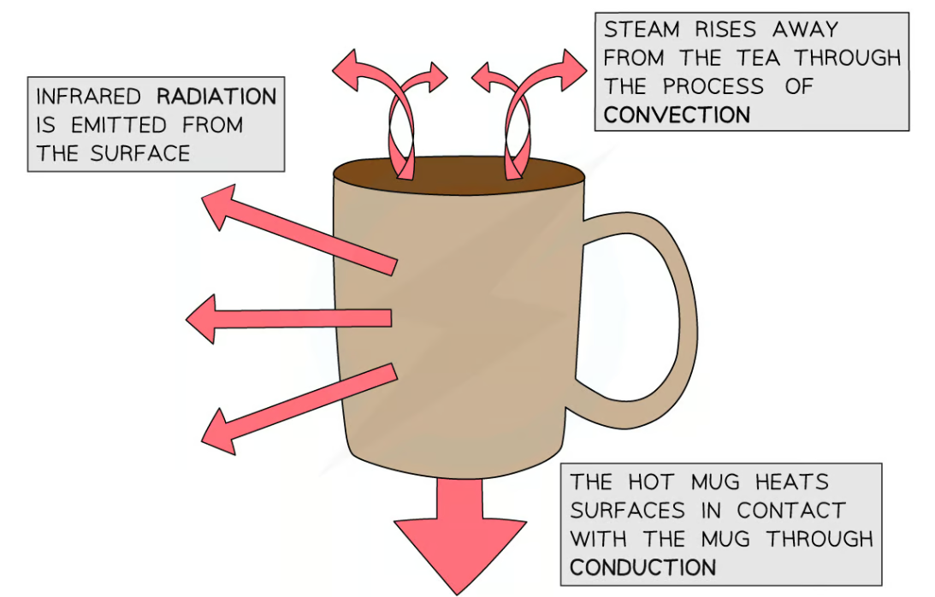
  - For example, a mug of hot coffee will cool down until it reaches room temperature

Energy Efficient Houses
It is very important that houses are energy efficient, because some process done at home that require energy produce carbon dioxide gas, which contributes to global warming and harms the environment.
The key to energy efficiency housing is insulation. Houses must be designed to reduce the rate at which energy is transferred between the inside and the outside of the house.
Insulating Houses Effectively
To insulate a house effectively, we must look at all the ways in which thermal energy can escape.
- Conduction : between building and outside
- Convection : the walls, windows, doors and roofs
A| Reducing Conduction
Use thermal insulators to build the house, such as bricks.
B| Reducing Convection
Walls
Walls are made up of 2 layers of bricks, which are excellent thermal insulators, separated by a layer of air. Convection currents may occur in the layer of air between the bricks.
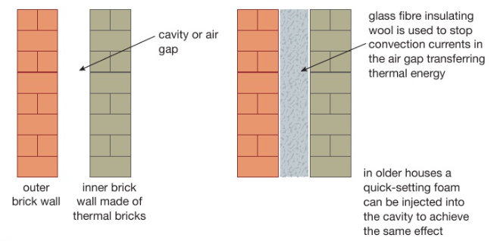
To avoid this convection current from occurring, glass fibre insulating wool is used in the air gap.

Windows
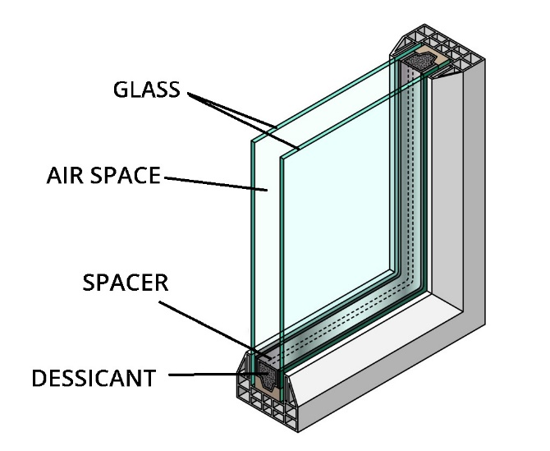
Double-glazed windows are used in
modern houses for better heat insulation.
Glass is a poor thermal conductor, but is
used in thin layers.
To improve insulating properties, two layers of glass are used to trap a layer of air.
Thickness of the glass is vital to be considered.
Too Thick | Too Thin
Convection currents will be able to occur.  Heat will be carried from hotter surfaces to colder ones. | Insulation will be reduced.  Heat will be transferred into and out of the building.
Insulating People and Animals
Wind can cause rapid heat loss from the human body.
It is done by forced convection currents; making air circulate close to the body’s surface. It may also cause rapid evaporation of sweat from the skin.
Winter clothes trap air around the body, providing insulation because trapped air cannot circulate and is a very poor conductor.
Animals keep warm in different ways.
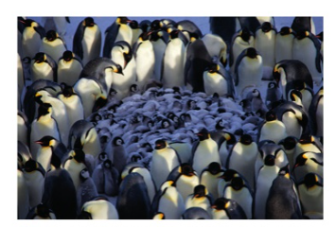
Birds fluff up their feathers on cold days in winter. This increases the thickness of the trapped air around their bodies, reducing heat lost by conduction.
Some birds like penguins will move
close together for warmth.

