 | 
Name: _________________ |  | Date: ____ /____ / 2025
Grade: 8 ( ) |  | Subject: Physics
Study sheet (2) Key concepts of physics
Units and Prefixes + Making Measurements
Units of physical quantities:
- Basic (SI Base), derived.
- Scalar, vector
Basic (SI Base Units) | Derived
Mass (kilogram: kg) | Speed (m/s)
Distance, length (metre: m) | Acceleration (m/s²)
Time (seconds: s) | Volume (m³)
Current (Ampere: A) | Density (kg/m³)
Temperature (Kelvin: K) | Force (N, kgm/s²)
Amount of substance (Mole: mol) | Energy (Joules: J, Nm, kgm²/s²)
 | Pressure (Pascals: Pa, N/m², kg/ms²)
- Scalar quantity: A quantity that is described by its magnitude (size, value). It has no direction
- Vector quantity: A quantity that is described by its magnitude and direction.
Scalar | Vector
Mass (kilogram: kg) | Force, Weight (N)
Distance, length (metre: m) | Displacement (m)
Energy (Joules: J, Nm) | Acceleration (m/s²)
Density (kg/m³) | Moment (Nm)
Volume (m³) | Pressure (Pa, N/m²)
Time (seconds: s)
Power (J/s, kgm²/s³)

Prefixes:
Powers of 10 → multiples 10², 10³… sub-multiples 10⁻¹, 10⁻²… Each power is defined by a prefix:
Prefix | Abbreviation | Power of 10
Giga- | G | 109
Mega- | M | 106
Kilo- | k | 103
Centi- | c | 10-2
Milli- | m | 10-3
Micro- | µ | 10-6
Nano- | n | 10-9

e.g: 12 gigapascals = 12 x10⁹ Pa (12 000 000 000Pa)
0.1 µm = 0.1 micrometre = 1 x 10⁻⁷m (0.0000001m)
Making measurements in physics:
- Measuring Lengths:
A short distance of length is measured by a rule (a ruler) to the nearest 1 mm, longer distances are measured by meter rule to the nearest 1 mm. Very short distances are measured by a micrometer screw gauge to the nearest 0.01 mm. Very long distances (e.g. length of a hall or game field) are measured by using a long measuring tape.

a. Steps to measuring length using a rule or a meter rule to the nearest millimeter:
- Place the object very close to metre rule, (if you cannot do this, you may use 2 pointers).
- To read the marks on the rule accurately, place your eyes vertically above the mark being read to avoid parallax error.
- Take two readings at both ends of the object and subtract the two readings to get the length.
- Repeat the above steps several times and get the average value of the length.

*Parallax error: the apparent shift in an object's position as it is viewed from different angles.
b. steps to measuring thickness up to 25 mm using a micrometer screw gauge to the nearest 0.01mm:
1. Read the main scale to the nearest 0.5mm.
2. Read the additional fraction of a millimeter from the fractional scale in a hundredth of a millimeter.
3. Add the main scale reading and the fractional scale reading.

Example 1:
State the measurement shown in the diagram on the scale of the micrometer screw gauge.
Thickness / length = main scale reading + fractional scale reading
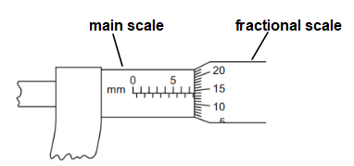

Remarks:
- If a certain reading is found to be wrong (anomalous), exclude it; or repeat the same measurement once again.
- Many instruments which have a pointer moving above a scale are liable to parallax error if the eye is not placed vertically above the pointer.
- When using a tape measure, avoid bending the tape to keep it in a perpendicular direction to the two walls.
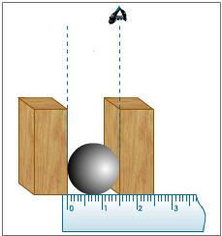
- To measure the diameter of a sphere or a cylinder, place it between two vertical parallel blocks and take the difference between the two readings at its two ends.
- To measure the diameter of a wire, a bead, or a small bearing; arrange a row of a large number of them and measure the total length. Now, divide this length by the number of beads (or turns) to get the desired diameter.
*For accuracy, measurements are usually repeated several times, and then the average value is obtained.

2. Measuring Volumes:
a. Volume of liquids:
The volume of liquid is usually measured by a measuring cylinder. When measuring the volume by a measuring cylinder, these precautions should be considered:
- The cylinder must be placed on a horizontal bench; otherwise error may arise due to tilting.
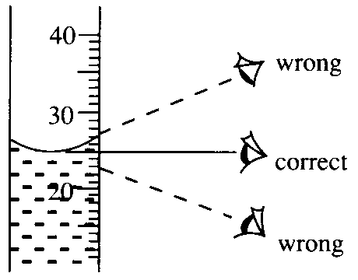
- Take the reading at the bottom of the meniscus or curved surface of the liquid. (Mercury is an exceptional case; reading should be taken from the top of the mercury's meniscus).
- The line of eyesight should be perpendicular to the scale to avoid parallax error.

b. Volume of regular Solids:
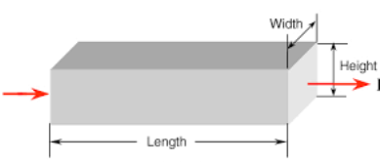
The volume of a regular solid can be calculated by measuring its dimensions and using the suitable formula.
- For a rectangular block
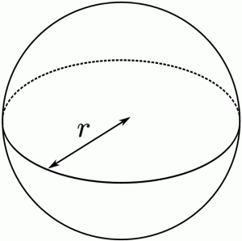
Volume = length x width x height
- For a sphere of radius "r":
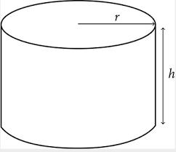
Volume =
- For a cylinder of radius "r" and height "h"
Volume = π r ² h

c. Volumes of irregular solids:
The volume of a solid of an irregular shape can be determined by immersing it in a liquid as follows:
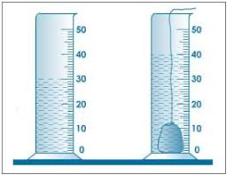
1. Select a measuring cylinder with an appropriate volume.
2. Fill it with water to immerse the object.
3. Measure the Volume (V1) of a certain amount of a liquid by measuring cylinder.
4. Tie the solid body by a fine thread and immerse it gently in the liquid, then get another reading for the volume (V2) of the liquid plus the solid body.
5. The volume of the solid body equals (V2- V1).

Remarks:
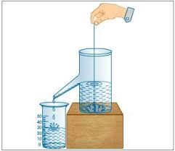
- When measuring the volume of small particles containing air spaces (e.g. some pebbles), the measured volume is greater than the true volume of the particles only.
- A displacement can, together with a measuring cylinder, can be used to measure the volume of irregular solid,

3. Measuring Masses:
- The Mass of a body is the amount of matter contained in that body.
- The mass depends on the number and the type of atoms contained in the body.
- The mass is usually measured in kilograms (or grams) by using a balance.
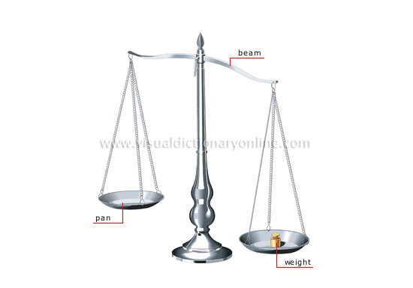
- The mass of an object is always constant it does not change by change in place, shape, temperature, time etc…
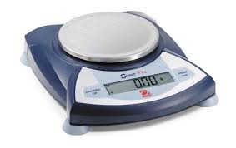

Mass can be measured by using top – pan balance or lever balance. When using a balance, notice that:
- the balance is clean & dry,
- the balance is placed horizontally,
- the balance’s pointer or digits read zero (tare the balance or notice and record the zero error).

Remarks:
When measuring very small objects, measure several units and then divide by the number measured. In this way the error is divided by the number measured, error is thus reduced.

Example: To find the mass of a small pin, measure the mass of, say, 50 pins using a balance, then divide the total mass by 50 to get the average mass of one pin.

4. Measuring Time:
Stop-clocks and stopwatches can be used to measure time intervals. An important factor when measuring time intervals is human reaction time. This can have a significant impact upon measurements when the measurements involved are very short (less than a second)
  - Long periods of time are measured by a clock or a watch.
  - Short times are measured by a stopwatch. (Make sure to reset the stopwatch to Zero before starting a measurement).
  - Very short times (fractions of second) are measured by electronic timers, called light gates, which should start and stop automatically.

Example 2:
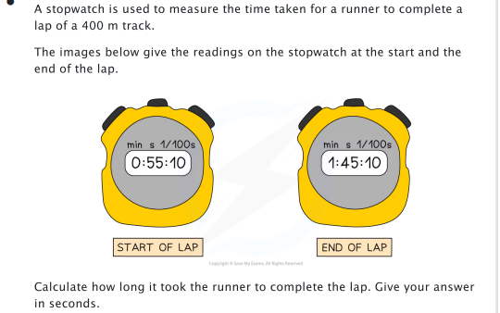

Experiment:
Measuring the periodic Time of a Pendulum:
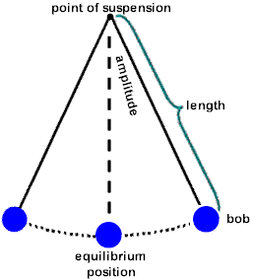
Steps:
- Set the pendulum to swing (a complete swing, or oscillation, starts from one end, all the way to the other and coming back).
- When the bob is at one end, start your stopwatch and count 30 complete swings then stop your stopwatch, and record the time taken by these swings.
- Repeat the above steps several times.
- Change the length of the thread holding the bob and repeat the above steps.
- In a table record your results and find the time taken by one swing for each length by dividing the total time on the number of swings.
Example 3:
How can you measure the time of one heart beat?
_____________________________________________________________________________________________________________________________________________________________________________________________________________________
______________________________________________________________________________________________________________________________________________

- When measuring the time taken by a free falling body, use an electronic timer to get an accurate value of this very small time. If the experiment is done by a stopwatch, repeat each measurement several times and then calculate the average time of fall.

Conversions and standard form:
  - Hours and seconds: 1 hour: 60 minutes
1minute: 60 seconds
- To convert from hours → seconds, multiply by 3600
- To convert from seconds → hours, divide by 3600
  - Kelvins and degrees Celsius
0 K = -237.15 ◦C
- To convert from Kelvin → degrees Celsius, subtract 273.15
- To convert from degrees Celsius → Kelvin, add 273.15
➔ m/s and km/h
- To convert from m/s → km/h, multiply by 3.6
- To convert from km/h → m/s, divide by 3.6

Significant figures:
- Non- zero digits are always significant 123 is 3 S.F. …… 123000 is 3 S.F. 1.78 is 3 S.F. …… 187.78 is 5 S.F.
- Zeros are only significant if they come between two significant digits OR are final (trailing) zeros in the decimal portion
108 is 3 S.F. …….. 180 is 2 S.F.
1.006 is 4 S.F…….. 1.6 is 2 S.F.
1.40 is 3 S.F. ……. 1.4000 is 5 S.F.
0.0014 is 2 S.F. ….. 0.00140 is 3 S.F.

Exam tip
In exam question, always round your answer to the lowest number of significant figures quoted in the question text.
For example: if the question uses the values 2.3 (2 S.F.) and 4.667 (4 S.F.), then the answer should be rounded to 2 S.F.
If in doubt, round your answer to 2 S.F. or 3 S.F.
Example: round 186.21 to 2 S.F.
- | Look for the 2nd S.F.
- | Check the number after, if ≥5 add 1 to the 2nd S.F. If < 5 keep the 2nd S.F. as it is.
- | Any remaining digits till the decimal point become 0.
186.21

190

Exercise 1:
- Round 0.029144 to 3 S.F.

- Round 10.0457 to 3 S.F.

Standard form:
A system of writing large or small numbers to be able to work with very large or very small numbers.
a = any number between 1 and 10 n > 0 for large numbers multiplied by 10 n < 0 for small numbers divided by 10

Standard form → a x 10^{n}
⁻ 300 000 000 in standard form → 3 x 10⁸ ⁻ 0.00002 in standard form → 2 x 10 ⁻⁵

Exam tip
When rounding a number in standard form to a certain number of n significant figures, only the value of a is rounded (the 10 value will not be significant).

Example: Write the number 143 000 000 in standard form to 2 significant figures.
- | Look for the 2nd S.F.
- | Check the number after, if ≥5 add 1 to the 2nd S.F. If < 5 keep the 2nd S.F. as it is.
- | Any remaining digits till the decimal point become 0.

143 000 000 → a x 10^{n}
140 000 000 a between 1 →10
a = 1.4 so the standard form of 143 000 000 to 2 S.F. is 1.4 x 10 ⁸
Exercise 2: Write the number 5 189 000 000 in standard form to 3 significant figures.

Examples on Basic and Derived Units:
Derived units are a combination of 2 or more base units.
- speed 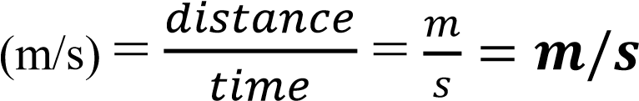

- acceleration

- force (N) = mass x acceleration
Newton = kg x m/s²
Newton (N) = kgm/s²

- pressure 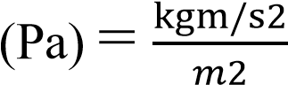 pascals (Pa) = kg/ms²

- gravitational potential energy (J) = weight x height (force x distance)
Joules = N x m
J = kgm/s² x m
J = kgm²/s²
- power 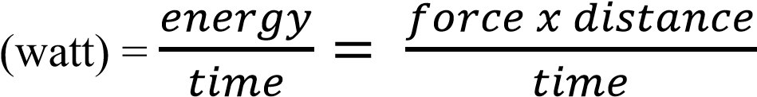

- watt (W) 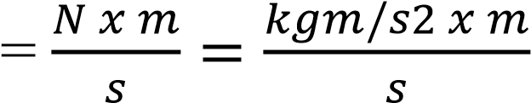 watt (W) = kgm²/s³

Examples on Scalar and Vector quantities:
Distance vs. Displacement
- Distance: length of travelled path.
- Displacement: shortest distance from start to endpoint.

Example 1:
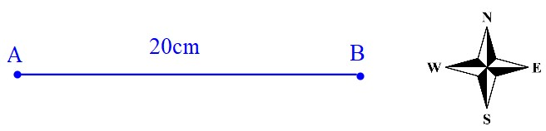
Magnitude only
- Distance from A → B = 20 cm
B → A = 20 cm

Magnitude + direction
- Displacement from A →B = 20 cm East / right / +x B →A = 20 cm West/ left / -x

Example 2:
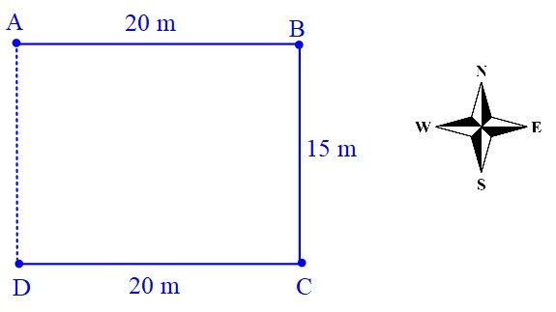
- Distance from A → D = _____________
D →A = _______________
- Displacement from A → D = _____________
D → A = _______________

Example 3:
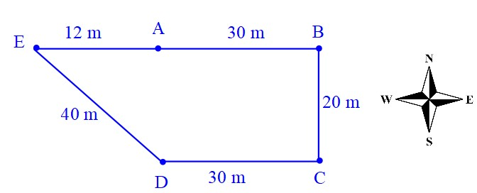
- Distance A → E =_______________________
- Displacement A → E = __________________
- Distance A → A = ______________________
- Displacement A →A = ___________________

Example 4:
- Distance A → C =

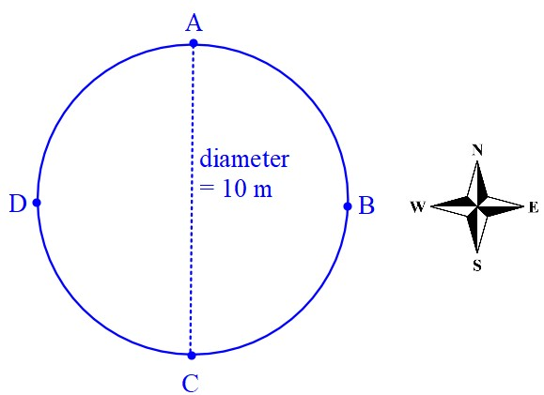

- Displacement A → C =
- Distance A → A =

- Displacement A → A =

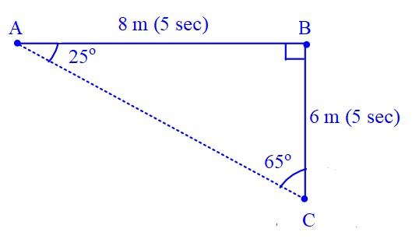
Example 5:
- Distance A → B =________________
- Displacement A → B = ______________
- Distance A → C = _______________
- Displacement A→ C = _____________
*Use Pythagoras theorem a²+ b² = c²
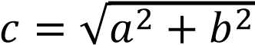
*Use a protractor to measure the angles
*Determine the direction according to angles or bearing of North.

- Calculate speed A → B =

A → C =

- Calculate velocity A→ C =

Teacher : Zeina Abu Manneh

