
Rosary School \ Marj El Hamam
Name: ………………………………
Subject: Math Revision Worksheet
Date:
/ 8 / 2025
Grade: 7 (A, B, C, D, E)
1. Round:
Number | 89.091 | 1347.99 | 209.92
Nearest tenth
Nearest whole number
Nearest 10
Nearest 100

2. Work out
a) $12 - -4=$ | b) $3+ -7=$ | c) $-2+8=$
d) $-15+ -4=$ | e) $-2 --5=$ | f) $-8 --12=$
3. a) Complete this Venn diagram to show the factors of 15 and 18.
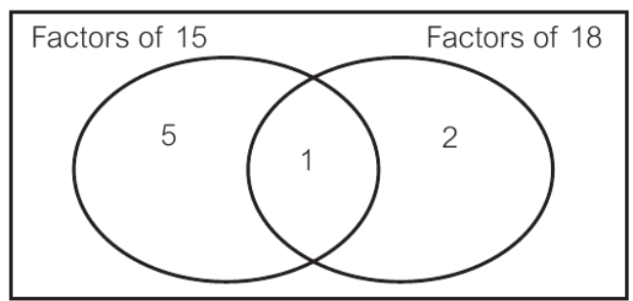
Factors of 15:

Factors of 18:

b) What is the HCF of 15 and 18?

4. What is the lowest common multiple of 8 and 12

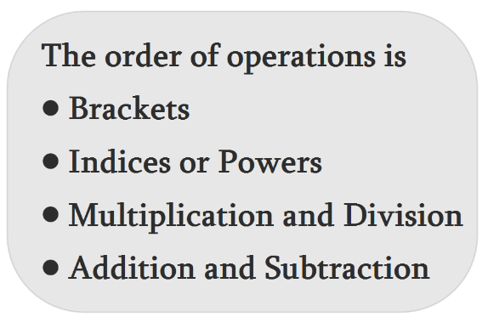
5. Solve each problem using the correct order of operations.
a) 5 × (2³ + 4) =

b) (6 + 2) × (8 – 3²) =

c) $\frac{ 27-\left(\sqrt[3]{125 } +4\right)}{2}$ =

6. t represents a number. Write and simplify an expression for
a) 2 more than triple the number | b) 5 less than double the number
c) 4 more than double the number | d) the number subtract 5
e) 3 divided by the number | f) the number multiplied by itself

7. Simplify
a) $2+ x^{3}+2x^{3}-5$
b) $9t×5t$
c) $\frac{ 15a }{3}$

8. Expand
a) $3( 5+x)$ | b) $3u( u-4)$
9. Use the formula $y=10x-z$ to work out the value of y when
a) $x=4, z=3$ | b) $x=5, z=-8$
10. Simplify.
- $\frac{ 16 }{24}$ | - $\frac{ 9 }{12}$
11. a) Write these improper fractions as mixed numbers.
- $\frac{ 23 }{ 3}$ = | - $\frac{ 14 }{5}$ =
b) Write these mixed numbers as improper fractions.
- 2$\frac{ 3 }{7}$ | - 5$\frac{ 1 }{2}$
12. Work out these. Give each answer in its simplest form and as a mixed number
where necessary.

- $\frac{ 1 }{4}+\frac{ 5 }{8}$ = | - 1$\frac{ 2 }{3}$ + 3$\frac{ 2 }{5}$
- 5$\frac{ 1 }{4}$ $-$ 3$\frac{ 5 }{8}$ | - 10 - 7$\frac{ 10 }{15}$ =

13. Convert the following fractions into decimals.
- $\frac{ 4 }{5}$ | - $\frac{ 24 }{60}$ | - $\frac{3}{ 10 }$
14. Work out. Give each answer in its simplest form and as a mixed number where necessary.
- $\frac{ 4 }{11}$ $×$ 22 =
- 20 $×$ $\frac{ 3 }{16}$ =
- $\frac{ 3 }{ 10 }$ $×$ 10 =
15. Complete this table.

Fraction | $$\frac{ 2 }{5}$$
Decimal |  | 2.75
Percentage |  |  | 150%

16. A bottle of perfume costs $80.
At an airport the price is reduced by 10%.
Work out the airport price of the bottle of perfume.

a) 3 days : 12 hours | b) 4 : 3.4
17. Simplify these ratios.
18. If a car travels 250 miles on 10 gallons of gas, how many miles will it travel on
30 gallons of gas?

19. There are only red sweets and blue sweets in a bag.
The ratio of the number of red sweets to the number of blue sweets is 2:1
There are 40 red sweets in the bag.
Work out the total number of sweets in the bag.

20. The ratio of men to women in a company is 3:1.
There are 288 employees in the company.
- How many employees are men?

- How many employees are women?

