

Rosary School \ Marj Elhamam

Name : ……………………… Date: / 8 / 2025
Subject: Revision Worksheet Grade: 5 ( )
Q1: Look at the Place Value Chart and then answer the following questions.
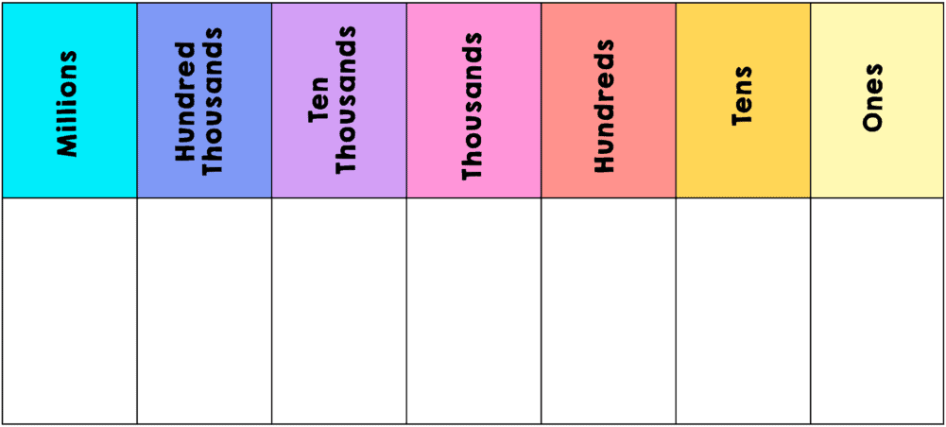

a) Write the number 93017 in the place value chart.

b) In the number 93017.

i) the value of number 1 is: ............................

ii) the value of number 3 is: .............................

c) What digit is in the thousands place: .....................................

Q2: The number 2 760 480 can be decomposed as:

.................. + .................... + ..................... + ..................... + .........................

Q3: Fill in the missing numbers.
a)
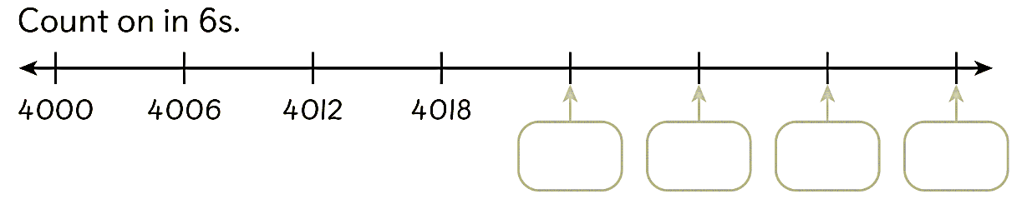

b)
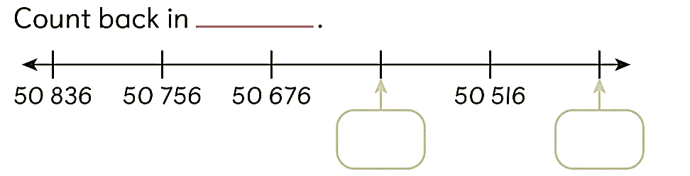
c) Count on in 8s.

-34, -26, -18, -10, ..........., ............., ............., ...............

d) Count back in 30s.

............., ................, ..............., 15, 45, 75, 105.

Q4: Compare the numbers below using " >, < and = "

a) 484 ______ 476

b) 81990 ______ 81990

c) 3127490 ______ 3927490

Q5: Arrange the numbers in order.
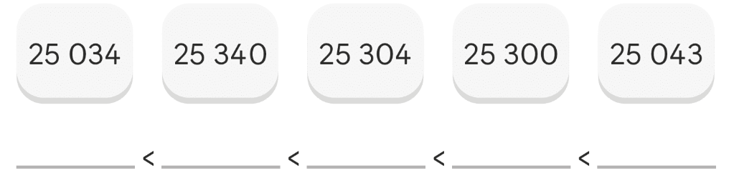
Q6: a) Round the number 136 to the nearest tens. ..................

b) Round the number 2492 to the nearest hundred. .................

c) Round the number 3842011 to the nearest ten thousand. ..................

Q7: Write the missing numbers on the number line.
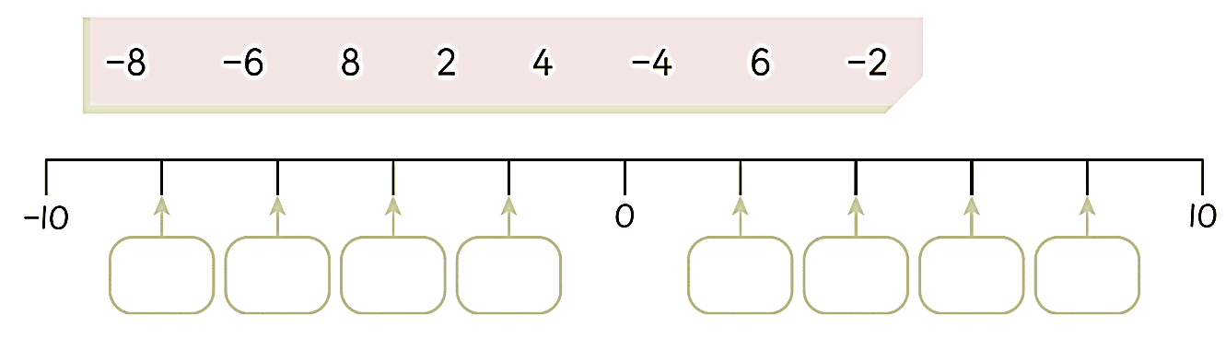

Q8: Put a tick (✔) or a cross (x) in the box to show if each statement is true or false.
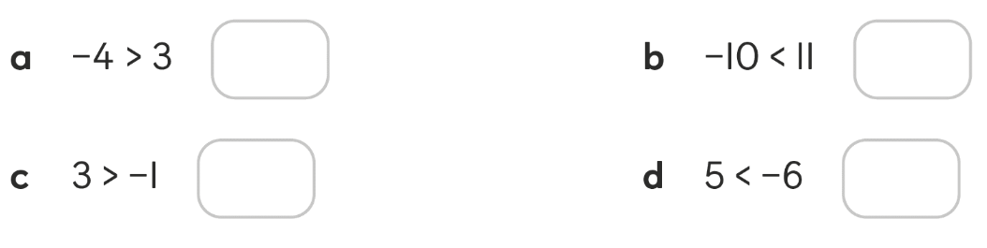
Q9: Put a ring around the numbers that are multiples of 6.

6 , 9 , 13 , 18 , 24 , 35 , 42

Q10: a) Is 9 a factor of 81? ( Yes / No )
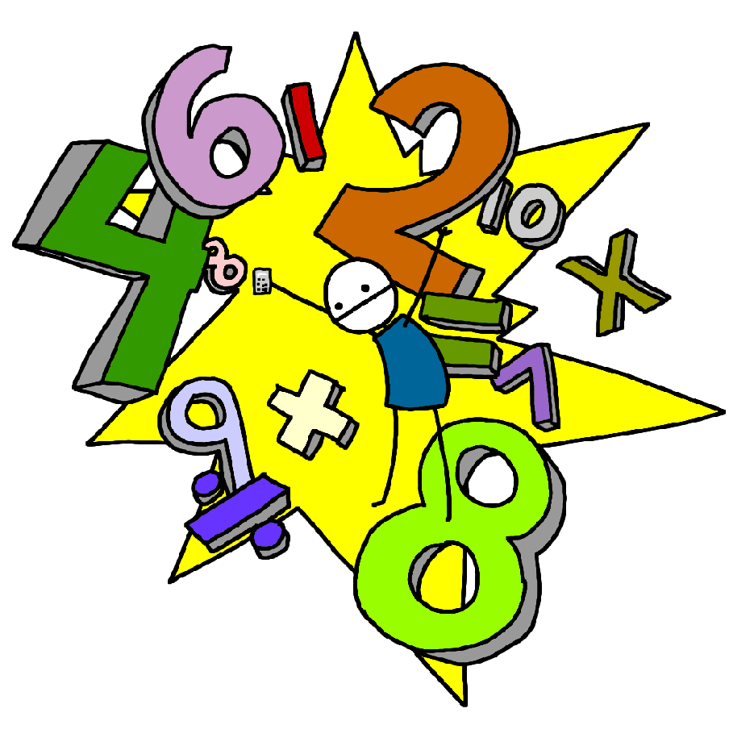
b) Complete the number sentence.

............... × ............... = 81
Q11: Write all the factors of 15.

...............................................................................................................................

Q12: Is the number divisible by 2, 5, 10, 25, 50 or 100?
If yes, mark with a tick (✔). If no, mark with a cross (x).

Number | Divisible by
Number | 2 | 5 | 10 | 25 | 50 | 100
350
700

Q13:
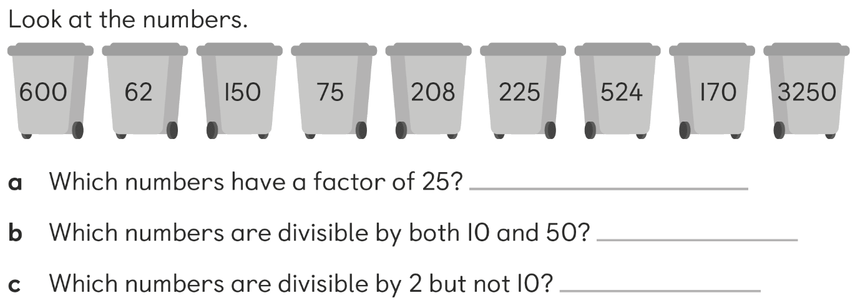

Q14: Find the value of the unknowns.

a) ______ + 5 = 11 b) 8 + ______ = 17

c) ______ - 12 = 24 d) 45 - ______ = 13

Q15: Find the sum of:

a) 628 + 74 = ................... b) 226 + 955 = ...................

Q16: What number do you think each shape stands for?
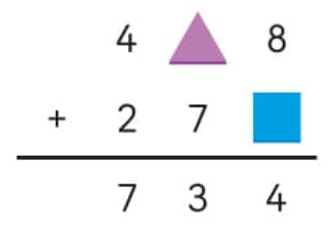

Q17: Find the difference of:

a) 303 – 15 = ................... b) 879 – 178 = .....................

Q18: Fill in the missing numbers.
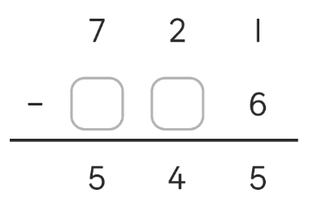

Q19: Multiply.

a) 96 × 100 = ...................... b) 4 × 100 = ........................

c) 64 × 10 = ....................... d) 51 × 10 = .......................

Q20: Divide.

a) 5550 ÷ 10 = .................. b) 7800 ÷ 100 = ...................

c) 71500 ÷ 100 = ................... d) 750 ÷ 10 = .......................

Q21: Multiply using the associative rule.

a) 2 × 7 × 5 = ....................... b) 6 × 5 × 4 = .........................

Q22: Find the product of:

a) 376 × 2 = ........................ b) 120 × 8 = ..........................

Q23: Divide.

a) 28 ÷ 9 = ................... r ...................

b) 37 ÷ 7 = ................... r ....................

Q24: 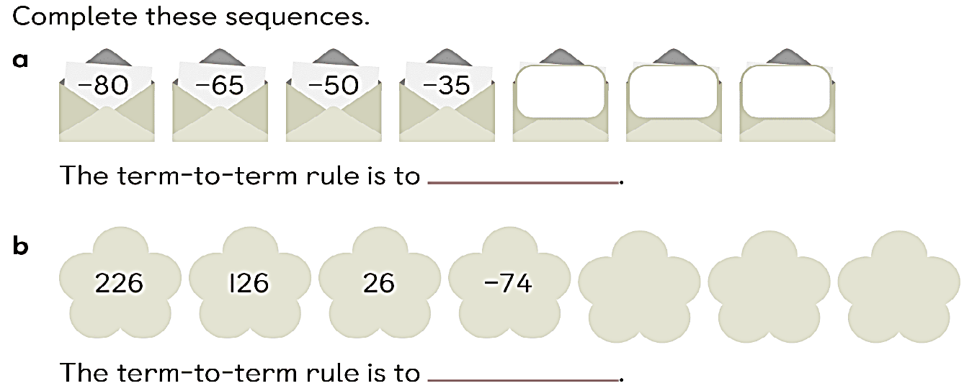

Q25: There are 146 seats in a cinema hall.
58 of the seats are empty.
How many of the seats are taken?

…………….

Q26: A chef makes 236 curry puffs and 329 vegetables puffs in one week.
How many puffs does the chef make in all?
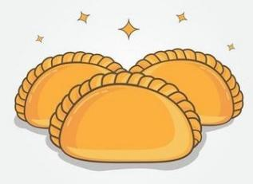
…………….

Q27: A store has 130 boxes of bottled water, there are 6 bottles in each box.
How many bottles are there in the store?



…………….

Q28: Samir read 750 pages in 10 days. He read the same number of pages each day.
How many pages did he read each day?
…………….

