Atoms, elements and compounds


Rosary School-Marj Elhamam
Study sheet (1)

Name : _____________________ Date : / /2025
Grade: 7 Grade (A,B,C,D,E) Subject : Chemistry
7Ha The air we breathe
All substances are made up of tiny particles called atoms.
Substances can be made of single atoms but they can also be made of atoms bonded together in small groups, called molecules. Substances can also be made of many trillions of atoms all bonded together.
Natural materials can be pure (containing one substance) or mixtures (containing two or more substances which are not joined together). A mixture is formed if elements are mixed without joining.
Air contains a mixture of particles.
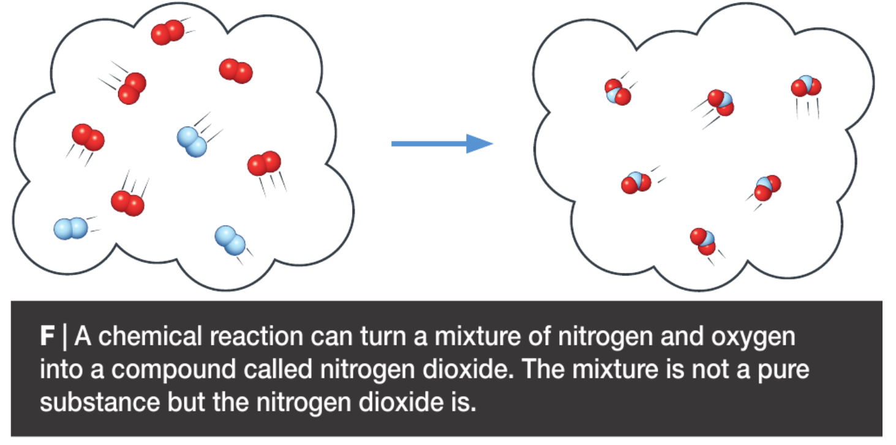
Elements are simple substances made up of only one kind of atom.
Most substances are compounds, which contain more than one kind of atom (more than one element) bonded (joined) chemically together.

Exercise (1)
Fill in the boxes below with the suitable description related to diagram:
- Molecules of a compound b) Molecules of elements
- Molecules of a mixture of elements d) Atoms of an element
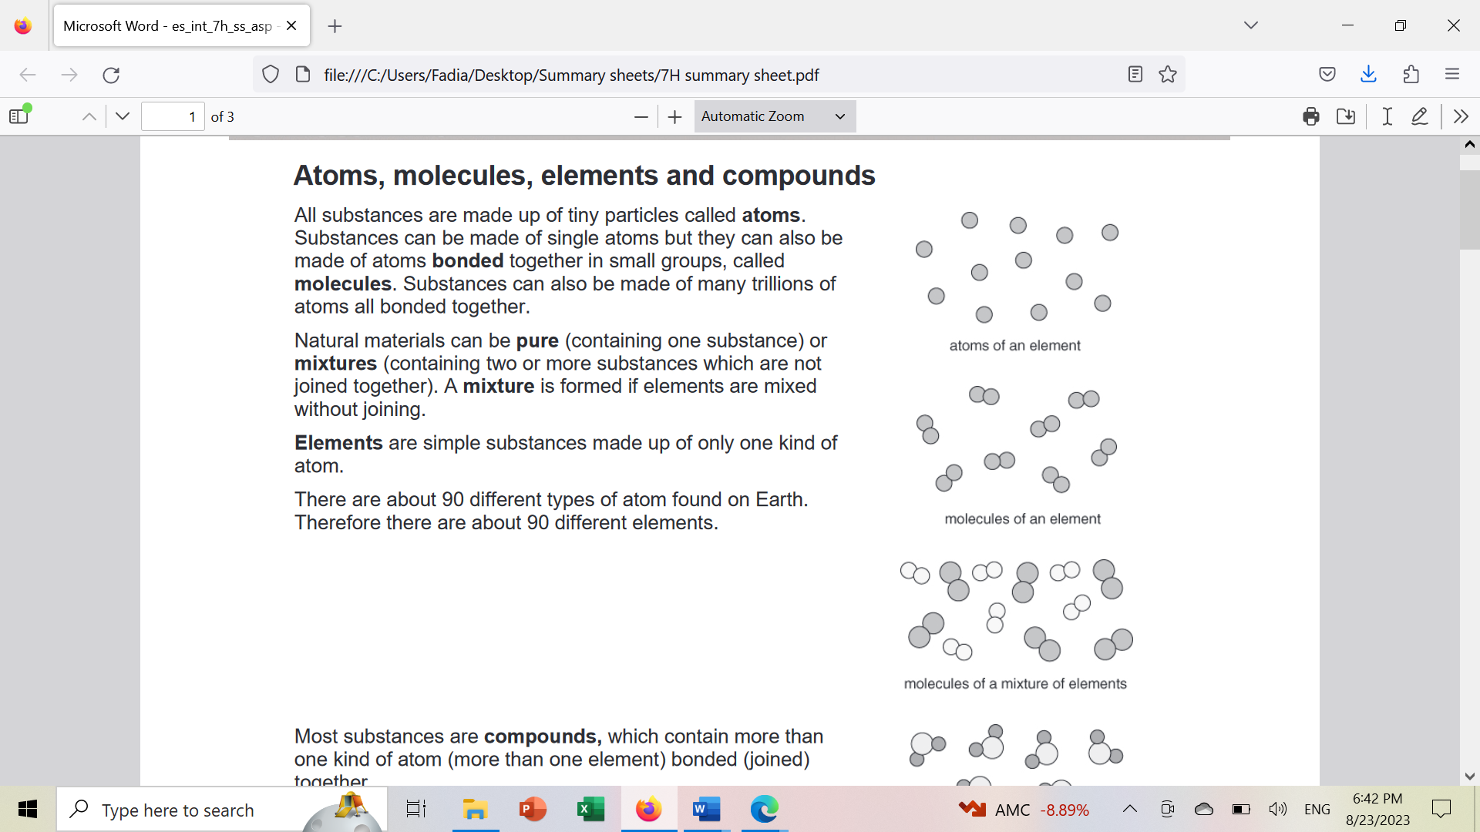

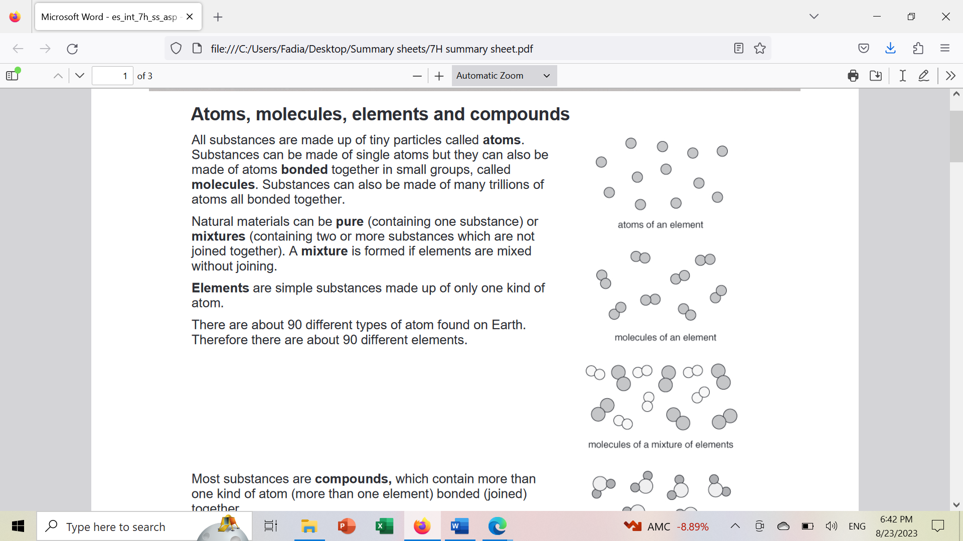
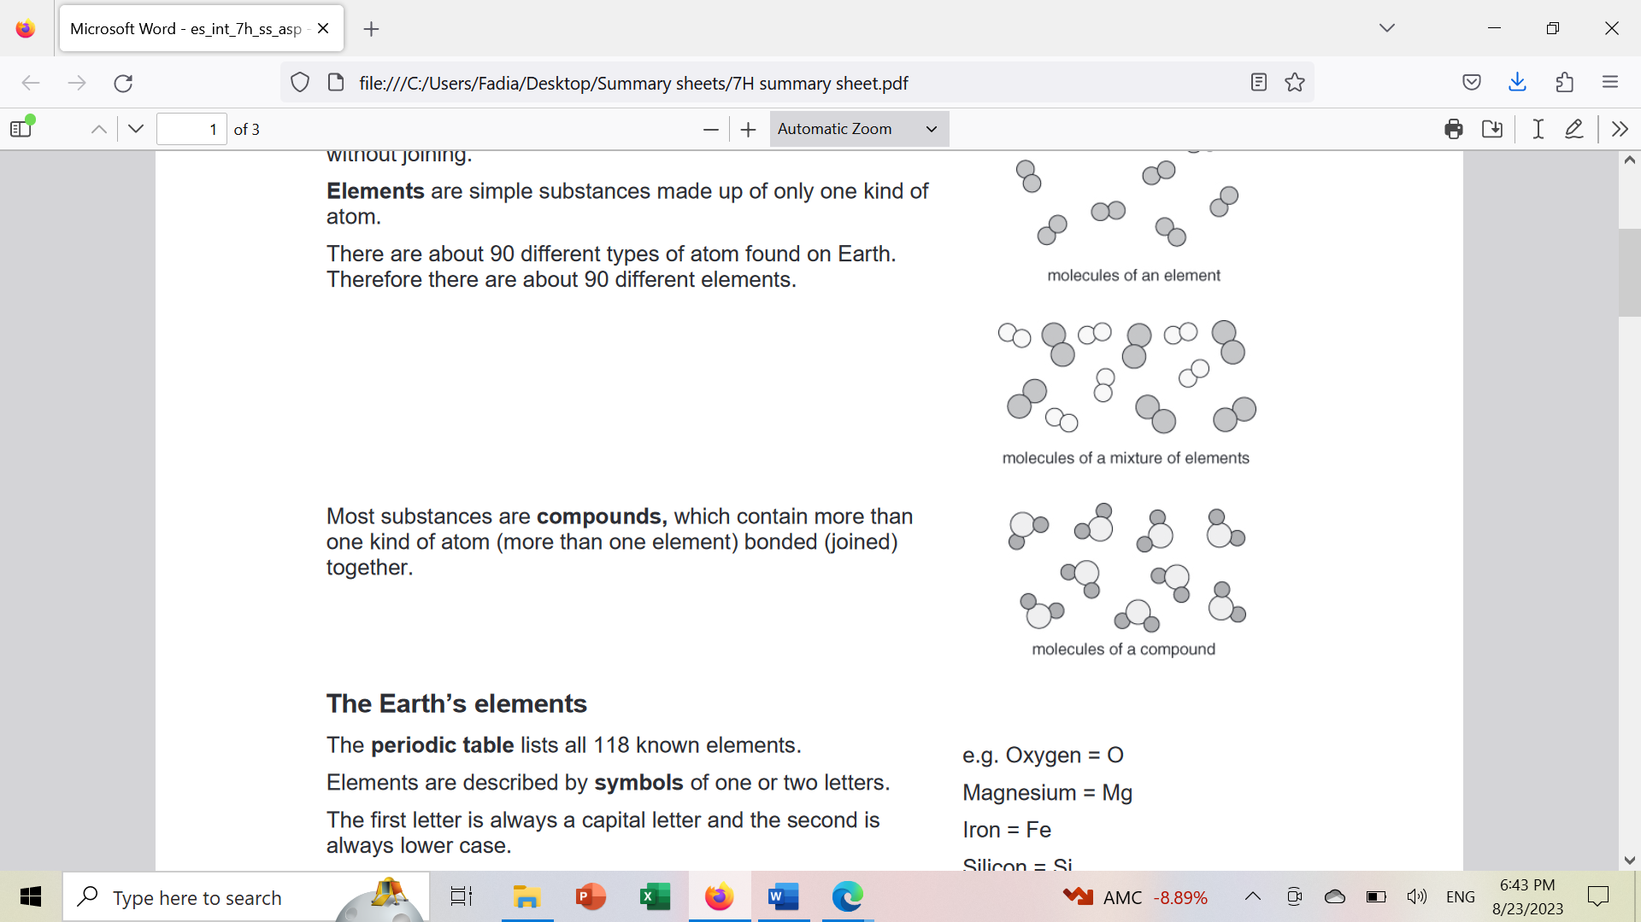

Workbook page 90+ 91
7Hb Earth’s Elements:
The periodic table lists all 118 known elements. (see page 205 in the mainbook)
Elements are described by symbols of one or two letters. The first letter is always a capital letter and the second is always lower case.
The symbols are convention, agreed and used by scientists all over the world. (international code).Symbols make it easy for scientists to communicate about elements even if they do not speak the same language.
e.g. Oxygen = O Magnesium = Mg Iron = Fe Silicon = Si
Calcium= Ca Aluminium= Al Sodium= Na
We obtain all the elements and compounds we need for living from the Earth’s atmosphere and crust.
Different elements have different properties and uses.
The properties of an element depend on its atoms and how they are arranged. The uses of an element are linked to its properties.
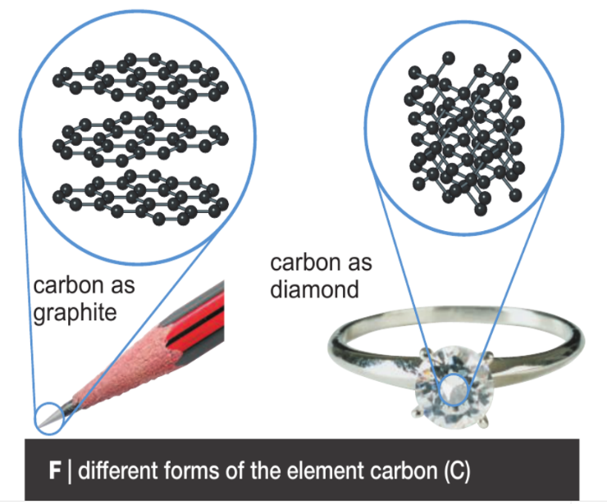
- The element carbon can be found in two different forms that contain the same atoms. Diamond is one of the hardest natural substances, while graphite is the soft solid used in pencil leads. The different properties are due to the different ways the atoms are joined together.

The gases in the air all look the same- they are all colourless gases. However, they behave differently.
- Oxygen makes things burn more quickly and so is used to help make very high-temperature flames in some tools.
- Argon, nitrogen and carbon dioxide can all stop things burning and so are used in fire extinguishing systems.
Our resources are limited and some may run out in the near future. We need to take care of our resources, recycle more and make less waste.
Workbook page 92
7Hc Metals and non-metals:
Elements can be classified as metals or non-metals, depending on their properties.
common physical properties of metals | common physical properties of non-metals
high melting point solids | low melting point (gases, liquids and solids)
malleable and ductile | brittle (when solid)
shiny (when polished) | not shiny
good conductors of heat | insulators (poor conductors) of heat
good conductors of electricity. | insulators of electricity.
e.g. copper, iron, aluminium, zinc, tin. | e.g. sulfur, oxygen, nitrogen, carbon, iodine.
The uses of an element depend on its properties.
- Copper and aluminium are used for electrical cables as they are strong, ductile and conduct electricity very well.
- Mercury is the only liquid metal. As it remains a liquid over a wide range of temperatures,it can be used in thermometers.
- Non- metallic silicon can be shiny like a metal, and has some unique conducting properties that make it useful to make silicon chips for the electronics industry.
- Unlike most non-metals graphite conducts electricity and is used in batteries and electric motors.
Workbook page 93
7Hd Making compounds
Compounds are formed when elements are mixed and react so that the atoms join together.
During a reaction, atoms are re-arranged and joined together in new ways. In the reaction of iron and sulfur, the atoms will join together to form a compound called iron sulfide. So new bonds have formed between sulfur and iron atoms , which are now bonded together.
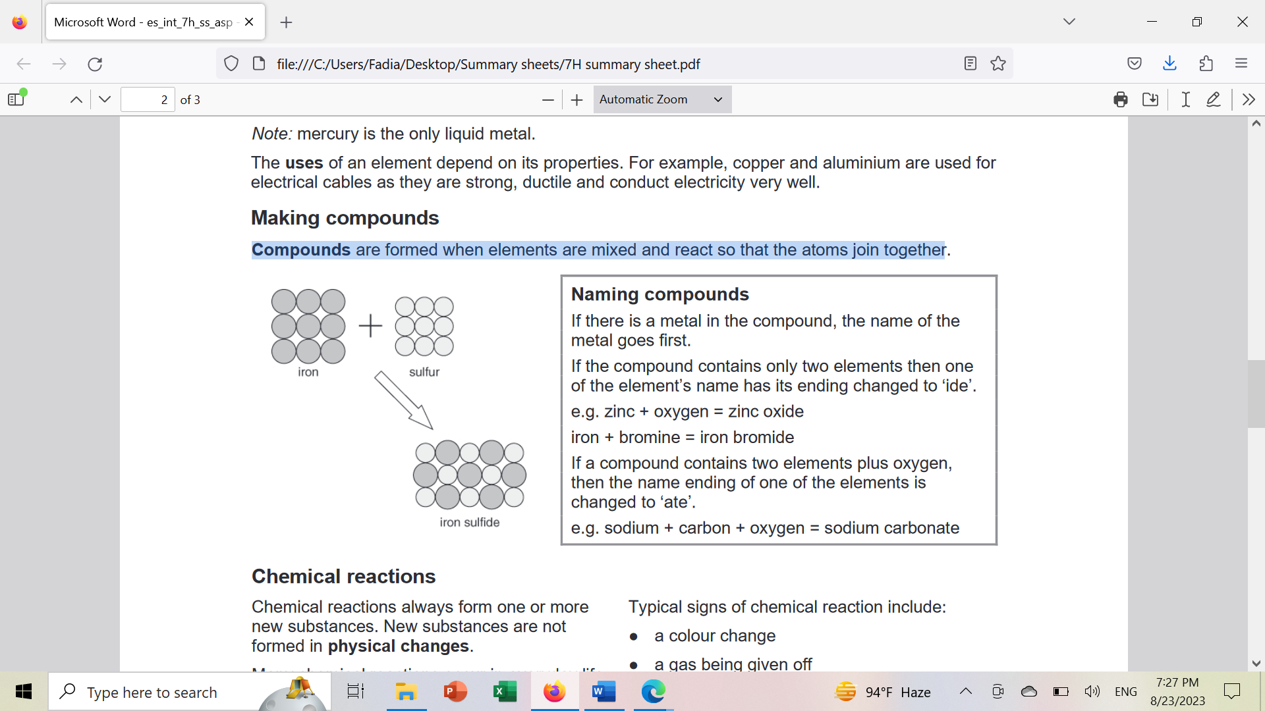
Naming compounds
If there is a metal in the compound, the name of the metal goes first.
If the compound contains only two elements then one of the element’s names has its ending changed to ‘ide’.
e.g. zinc + oxygen zinc oxide iron + bromine iron bromide

If a compound contains two elements plus oxygen, then the name ending of one of the elements is changed to ‘ate’.
e.g. sodium + carbon + oxygen sodium carbonate

Workbook page 95

7He Chemical reactions
Chemical reactions always form one or more new substances. New substances are not formed in physical changes.
Many chemical reactions occur in everyday life, for example, burning, cooking, rusting, and digesting food.
Typical signs of chemical reaction include:
● a colour change
● a gas being given off
● a solid forming in a liquid
● an energy change

How chemical reactions start:
1- Some reactions start just by mixing the right substances together. | e.g. acid and alkalis
2- Heat is often needed to start a reaction, but once started many reactions give out heat. | e.g. burning natural gas
Others need a continuous supply of energy to keep them going. | e.g. breaking down metal ores

Modelling chemical reactions using word equations
Chemical reactions can be described using models called word equation.
reactants products
e.g. zinc + chlorine zinc chloride
reactant product
Thermal decomposition reactions involve breaking down a single compound using heat.
e.g. tin carbonate tin oxide + carbon dioxide
copper carbonate copper oxide + carbon dioxide
mercury oxide mercury + oxygen
The carbon dioxide can be detected using limewater (which turns ‘milky’ when carbon dioxide is added.
The apparatus used to investigate the thermal decomposition of copper carbonate.

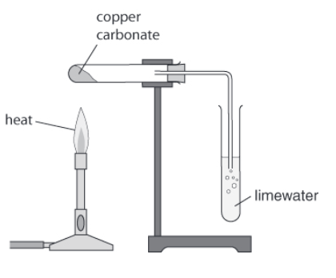
Workbook page 96+97

Exercise (2)
Write the word equation for the thermal decomposition of copper carbonate.
________________________________________________________________________

Write the names of the products when copper carbonate decomposes.
________________________________________________________________________

Write the names of elements that make up copper carbonate.
________________________________________________________________________

