4.1 Food chains, food webs and energy transfers
Getting started P.98
1 a A producer is a living thing (usually a green plant) that can make its own food.
b Fern, bean plant, palm tree
2 a A consumer is a living thing that cannot make its own food and must eat other
living things to obtain its energy.
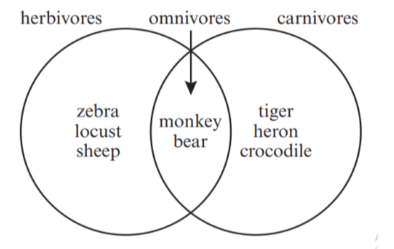
b

Activity P.99: Draw food chains
1 Corn → mouse → snake
2 Cabbage → snail → duck → fox
3 Pond weed → tadpole → fish → person

Think like a scientist P.101: Explain a food web and draw food chains
1 a Palm shoot, fig, jack fruit
b Spotted deer, coconut palm beetle, fruit bat
c Tiger, python, hawk
d Orangutan
2 Palm shoot, fig, jack fruit, coconut palm beetle
3 a Tiger, python
b Both eat spotted deer; python also eats the fruit bat.
4 a Any three from:
fig → orangutan → python
fig → orangutan → tiger
fig → fruit bat → hawk
fig → fruit bat → python
jack fruit → fruit bat → hawk
jack fruit → fruit bat → python
palm shoot → fruit bat → hawk
palm shoot → fruit bat → python
palm shoot → spotted deer → tiger
palm shoot → spotted deer → python
jack fruit → orangutan → python
jack fruit → orangutan → tiger
palm shoot → orangutan → python
palm shoot → orangutan → tiger
b Any one from:
palm shoot → coconut palm beetle → orangutan → python
palm shoot → coconut palm beetle → orangutan → tiger
5 A food web shows that living things eat a range of other living things to obtain
their energy, not just one thing as shown in a food chain.

Questions P102
1 From the Sun
2 They use it to make food.
3 Energy is transferred from the producer when a consumer eats the producer.
4 A consumer, such as a hawk, does not depend directly on producers to get its
energy because it does not eat plants. A hawk eats animals that get their energy
from eating plants, and in this way depends on energy stored in the producers.
5 a The amount of energy gets less and less as it is transferred through a food
chain.
b This is because not all of the energy in a food a consumer eats is passed on to
the next link in the chain – some of the energy is used up by the consumer and as
heat.

