4.1 Food chains, food webs and energy transfers
Focus:
1a
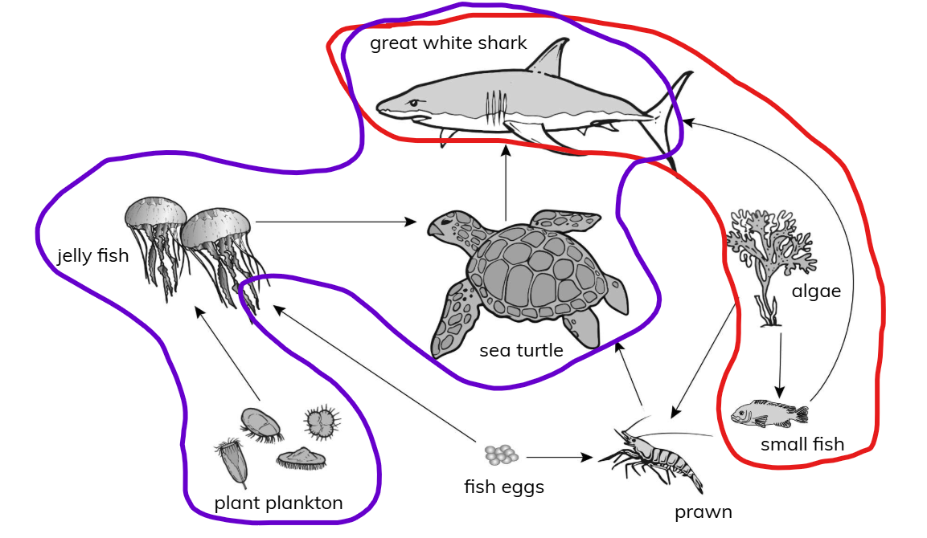

b The arrows show the direction in which energy moves from one living thing to the next living thing in the food chain.

Practice:
2 a
algae → prawn → sea turtle → great white shark
Plant plankton -> Jelly fish -> sea turtle
b Plant plankton, algae
c i Small fish
ii Jelly fish, prawn
iii Sea turtle, great white shark
d The Sun
e Great white sharks are predators of the sea turtle. If there were no more of them, the numbers of sea turtles would increase because no other animals in the food web eat them. However, their numbers would only increase if there was enough food for them to eat.

