
9Fa Types of explosion (coursebook answers pages 74-75)
Question one:
- liquid to gas
- No new substance is formed and the gas changes back to liquid when it cools down.
- There is a sudden increase in volume and a huge transfer of energy to the surroundings.

Question two:
- physical, because no new substance is formed / liquid wax can easily be changed back to solid wax
- chemical, because new substances have been formed or the reaction cannot be reversed
- chemical, because new substances have been formed or the reaction cannot be reversed

Question three: Petrol evaporated.

Question four: Chemical reaction, as the petrol is burning to form new products.

Question five: Increased.

Question six: carbon + oxygen → carbon dioxide + heat
C + O₂ → CO₂ + heat
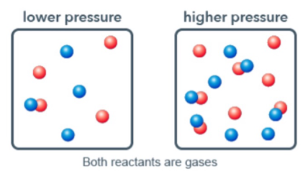
Question eight:
increasing the number of gas particles means that the particles
are closer together and hit the walls of the container more frequently.

