


Cambridge Primary Checkpoint

SCIENCE 0097/02
Paper 2

35 minutes
You must answer on the question paper. No additional materials are needed.

INSTRUCTIONS
- Answer all questions.
- Use a black or dark blue pen. You may use an HB pencil for any diagrams or graphs.
- Write your name, centre number and candidate number in the boxes at the top of the page.
- Write your answer to each question in the space provided.
- Do not use an erasable pen or correction fluid.
- Do not write on any bar codes.
- You should show all your working in the booklet.
- You may use a calculator.

INFORMATION
- The total mark for this paper is 40.
- The number of marks for each question or part question is shown in brackets [ ].


  - There are two lamps in the electrical circuit.

Name the type of circuit and name the two other components.
type of circuit components

[2]

  - Angelique has a buzzer.

Draw the symbol for a buzzer.

[1]

  - Angelique adds the buzzer to her electrical circuit.
Explain what happens to the brightness of the two lamps. Complete the sentence.
The brightness of the two lamps because
. [2]

- Two of these types of rock are igneous and sedimentary.

Name the other type of rock.
[1]

- Look at the information.

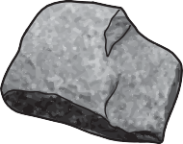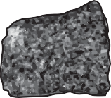

granite is specked black and white
gabbro is black with crystals

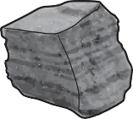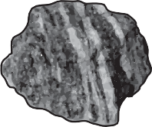

sandstone has layers made of grains of sand
schist has layers and crystals

Which rock is sedimentary?
[1]

- Some diseases are caused by infection with different organisms.

  - Influenza (flu) is caused by a virus.

Complete the sentences.

The influenza virus is passed from the first host to a second host.
The virus travels in the air when the first host . The second host knows they have the virus because they feel
. To stop themselves getting infected by the flu virus, the person
. [2]

  - Food poisoning is an illness.

Food poisoning may be caused by eating food containing bacteria. It is important to reduce the spread of bacteria.
Keeping uncooked food and cooked food separate reduces the spread of bacteria.

Describe two other ways to reduce the spread of bacteria. 1

2

[2]

  - Humans have defence mechanisms to stop bacteria making them ill.

What is in the stomach to kill bacteria?
[1]

- (a) Yuri has an optical fibre.
The surface of the optical fibre is made of glass. This glass acts like a mirror.
Look at the diagram of the optical fibre.
glass
light ray
glass

Complete the path of the light ray through the optical fibre. [1]

- Yuri also has a beaker of water.

The surface of water in the beaker acts like a mirror.

Look at the diagram.






beaker

surface of water

X light source

Complete the path of the light ray from the light source to the X on the side
of the beaker. [1]

- Name the process that happens when light hits a mirror.
[1]

- Water has mass and weight.

Describe the difference between mass and weight.

[2]

- Blessy mixes different solids with a liquid.

She uses this equipment.

gas syringe

thermometer

solid
liquid

Here are her results.

solid | results
A | produces a gas which collects in the gas syringe
B | mixture increases in temperature
C | solid dissolves and the mixture gets colder
D | mixture changes colour
E | solid remains in the liquid and temperature stays the same

  - How many of the solids have a chemical reaction with the liquid?

Circle the correct number.

1 2 3 4 5
[1]

  - Solid A produces a gas which collects in the gas syringe.

Blessy measures the mass of the gas syringe when it is empty.
Blessy measures the mass of the gas syringe when it is full of gas. Complete the sentence.
The mass increases because the gas inside the syringe has
.
[1]

  - Blessy writes some notes about mixing solid A with a liquid.

The gas is carbon dioxide. Solid A is copper carbonate.
The name of the liquid at the end is copper sulfate.
The only liquid in the flask at the start is dilute sulfuric acid. Complete the sentences.
The reactants of this reaction are
.

The products of this reaction are
. [2]

  - Blessy uses four books to find some information about sulfuric acid.

She finds the same information in every book.

boiling point = 337 °C melting point = 10 °C

Explain why this information is always the same for sulfuric acid.

[1]

  - Substances have properties.

Complete the sentence.
Two different properties are electrical conductivity and conductivity.
[1]

- Oliver wants to find out if adding sand to soil helps beans grow.

In his investigation Oliver:
- adds a different mass of sand to the soil in five pots
- keeps the five pots in the same conditions
- adds 10 bean seeds to each pot of soil
- adds water to the pots each day
- measures the length of the bean roots after 25 days
- calculates the mean length of the roots for each pot.

Here are his results.

mass of sand added to pot in g | mean length of roots in cm
0 | 5.8
2 | 4.8
4 | 3.6
6 | 2.6
8 | 1.4

  - Complete the graph by:

    - plotting the last two points
    - drawing a line of best fit.

6
5
4

mean length of roots
in cm
3
2
1
00 2 4 6 8
mass of sand added to pot in g

[2]

  - Write down a conclusion for his results.

[1]

  - Soils may be classified by the amount of sand and clay they contain.

Name one other substance used to classify soils.

[1]

  - Look at the model of sand and clay particles.
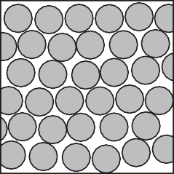
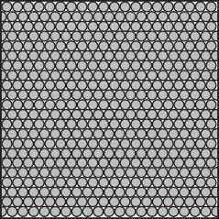
sand clay

Tick (✓) the boxes next to the two correct statements. sand particles are larger than clay particles
clay has larger air spaces between the particles than sand particles

sand lets water move between the particles

clay particles do not stick together

[2]

- Rajiv and Pierre measure their pulse rate before, during and after exercise.
  - Before Rajiv and Pierre start exercising they consider the risks.

One risk is falling over when running, causing an injury to their ankles. This risk is reduced by wearing running shoes.
Write down one other risk and how to reduce this risk. risk

how to reduce this risk

[2]

  - They present their results using a graph.

140
120
100

recovery time

pulse rate
in beats per 80
minute 60
40
20
0

before exercise

during exercise

recovery time

after exercise
Rajiv Pierre

time

Write down one similarity and one difference in the pulse rates of Rajiv and Pierre.
similarity

difference

[2]

  - Rajiv and Pierre also measure their breathing rate.
What happens to breathing rate during exercise? Complete the sentence.
The breathing rate during exercise because

. [2]

- Mia makes and eats an ice lolly.

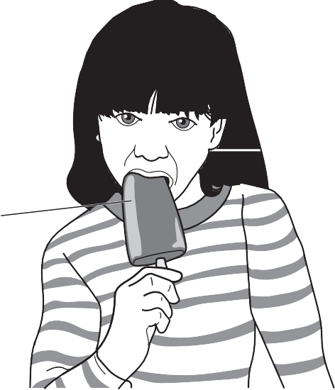
ice lolly

Mia puts the orange juice in a freezer to make her ice lolly.
  - Orange juice is mostly made of water.
Suggest the temperature at which orange juice in the ice lolly changes state.

°C

[1]
  - Complete the sentences to explain what happens to the orange juice when Mia makes her ice lolly.
Orange juice changes from a to a . This is a change.
[2]

  - Complete the sentences to explain what happens to the ice lolly when Mia eats her ice lolly.
When an ice lolly is placed in the mouth, it . The ice lolly changes from a to a .
[2]

BLANK PAGE

Permission to reproduce items where third-party owned material protected by copyright is included has been sought and cleared where possible. Every reasonable effort has been made by the publisher (UCLES) to trace copyright holders, but if any items requiring clearance have unwittingly been included, the publisher will be pleased to make amends at the earliest possible opportunity.

To avoid the issue of disclosure of answer-related information to candidates, all copyright acknowledgements are reproduced online in the Cambridge Assessment International Education Copyright Acknowledgements Booklet. This is produced annually and is available to download at https://primary.cambridgeinternational.org/

Cambridge Assessment International Education is part of Cambridge Assessment. Cambridge Assessment is the brand name of the University of Cambridge Local Examinations Syndicate (UCLES), which is a department of the University of Cambridge.

