

Rosary School – Marj Elhamam
Worksheet 1
Name: _________________ |  | Date: __ /__ / 2025
Grade: 5(A, B, C, D, E) |  | Subject: Science
Q1: Questions 1a–f are based on the food web below.
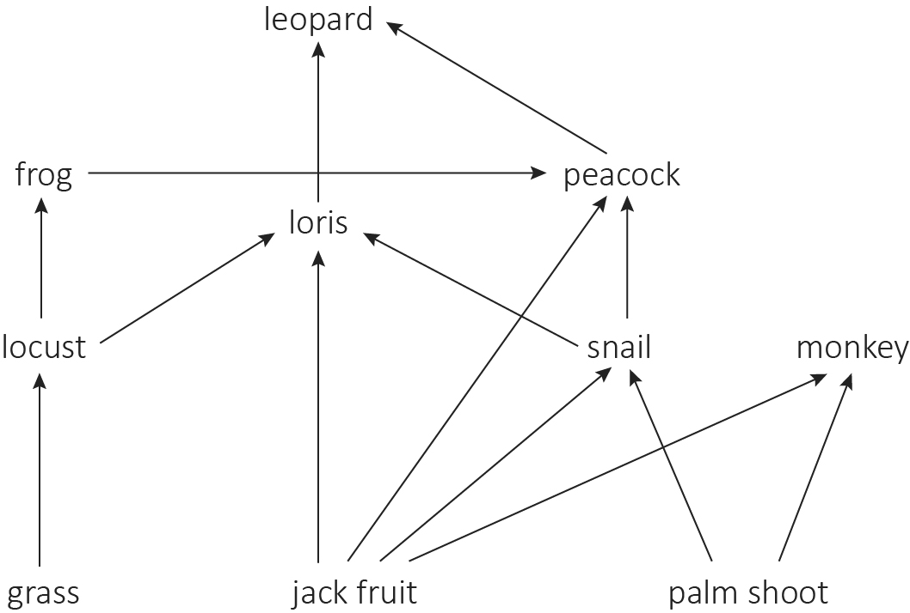

a- Name two producers in the food web.
_________________________________________________________________
b- Name two herbivores in the food web.
_________________________________________________________________
c- Name two carnivores in the food web.
_________________________________________________________________
d- Name two omnivores in the food web.
_________________________________________________________________
e- Draw one food chain in the food web that has exactly three links.
_________________________________________________________________
f- Draw one food chain in the food web that has exactly four links.
_________________________________________________________________
Q2: The diagram below shows part of a food web from the ocean.
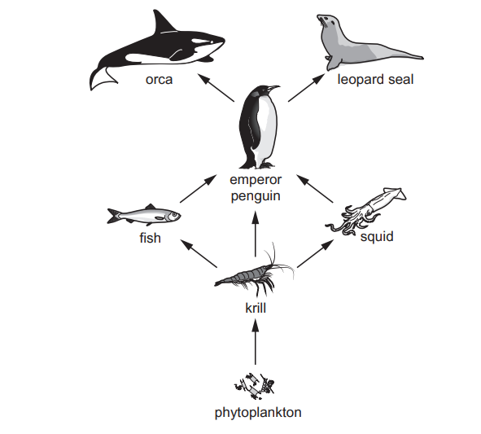
- Phytoplankton are producers. Define the term producer.
____________________________________________________________________________________________________________________________________
- Identify a primary consumer.
__________________________________________________________________
- Identify two organisms eaten by emperor penguins
1 _____________________________
2 _____________________________

- Orcas also eat fish. Draw one arrow on the diagram to show this feeding relationship.

- Draw one food chain in the food web that has exactly three links.
__________________________________________________________________

Q3: This is a food chain on a farm where the farmer sprays pesticides on his crops. cabbage → bug → lizard → bird
a. Explain what a pesticide is. ____________________________________________________________________________________________________________________________________
b. Which link in the food chain will be affected first by the pesticide? __________________________________________________________________
c. How does the pesticide move through the food chain? __________________________________________________________________

Teachers: Marah Naber and Daniella Petro

