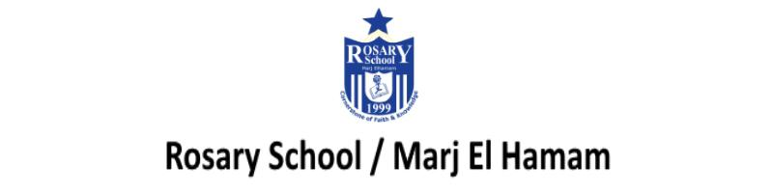

9Fb Reactivity (Course book answers pages 76-77)
Question one:
- potassium, sodium, lithium, calcium or magnesium (aluminium, zinc, iron, tin, lead)
- copper ( mercury, silver)
- mercury or silver

Question two:
list of metals in order of reactivity, with the most reactive at the top

Question three:
- sodium + water → sodium hydroxide + hydrogen
- magnesium + sulfuric acid → magnesium sulfate + hydrogen
- zinc + oxygen → zinc oxide

Question four:
rubidium, barium, cobalt

Question five:
- nucleus
- Neutrons have no electrical charge ,electrons have negative charge. Neutrons are only found in the nuclei of atoms but electrons are only found outside the nucleus.

Question six:
- 12 (mass number – atomic number = number of neutrons)
- There is no overall charge on a sodium atom because it has the same number of positively charged protons as it has negatively charged electrons and neutral neutrons.

Question seven:
