

Rosary School – Marj Elhamam
Worksheet 1
Name: _________________ |  | Date: __ /__ / 2025
Grade: 5(A, B, C, D, E) |  | Subject: Science
Q1: Questions 1a–f are based on the food web below.
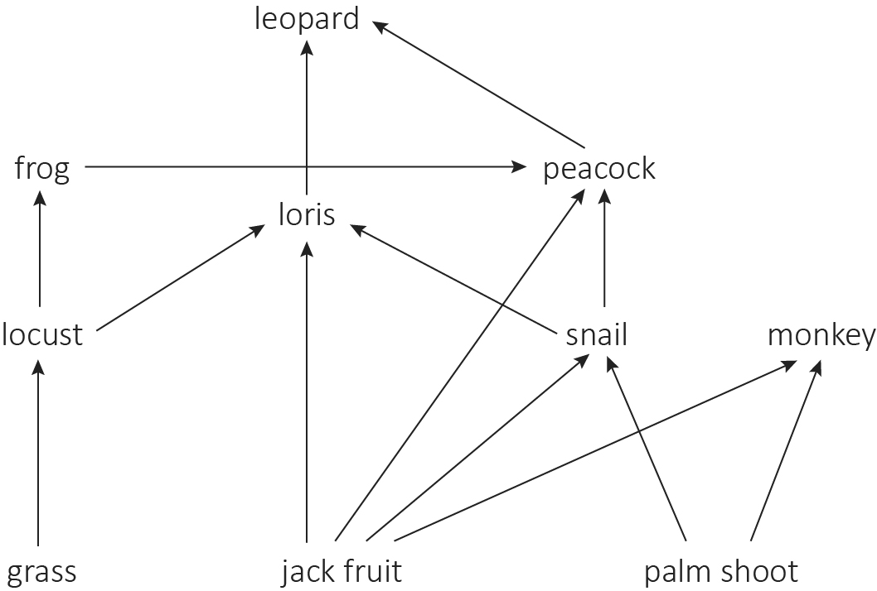

a- Name two producers in the food web.
Any two from: grass, jack fruit, palm shoot
b- Name two herbivores in the food web.
Any two from: locust, snail, monkey
c- Name two carnivores in the food web.
Frog, leopard
d- Name two omnivores in the food web.
Peacock, loris
e- Draw one food chain in the food web that has exactly three links.
Jack fruit loris leopard
f- Draw one food chain in the food web that has exactly four links.
Jack fruit snail peacock leopard
Q2: The diagram below shows part of a food web from the ocean.
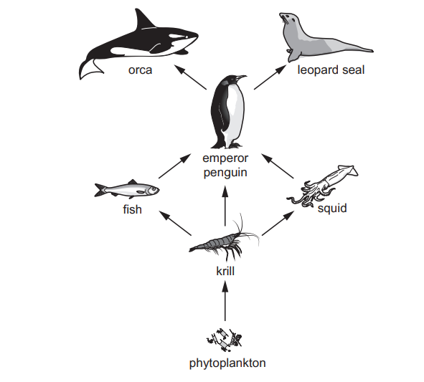
- Phytoplankton are producers. Define the term producer.
A living thing (usually a green plant) that can make it’s own food
- Identify a primary consumer.
Krill
- Identify two organisms eaten by emperor penguins
1 Fish
2 Squid

- Orcas also eat fish. Draw one arrow on the diagram to show this feeding relationship.

- Draw one food chain in the food web that has exactly three links.
Phytoplankton krill fish

Q3: This is a food chain on a farm where the farmer sprays pesticides on his crops. cabbage → bug → lizard → bird
a. Explain what a pesticide is.
Chemicals that farmers spray on their crops to kill pests, such as insects and snails
b. Which link in the food chain will be affected first by the pesticide?
The bug
c. How does the pesticide move through the food chain?
The pesticide moves through the food chain in the bodies of animals that eat the sprayed plants and the animals that eat them

Teachers: Marah Naber and Daniella Petro

