

Rosary School – Marj Elhamam
Worksheet 2
Name: _________________ |  | Date: __ /__ /2025
Grade: 5(A, B, C, D, E) |  | Subject : Science

Question 1:
Study the food web:
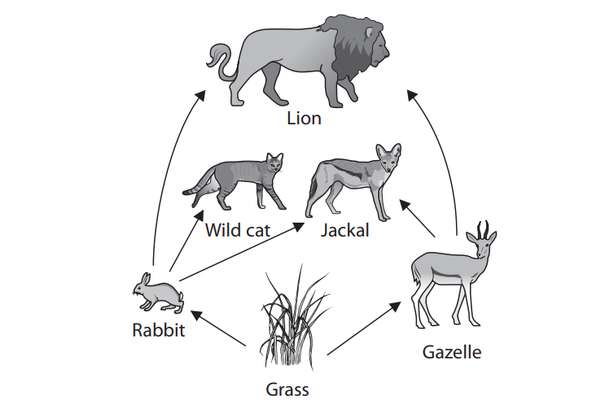
a. Complete the table by writing the name of one living thing that belong to each group.
Producer | herbivore | Secondary comsumer | prey | Top predator

b. Which two animals eat the Gazelle?
____________________________________________________________________________________________________________________________________

c. Identify and draw two food chains in the food web that have three links.
____________________________________________________________________________________________________________________________________
Question 2:
The table shows how four organisms get food for energy
Organism | How the organism gets food for energy
Plants | Make own food
Small birds | Eat beetles
Slugs | Eat plants
Beetles | Eat slugs

a. Use information in the table to complete a food chain linking these four organisms. The first box has been completed for you.
b. What is the main energy source of this food chain?
__________________________________________________________________
c. What does the direction of arrows show in these charts?
__________________________________________________________________
d. What happens to the amount of energy as it is transferred through the food chain?
_________________________________________________________________

Teachers: Marah Al Naber and Daniela Petro

