

Rosary School – Marj Elhamam
Worksheet 2
Name: _________________ |  | Date: __ /__ /2025
Grade: 5(A, B, C, D, E) |  | Subject : Science

Question 1:
Study the food web:
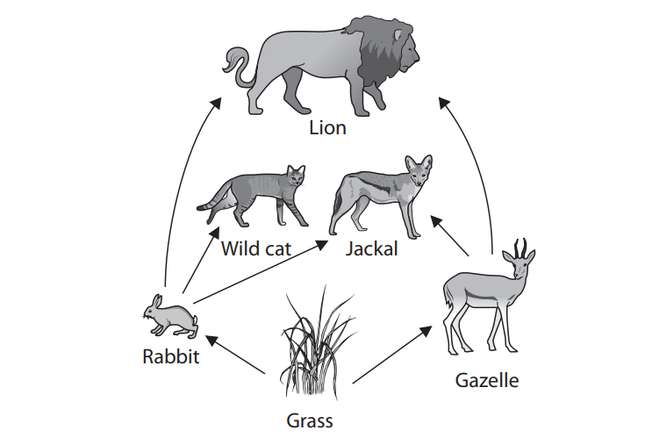
a. Complete the table by writing the name of one living thing that belong to each group.
Producer | herbivore | Secondary comsumer | prey | Top predator
Grass | Rabbit | Jackal | Gazelle | Lion

b. Which two animals eat the Gazelle?
Jackal
Lion

c. Identify and draw two food chains in the food web that have three links.
Grass Rabbit Wild cat
Grass Gazelle Lion
Question 2:
The table shows how four organisms get food for energy
Organism | How the organism gets food for energy
Plants | Make own food
Small birds | Eat beetles
Slugs | Eat plants
Beetles | Eat slugs

a. Use information in the table to complete a food chain linking these four organisms. The first box has been completed for you.
Small birds
Beetles
Slugs
b. What is the main energy source of this food chain?
The sun
c. What does the direction of arrows show in these charts?
The direction in which the energy transfers
d. What happens to the amount of energy as it is transferred through the food chain?
It gets less and less

Teachers: Marah Al Naber and Daniela Petro

