1 Look at this food web for a field of grass.
grass
grasshopper
vole
slug
thrush
hawk
fox
rabbit
- Write down the names of all the predators in this food web.
[1]

- What is the energy source for this food web?
[1]

- Describe how energy is transferred through this food web.

[1]

- Write down one food chain from this food web that contains the fox.
[1]

- A farmer sprays a toxic substance on the field to kill the grasshoppers.
Some of the voles in the field also die. Explain why.

[1]

2 Blessy has two substances:
- a colourless solution called vinegar
- a white solid called washing soda. Blessy adds vinegar to some washing soda. A chemical reaction takes place.
Carbon dioxide gas and liquid water are made. A solution of sodium ethanoate is also made.
- Complete the table to name the reactants and products in this chemical reaction.

name of reactants | name of products
[2]

One way that Blessy knows a chemical reaction happens is because she sees a gas is made.

- Describe one observation Blessy makes that shows a gas is made.
[1]

- Suggest two other observations Blessy makes that show a chemical reaction takes place.
observation 1
observation 2

[2]

3 Physical changes take place during puberty in humans.

- Describe one physical change that only takes place in females.
[1]

- Describe one physical change that only takes place in males.
[1]

- Describe one physical change that takes place in both males and females.
[1]

4 Chen investigates the water content of different soils. Chen:
- step 1 – measures the mass of an empty evaporating basin
- step 2 – puts some soil into the evaporating basin
- step 3 – measures the mass of the soil and evaporating basin
- step 4 – heats the soil and evaporating basin for 30 minutes
- step 5 – lets the soil and evaporating basin cool down
- step 6 – measures the mass of the dry soil and evaporating basin.
- Write down the name of the equipment Chen uses to measure mass in steps
1, 3 and 6.
[1]

- Complete the diagram by labelling the equipment Chen uses in step 4.

soil
....................................

gauze tripod

....................................

laboratory mat

[2]

- Look at the table of results.

 | mass in g
step 1 – mass of empty evaporating basin | 25.15
step 3 – mass of soil and evaporating basin | 30.25
step 6 – mass of dry soil and evaporating basin | 29.26
Calculate the mass of soil in step 3.

mass = g [1]

- Explain why the mass decreases between step 3 and step 6.

[1]

5 This question is about gravity, mass and weight.

Look at the table showing the mass and weight of an object on different planets.

planet | mass of object in  …………………… | weight of object in  ……………………
W | 20 | 200
X | 20 | 2000
Y | …………………… | 1000
Z | 20 | ……………………
- Complete the table headings by writing the name of the unit for:
  - mass
  - weight.
[2]

- Mass and weight have different units.

Write down one other difference between mass and weight.

[1]

- What is the mass of the object on planet Y?
Write your answer in the table.
[1]

- The force of gravity on planet Z is half the force of gravity on planet W. What is the weight of the object on planet Z?
Write your answer in the table.
[1]

6 Boiling and evaporation of water are both physical changes that are reversible.

- Describe how to reverse boiling and evaporation.
[1]

- Write down the name of the process that is the reverse of boiling and evaporation.
[1]

- What is the change of state when water boils?
to [1]

- Describe two differences between boiling and evaporating.
1

2

[2]

- Write down the name of one other physical change.
[1]

7 Circuit diagrams are models of electrical circuits.

Look at the circuit diagrams for circuit A and circuit B.
circuit A circuit B

- Complete the table about the number of components in circuit A and circuit B.

circuit | number of components
circuit | buzzers | closed switches | open switches | lamps
A
B
[2]

- Mike describes the electrical circuit he makes.

‘My electrical circuit has one cell, two buzzers, one closed switch and five wires.’
Suggest an advantage of using a circuit diagram to describe his electrical circuit.

[1]

- Look at the circuit diagram for circuit C.

circuit C

Jamila says that circuit C contains one battery of cells. Explain why Jamila is not correct.
[1]

8 This question is about human diseases.

Look at the table that shows information about some human diseases.

disease | cause of infection | how infection enters the body
cholera | bacteria | unsafe water and food
malaria | parasite | insect bite
Zika | virus | insect bite
tetanus | bacteria | through cuts in the skin
yellow fever | virus | insect bite
- Bacteria, parasites and viruses all cause disease in humans.

Write down one other type of living thing that causes disease in humans.
[1]

- Write down one disease from the table that is controlled by using good hygiene.
[1]

- Describe two ways to reduce infection with malaria.
1

2

[2]

9 Look at the force diagram.

reaction

driving force
friction and air resistance

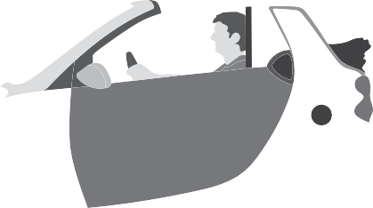




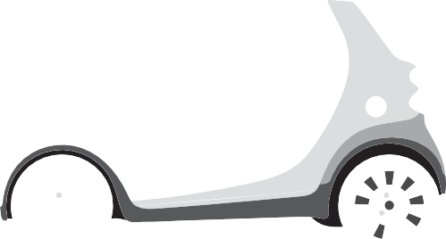



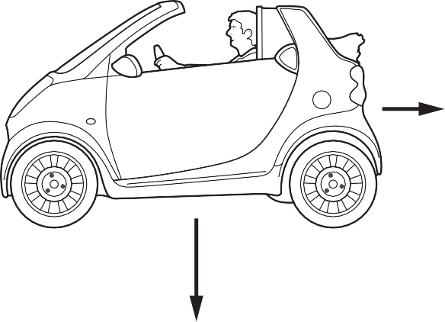
weight

- The reaction force and the weight are equal in size. Explain how the force diagram shows this.
[1]

- The car is moving to the left (). Explain why.
Use information from the force diagram.

[1]

- The driver of the car uses the brakes and the car slows down. This is because there is a braking force acting on the car.
Draw a labelled arrow on the diagram to show the direction of the braking force.
[1]

BLANK PAGE

Permission to reproduce items where third-party owned material protected by copyright is included has been sought and cleared where possible. Every reasonable effort has been made by the publisher (UCLES) to trace copyright holders, but if any items requiring clearance have unwittingly been included, the publisher will be pleased to make amends at the earliest possible opportunity.

To avoid the issue of disclosure of answer-related information to candidates, all copyright acknowledgements are reproduced online in the Cambridge Assessment International Education Copyright Acknowledgements Booklet. This is produced annually and is available to download at
https://primary.cambridgeinternational.org/

Cambridge Assessment International Education is part of Cambridge Assessment. Cambridge Assessment is the brand name of the University of Cambridge Local Examinations Syndicate (UCLES), which is a department of the University of Cambridge.

