

Rosary School \ Marj Elhamam

Name : ……………………………… Date : / 9 / 2025
Subject: Worksheet (1) / unit (1) Grade : 6 ( )
Analysing and displaying data

Q1. Find the mode of each set of data:


- 2, 5, 6, 5, 8, 5, 7 mode= __________
- 9, 3, 6, 9, 2, 6 mode= __________
- 1, 2, 3, 4, 5 mode= __________
- 11, 15, 11, 20, 22, 20 mode= ___________
- 8, 9, 8, 7, 9, 10, 8 mode= __________
Color | Frequency
Red | 10 students
Blue | 12 students
Green | 7students
Yellow | 12 students
Q2. Salim did a survey of favorite colors, the results are shown in the following frequency table.

What is the mode color?_______________
Q3. A shopkeeper records the number of ice creams sold each day:
12, 15, 18, 15, 20, 18, 15
Find the mode. _________________

Q4. A dice was rolled 12 times, and these numbers came up:
2, 5, 3, 2, 4, 5, 6, 2, 1, 5, 2, 3

Which number is the mode? _____________

Q5. Find the median of each set of data:
- 3, 7, 9, 11, 13 median= ____________
- 18, 25, 22, 20, 19 median= ____________
- 12, 15, 18, 21, 24 median= ____________
- 5, 10, 15, 20, 25, 30 median= ____________
- 2, 4, 6, 8, 10, 12, 14 median= ____________
- 1, 3, 5, 7, 9, 11, 13, 15 median= ____________
Q6. The ages of 7 cousins are:
5, 8, 10, 6, 12, 7, 9
What is the median age?__________________

Q7. Five students got these marks in a spelling test:
18, 25, 22, 20, 19
What is the median score? ______________

Q8. Find the mean of each set of data:
- 6, 8, 10, 12, 14 mean= _______________
- 5, 7, 9, 11 mean= _______________
- 5, 10, 15, 20, 25 mean= _______________
- 3, 6, 9, 12, 15 mean= _______________
- 2, 4, 6, 8, 10, 12 mean= _______________

Q9. A shopkeeper counted the apples in 4 baskets, here are the results:

15, 20, 22, 18
What is the mean of apples in a basket?
mean= ____________
Q10. Find the range of each set of data:
- 3, 7, 9, 12, 15 Range=_______________
- 10, 20, 25, 30, 40 Range=_______________
- 5, 8, 12, 6, 10 Range=_______________

Q11. Ali recorded the number of pages he read in 5 days:
3, 7, 9, 12, 15 pages.
What is the range of pages Ali read? ________________

Q12. Which of these are discrete and which are continuous?
a) Number of pencils in your bag. _______________
b) Height of your teacher. _______________
c) Number of goals scored in a match. _______________
d) Time taken to run a race. _______________

Q13. The scores of 20 students in a spelling quiz are:

5, 6, 7, 5, 8, 6, 7, 5, 9, 6, 8, 7, 6, 5, 7, 8, 9, 6, 7, 5
Score | Tally | Frequency
5
6
7
8
9
- Complete the frequency table below:

- What is the mode? ______________

Q14. The ages of 30 students in a club are:
10, 11, 10, 12, 13, 11, 14, 12, 10, 13, 12, 11, 10, 14, 13, 12, 11, 10, 15, 12,
13, 11, 12, 14, 13, 12, 11, 10, 13, 12
Complete the grouped frequency table below.
Age (years) | Tally | Frequency
10–11
12–13
14–15

Q15. A survey was conducted to find out the favorite sports of boys and girls in a class.
The data collected is shown by the following table:
Sport | Boys | Girls
Football | 8 | 2
Basketball | 5 | 3
Swimming | 3 | 6
Tennis | 2 | 4


a) Draw a dual bar chart to represent the data.
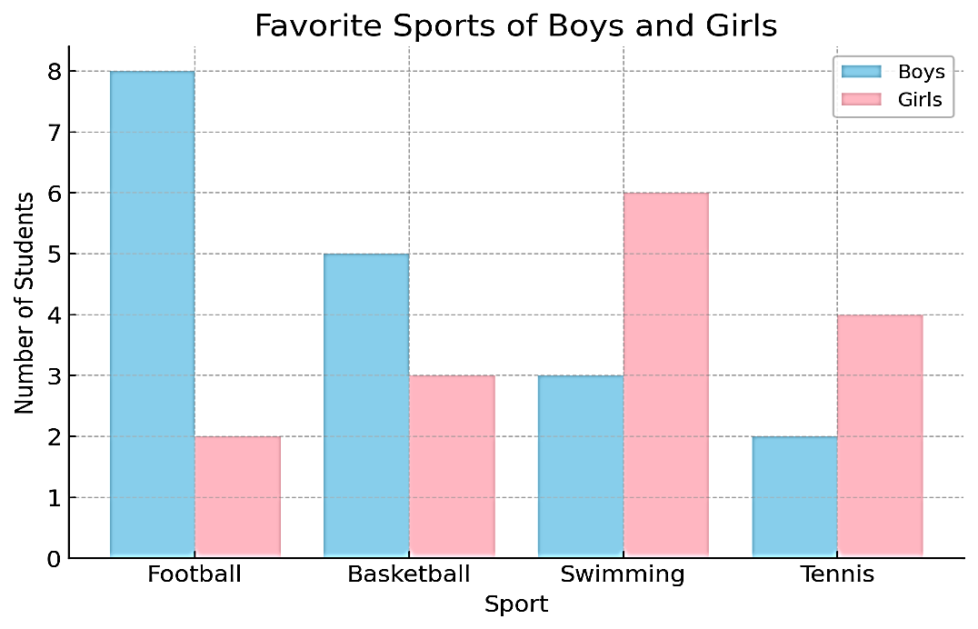

b) Draw a compound bar chart to represent the data.

Q16. The composite bar chart shows the results of driving tests one morning in three different test centers.
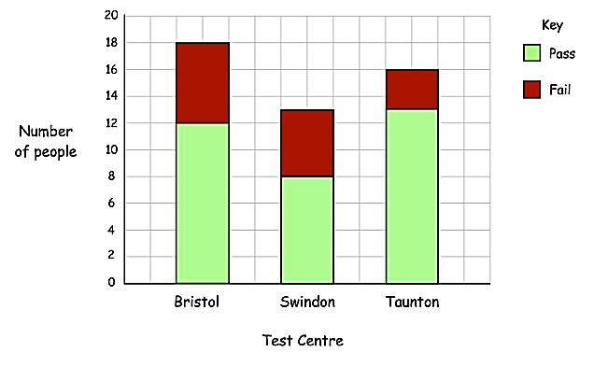

- How many people passed their driving test at the Bristol test centre? ____________

- How many people failed their driving test at the Taunton test centre? _____________

- How many people tested at Swindon test centre ? ___________

Q16. Students collected and recorded the weight of old newspapers for 5 months.

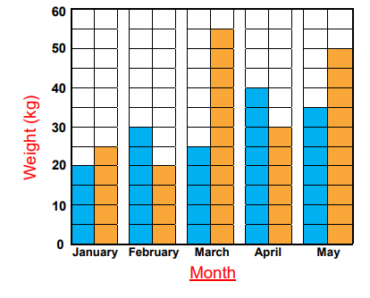
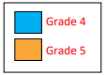

- In which month did grade 4 pupils collect the most newspapers?
_________________________

- In which month did grade 5 pupils collect the fewest newspapers?
__________________________

- How many kg of newspapers did the Grade 5 students collect?
__________________________
- Which month has the fewest newspapers collected?
___________________________

- What is the difference between the total collection of Grades 4 and Grade 5?

___________________________

Q17. Carol recorded the number of books she borrowed for 5 weeks.
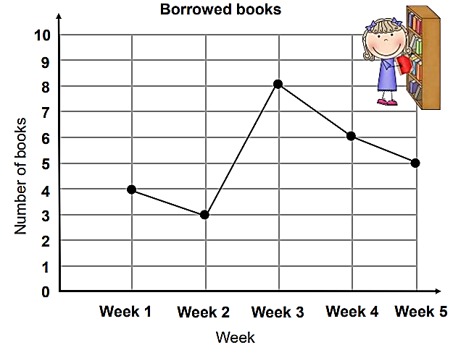
- How many books were borrowed on week 4?
__________________________
- What week did Carol borrow 6 books?
___________________________
- How many more books were borrowed on week 1 than week 2?
___________________________
- What week did Carol borrow the most books?
___________________________
- What week did Carol borrow the fewest books?
___________________________

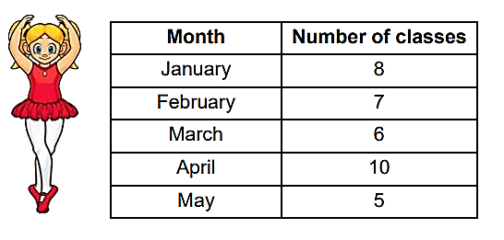
Q18. Mary recorded the number of ballet classes she had for 5 months. Draw a line graph using the given data.


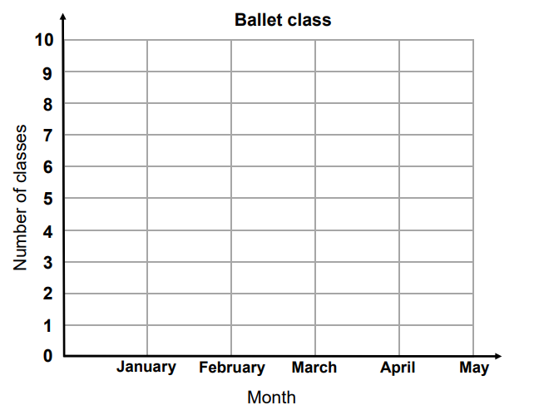

Teachers: Eman Nabas and Qusie Hijazeen

