

Rosary School – Marj Elhamam
Past paper questions
Name: _________________ |  | Date: ____ /____ / 2025
Grade: 9( A,B,C ,D) |  | Subject : Chemistry
Unit 1: States of Matter
Question one:
A)
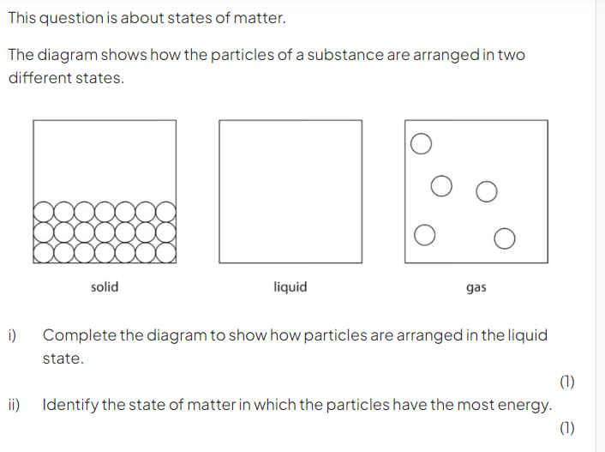
B)
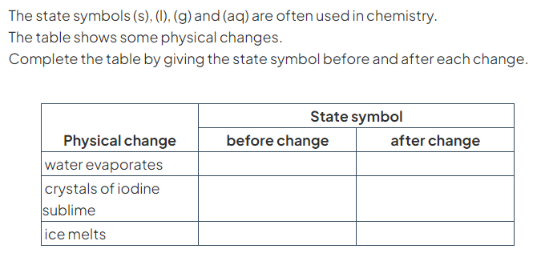

C)
(2)
_______________________________________________________________________________________________________________________________________________________________________________________________________________

Question two:
A)
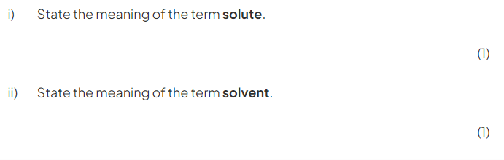
B)
(2)
_____________________________________________________________
C)
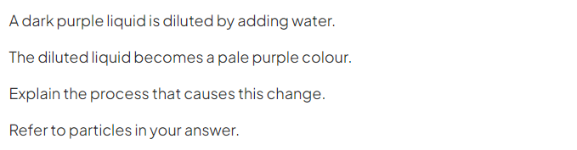(2)
_______________________________________________________________
_______________________________________________________________
Question three:
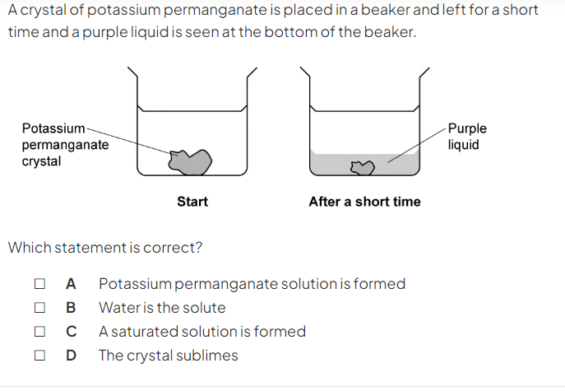(1)

Question four:
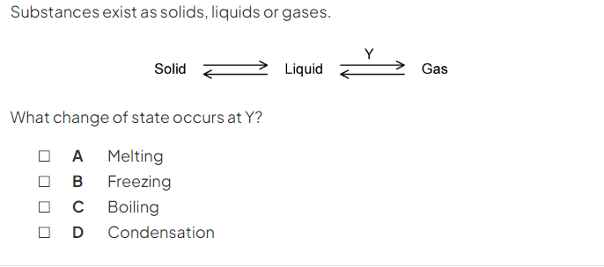(1)

Question five:
A)
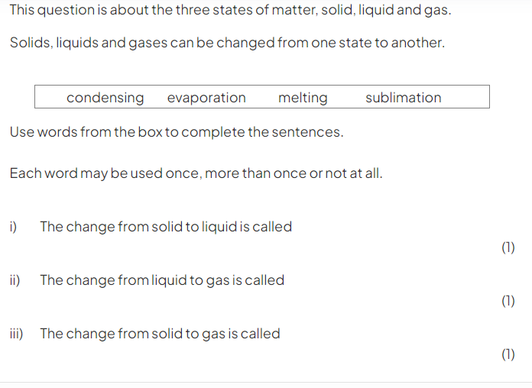
B)
(3)
_______________________________________________________________________________________________________________________________________________________________________________________________________________

Question six:
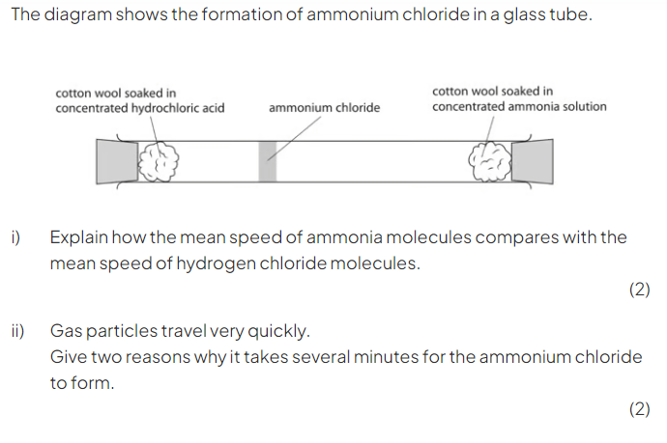
i) __________________________________________________________________________________________________________________________________________
ii) __________________________________________________________________________________________________________________________________________

Question seven:
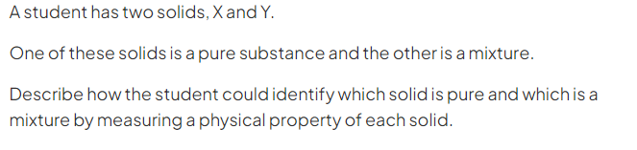(3)
__________________________________________________________________________________________________________________________________________

Question eight:
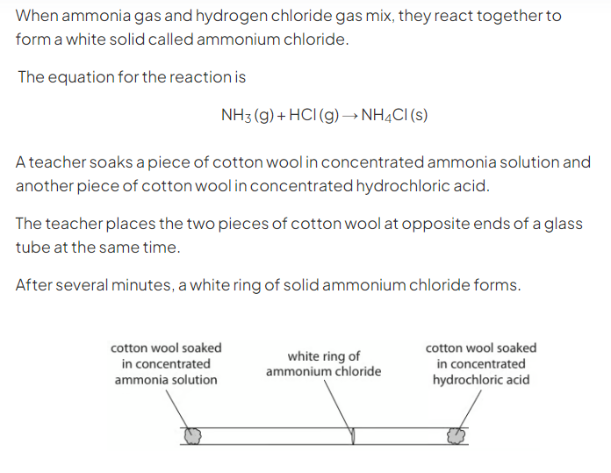
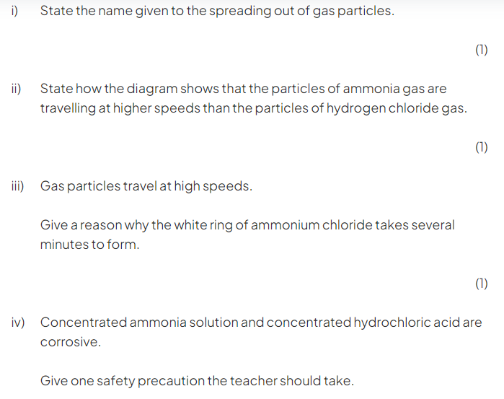(1)

Question nine:
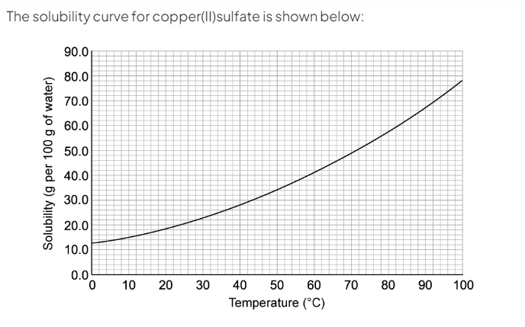
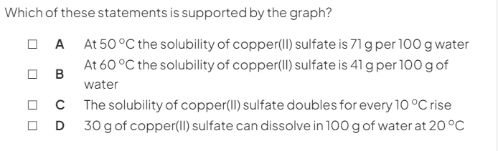
(1)

Question ten:
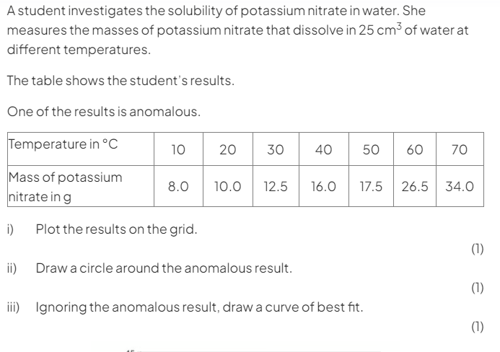
A)
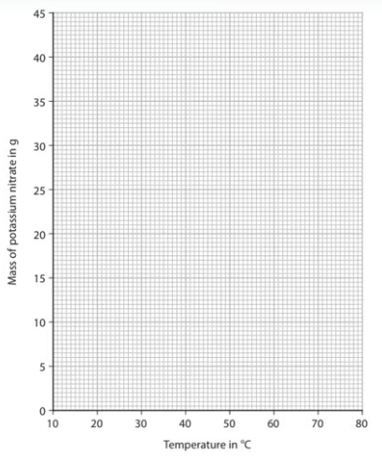
B)
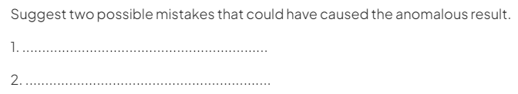(2)
C)
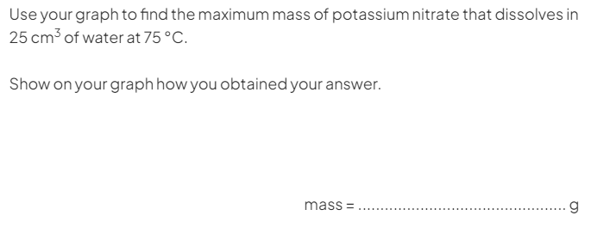(2)
Question eleven:
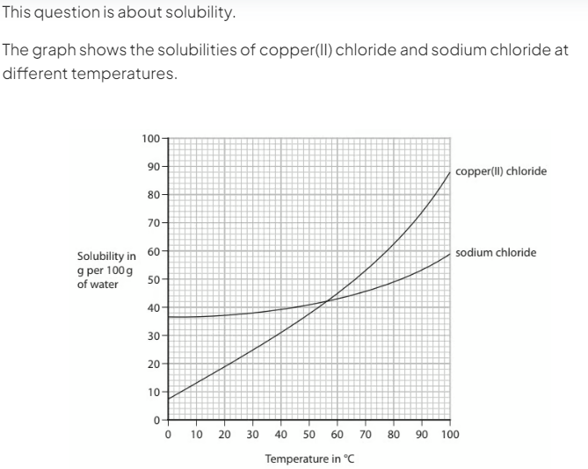
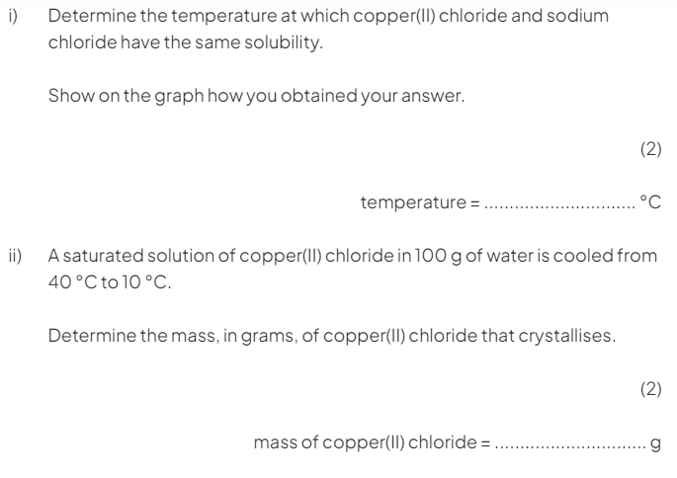
Question twelve:
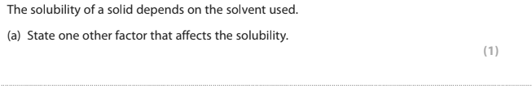
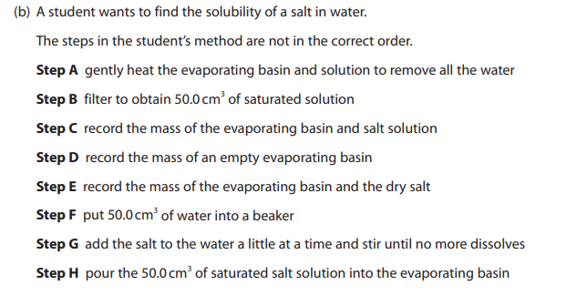
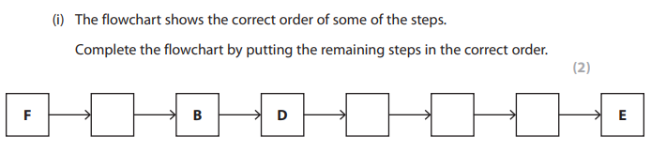
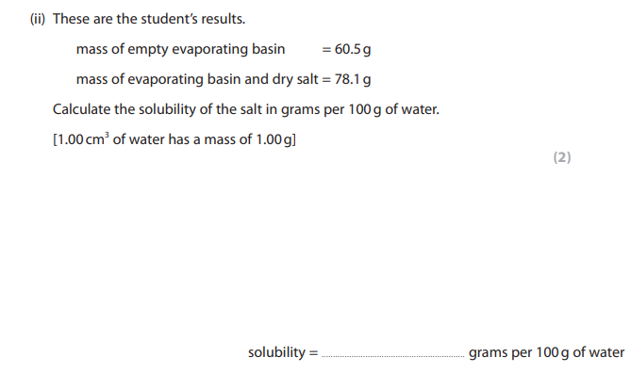

Question thirteen:
