

Rosary School –Marj Elhamam
Worksheet 3
Name: _____________ |  | Date: __ /__ /2025
Grade: 5(A, B, C, D, E) |  | Subject: Science
Think like a scientist p.38
*Plan a fair test to compare boiling points of different substances.

Note: In a fair test we change one factor or variable and keep all the others the same.

- Class 5 compared boiling points of 3 different substances. They conducted a fair test.

- Materials and Equipment:
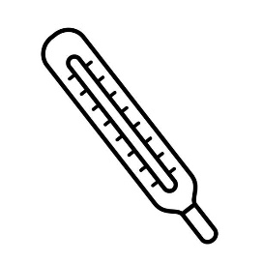
- Liquids (water, vinegar and olive oil ) - Thermometer

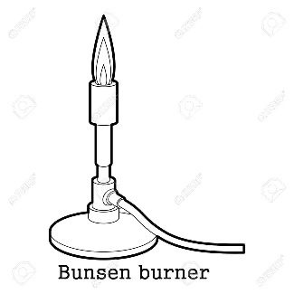
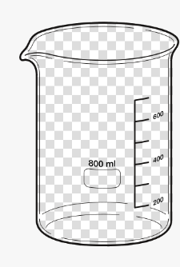
- Beakers - Bunsen Burner

- Procedures:
- Heat each liquid in a beaker, until it boils.
- Measure and record the temperature of the boiling liquid in each beaker by using the thermometer.

- Results:
**Note: Record readings in a table. Present results in a bar graph
- These are their results :
Substance | Boiling point
Water | 100 ° C
Vinegar | 118 °C
Olive oil | 300°C

- Conclusion:
Each substance boils at a certain temperature.

**Notes of fair testing:
In this experiment:
- Variable that changes is the substance tested (independent variable).
- Variable that is measured (dependent variable) is the temperature at which the substance boils.
- Variables that stay the same (control variables) are:
The thermometer used AND the method used to test each substance.
Question:
- Class 5 compared melting points of 3 different substances. They conducted a fair test.
They recorded the readings in a table and drew the following bar graph.
Substance | Melting Point
Aluminum | 660 ᵒC
Iron | 1538 ᵒC
Gold | 1064 ᵒC

- In order to make the investigation a fair test, name:
- The factors that they kept the same.
1.____________________________________________________
2.____________________________________________________
- One factor that they changed.____________________________________
- What did they measure?____________________________________________
- What materials and equipment did they use?
________________________________________________________________________________________________________________________________________________________________________________________________
- What did they do to compare the melting points of different substances?
________________________________________________________________________________________________________________________________________________________________________________________________
- Were there any dangers of risks in their investigation? How did they work safely?
________________________________________________________________________________________________________________________________

Teachers: Marah Naber, Daniela Petro

