Topic 2.1: Materials: properties and changes
Focus p 18
1 Boiling point is a property of a substance, so different substances will have different boiling points.
2 a Cooking oil
b Nail polish remover
c About 130 °C
d Evaporation

3 Temperatures marked off at 50.5 °C, 60 °C, 100 °C.
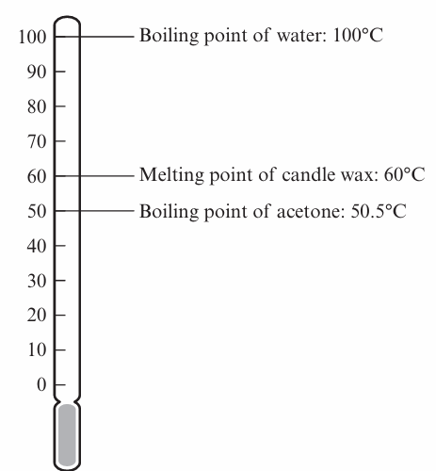
Practice p20
4 a Drawing B
b Evaporation
c i In both processes liquid water changes into water vapor gas.
ii Boiling happens when water is heated to 100 °C; evaporation happens at much lower temperatures; bubbles of gas form throughout the liquid in boiling, no bubbles form in evaporation.
d i Beaker A – any temperature in normal room temperature range of about 20–30 °C
ii Beaker B: 100 °C

Challenge
5 a. Olive oil, vinegar, water
b. Water
c. Check bar graph using this checklist:
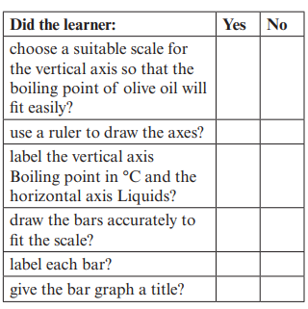
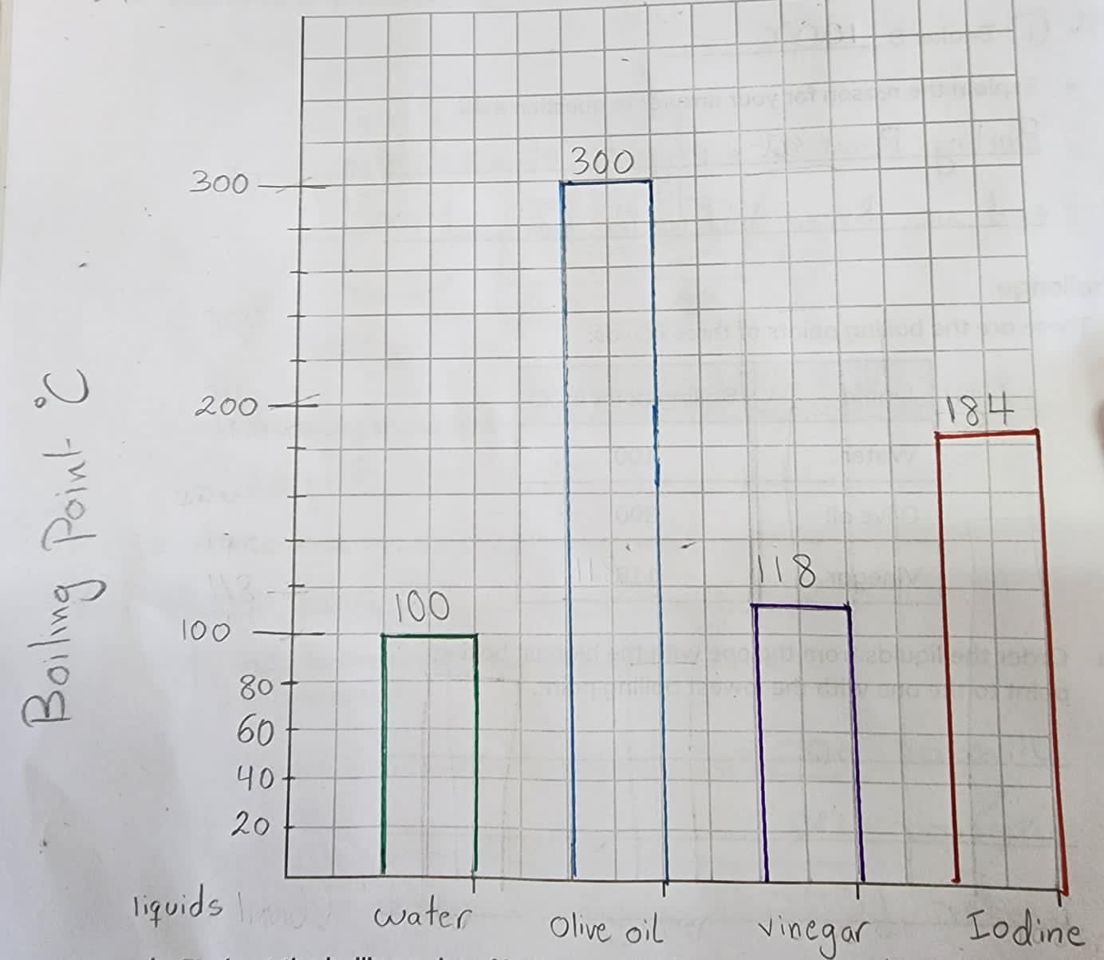

d. Bar with height at 184 °C added to graph
e. Cooking oils boil at a much higher temperature than water. So, a burn from boiling oil will be much worse and more dangerous than a burn from boiling water.

