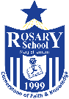
Rosary School - Marj Elhamam
Worksheet (1)
Name: Date: ___/9/2025
Grade: 8th (A, B, C, D) Subject: Chesmitry
Question one:
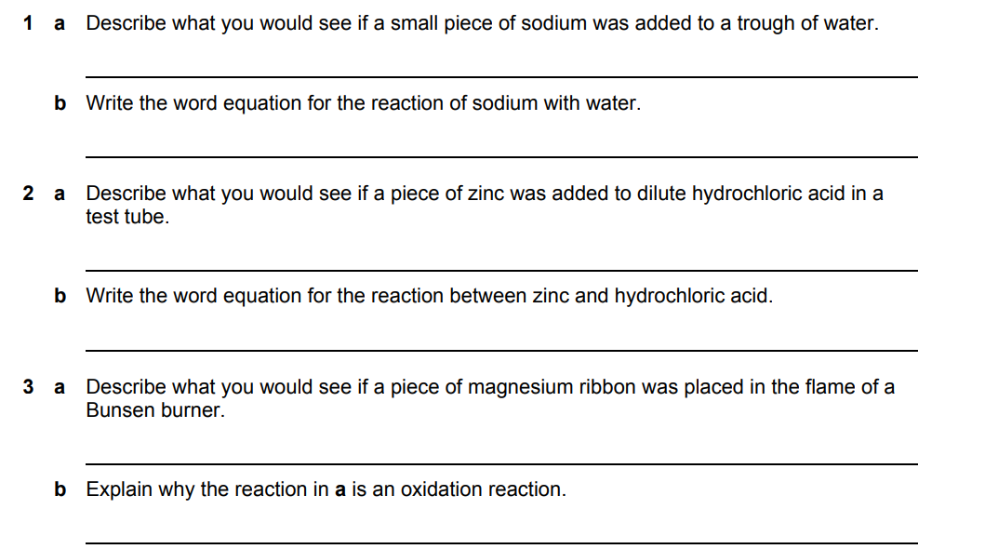
4
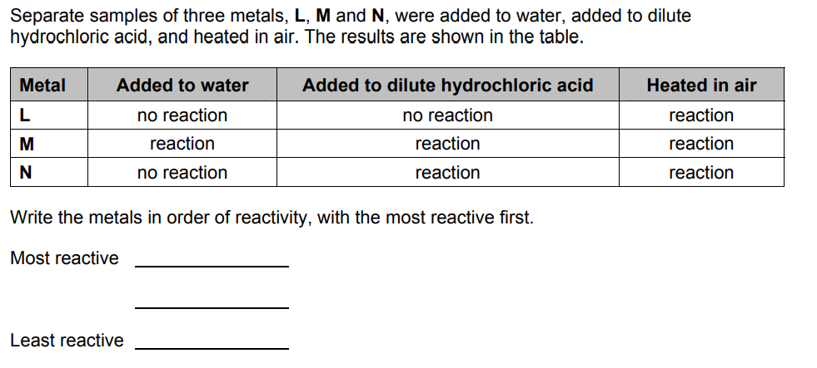
Question two:
