

Rosary School – Marj Elhamam
Worksheet 1
Name: ________________ |  | Date: ____ /____ / 2025
Grade: 7 (A,B,C,D,E) |  | Subject : Physics

Question 1:
For each description identify the body in the Solar System which is being described.
- The fourth planet from the sun. Mars
- A naturel satellite orbiting a planet. Moon
- The force which keeps satellites in orbit. Gravitational force
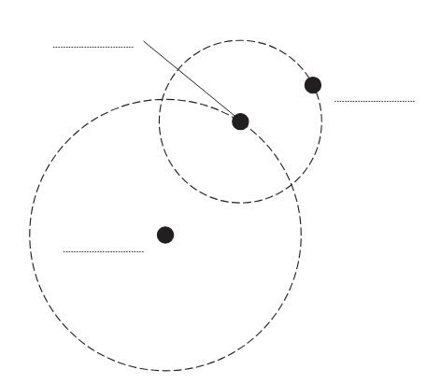
Question 2:
The diagram shows the orbits of a planet and a moon in the Solar System.
Moon
Planet
The diagram is not to scale.
Sun
On the diagram, label the planet, the moon and the Sun.
Question 3:
a. Describe the modern model suggested by Johannes Kepler.
8 Planets orbit the sun in elliptical orbits.
b. What are the different shapes of the moon called? Phases of the Moon
c. Explain why the moon looks different as it orbits the Earth.
Because we see different parts of the lit up side of the moon which is always facing the sun.

Question 4:
The UK is in the northern hemisphere of the Earth. In the middle of summer, there are over 16 hours of daylight in the UK.
- How is the number of hours of daylight in the UK different in the winter?
It is less in winter than in summer
b. Why is the length of daylight different at different times of the year? Tick one box.
□ The Earth spins on its axis faster in winter.
The Earth’s axis is tilted.
□ The Earth is further away in its orbit from the Sun during winter.
c. When it is summer in the UK: [1]
the northern hemisphere is tilted towards the Sun.
□ the southern hemisphere is tilted towards the Sun.
□ the northern hemisphere is tilted towards the moon.
d. Give one reason why the Sun feels hotter in summer than in winter in the UK.
The sun rays are more concentrated
Question 5:
Diagram 2 shows the Moon orbiting the Earth.
- Draw an arrow on diagram 2 to show the gravitational force acting on the Moon due to the Earth.
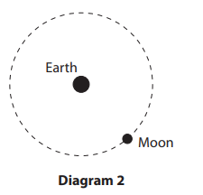
- Explain why do we see different phases of the moon.
The lit up side of the Moon is always facing the Sun; we can see different parts of the lit up side of the moon as it orbits the Earth.
Give a name for a large collection of billions of stars. Galaxy

