

Rosary School – Marj Elhamam
Unit 1: Elements, compounds & mixtures
Name: _________________ |  | Date: ____ /____ / 2025
Grade: 9( A,B,C ,D) |  | Chm chemistry summary notes

Objectives:
1.8 understand how to classify a substance as an element, compound or mixture.
1.9 understand that a pure substance has a fixed melting and boiling point, but a mixture may melt or boil over a range of temperatures.
1.10 describe these experimental techniques for the separation of mixtures.
* simple distillation
* fractional distillation
*filtration
* crystallization
*paper chromatography
1.11 understand how a chromatogram provides information about the composition of a mixture.
1.12 understand how to use the calculation of R_{f} values to identify the components of a mixture.
1.13 practical: investigate paper chromatography using inks/food colourings.
_________________________________________________________________________
All substances can be classified into one of these three types:
1) Elements
2) Compounds
3) Mixtures

What is an element?
A substance made of atoms that all contain the same number of protons and cannot be split into anything simpler (one type of atom).
-There are 118 elements found in the Periodic Table. E.g. copper, iron, magnesium
What is a compound?
-A pure substance made up of two or more different elements chemically combined together.
-There are an unlimited number of compounds. E.g. copper (II) sulfate (CuSO₄),
calcium carbonate (CaCO₃)
What is a mixture?
A combination of two or more different substances (elements and/or compounds), not chemically combined together.
-Mixtures can be separated by physical methods such as filtration or evaporation.
E.g. Air is one of many mixtures because it contains various gases.
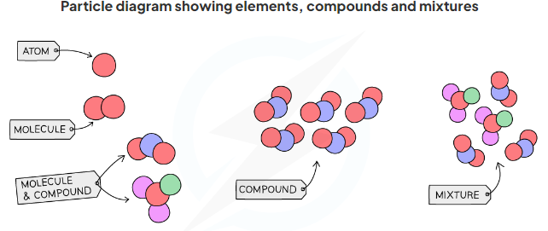
Difference between molecule and a compound:
In molecules: atoms can be the same element or different elements such as O₂ and H₂O.
In compounds: atoms are made from different elements such as H₂O and NaCl.
all compounds are molecules, but not all molecules are compounds.
Homework: Q 1 & 2 page 22.

Exam Tip
As well as learning the definitions for an element, compound and mixture, you must be able to classify any given substance.

Example:
Fe + S FeS
Iron and sulphur are joined chemically together to form the compound of FeS whereas; FeS cannot be separated back to its original elements Fe and S by using physical means.
Elements Fe (grey) and S (yellow) are separated from each other by using a magnet.
Iron reacts with dilute acids to give off hydrogen gas
Sulfur does not react with acids
However, FeS reacts with acids to produce poisonous hydrogen sulphide gas.
To sum up: in a mixture, each element keeps its own properties, but properties of compounds are quite different.
Pure Substance vs. Mixture
A pure substance is a material or chemical made from only one component that has a fixed composition.
- A pure substance may consist of a single element OR a single compound which contains no other substances. Example: gold, water.
- Pure substances have fixed/sharp boiling and melting points.
- For example, water:
- Melting point = 0° C
-Boiling point =100° C
- Impure substances boil and melt over a range of temperatures
- The presence of impurities lowers the melting point and raises the boiling point.
- The melting and boiling points can be shown using heating and cooling curves.
Exam tip
Make sure you can describe and identify pure substances.
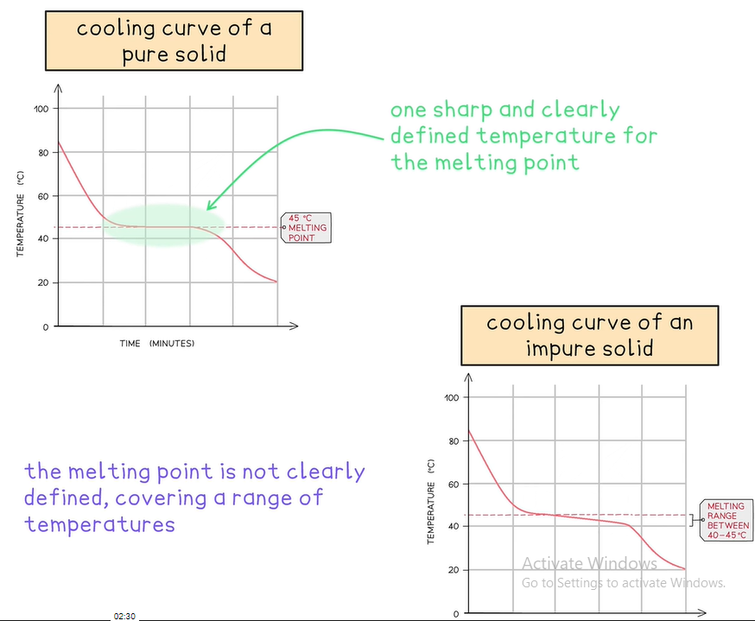

- Therefore, measuring the melting or boiling points of a substance can help determine whether a substance is pure or not.
- Notes:
-If the substance is solid, test the melting point.
-If the substance is liquid, test the boiling point.
Exam Tip:
Heating curves can also be used for melting and boiling points.

Exam Style Questions:
Question one:
Sulfur has a melting point of 114 ° C.
A student tests the melting point of a sample of sulphur. It begins to melt at 100° C and finishes melting at 113 °C.
Explain whether the substance is pure or impure? (2)
________________________________________________________________________
________________________________________________________________________

Question two:
Suggest how a soluble impurity could affect the melting point of ice. (1)
_______________________________________________________________________________________________________________________________________________________
Question three:
A student has two solids, A and B.
One of these solids is a pure substance and the other is a mixture.
Describe how the student could identify which solid is pure and which is a mixture by measuring a physical property of each solid. (3)
___________________________________________________________________________ __________________________________________________________________________________________________________________________________________________________
Homework: Q3 page 22
Exam tip
1) Work out what the question is actually asking you.
2) Try to work out what each mark is likely to be for.

Methods of separation techniques

1) Filtration:
Filtration is used to separate an undissolved solid from a mixture of the solid and a liquid / solution (e.g. sand from a mixture of sand and water)
The filtration process:
1) A piece of filter paper is placed in a filter funnel above a beaker.
2) A mixture of insoluble solid and liquid is poured into the filter funnel.
3) The filter paper will only allow small liquid particles to pass through is called filtrate.
4) Solid particles are too large to pass through the filter paper so will stay behind as residue.

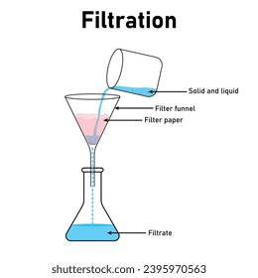
Note:
It can be used to separate two solids (if one of them dissolves in water) such as, rock salt
2) Crystallization
Crystallisation is used to separate a dissolved solid from a solution, when the solid is much more soluble in hot solvent than in cold (for example, it could be used to separate copper sulphate from a solution of copper (II) sulphate in water)
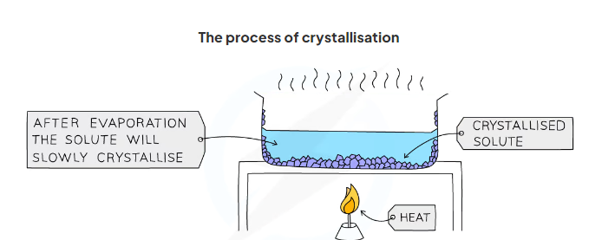
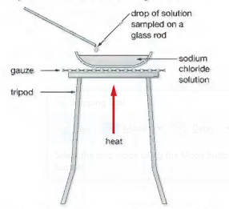

The process of crystallization:
1) The solution is heated, in an evaporating basin to boil off some of the water until an almost saturated solution is formed.
2) Test if the solution is saturated by dipping a clean, dry, cold glass rod into the solution. If the solution is saturated, crystals will form on the glass rod.
3) The saturated solution (crystals) is allowed to cool slowly.
4) The crystals can now be removed from the mixture by filtration.
5) Leave the crystals to dry.

Making pure salt from rock salt

3) Simple distillation
Simple distillation is used to separate a liquid and soluble solid from a solution (e.g., water from a solution of salt water) or a pure liquid from a mixture of liquids.
The process of simple distillation:
1) The solution is heated, and pure water evaporates producing a vapour which rises through the neck of the round bottomed flask.
2) The vapour passes through the condenser, where it cools and condenses, turning into the pure liquid that is collected in a beaker.
3) After all the water has evaporated from the solution, only the solid solute will be left behind.
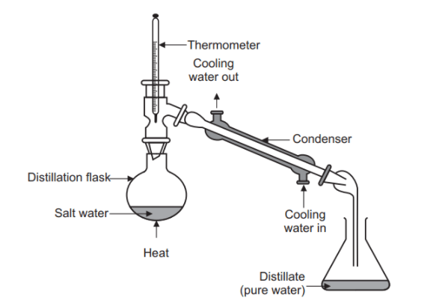
Liebig
Question four: Explain why water is always fed at the lower end of the condenser?
____________________________________________________________________________________________________________________________________________________________________________________________________________________________________
past paper question:
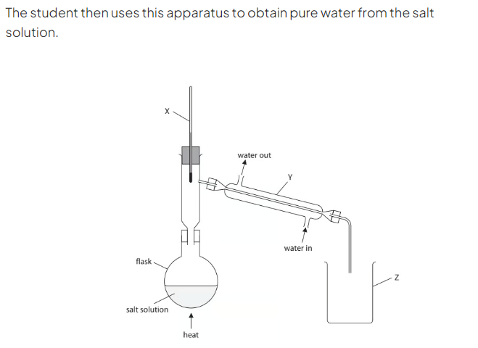
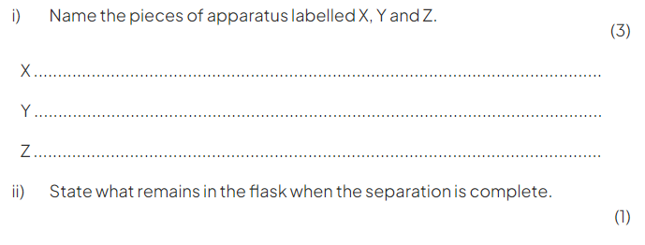
Exam tip:
If asked to draw or label a diagram of simple distillation, make sure that the water goes at the bottom of the condenser near the collecting beaker and comes out at the top of the column.

4) Fractional distillation
Fractional distillation is used to separate two or more liquids that are miscible with one another (e.g. ethanol and water from a mixture of the two)
The process of fractional distillation:
1) The solution is heated to the temperature of the substance with the lowest boiling point.
2) This substance will rise and evaporate first, and vapours will pass through a condenser, where they cool and condense, turning into a liquid that will be collected in a beaker.
3) All of the substance is evaporated and collected, leaving behind the other components(s) of the mixture.
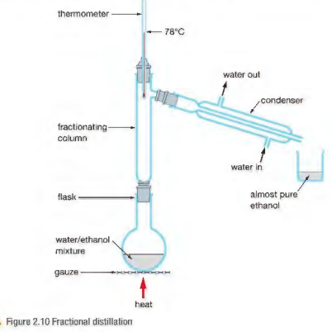
Example of water and ethanol
-Ethanol has a boiling point of 78 ºC and water of 100 ºC
-The mixture is heated until it reaches 78 ºC, at which point the ethanol boils and distils out of the mixture and condenses into the beaker.
When the temperature starts to increase to 100 ºC heating should be stopped. Water and ethanol are now separated (temperature should be controlled).

Why do we use a fractionating column?
Fractionating column has a large surface area, which helps the separation of two vapours.
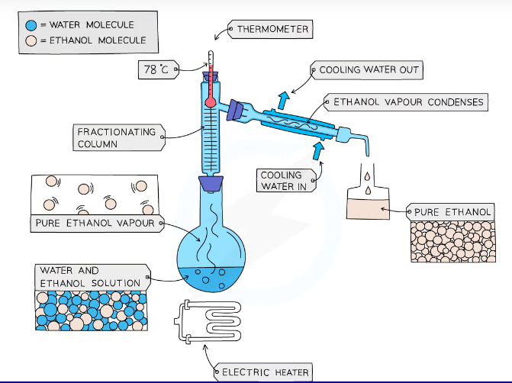
5) Paper chromatography
Paper chromatography is used to separate substances that have different solubilities in a given solvent (e.g. different coloured inks that have been mixed to make black ink)
The process of chromatography:
1) Draw a pencil line approximately 1.5 cm from the bottom of the paper. Pencil is used for this as ink would dissolve in the solvent therefore, would interfere with/ contaminate the results.
2) Add spots of the samples to be separated by using a pipette or a capillary tube on the pencil line and allow it to dry.
3) Add the chromatography paper to a beaker.
4) add a solvent below the pencil line so that the inks/ colourings don't just dissolve in the solvent and to prevent smudging.
5) Leave the paper until the solvent has moved near the top of the paper.
6)then take the paper out and leave it to dry.
Question: What are the problems that are prevented by fitting the beaker with a lid?
1-stop evaporation of the solvent from the surface of the paper.
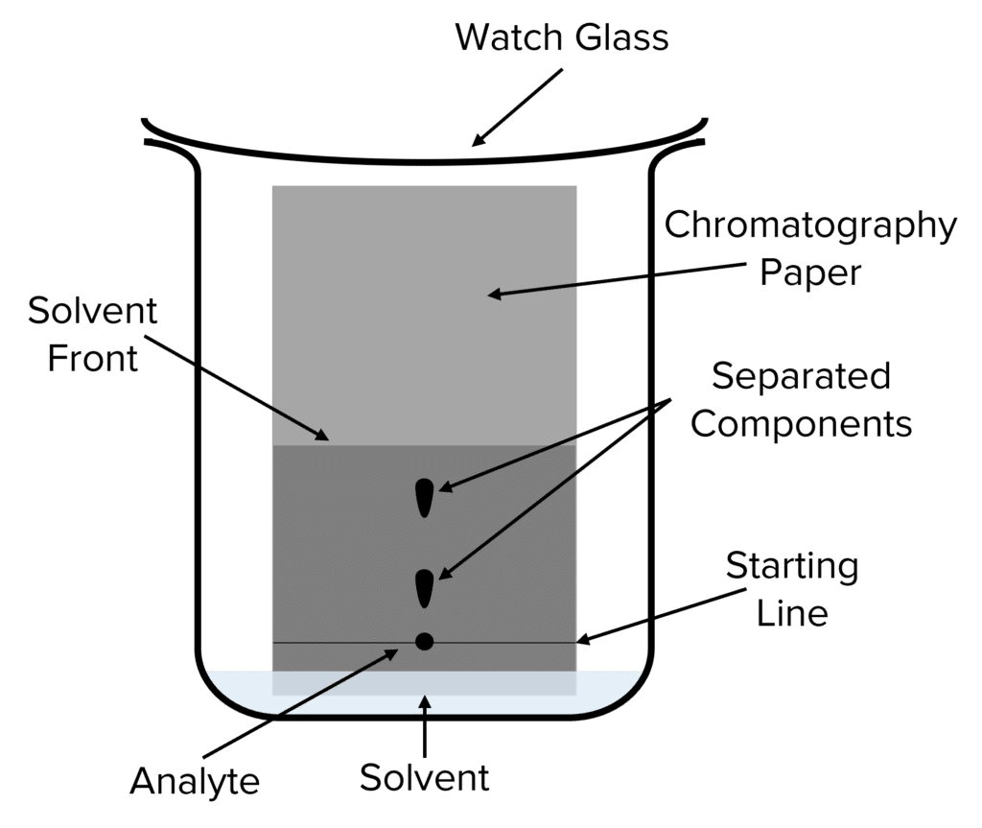
2- risk of fire
3- Fumes may be toxic/ poisonous.

Exam Tip:
You must be able to describe this process.

Notes:
1) Different substances have different solubilities so will travel at different rates, causing the substances to spread apart.
2) The more soluble the substances, the higher up the paper it will travel.
3) If the dye does not move from the pencil line, then the dye is not at all soluble in the solvent you are using. In this case you need to find a different solvent.
4) A solvent front is the highest level of solvent on the paper at any time.
The dyes that make up the mixture will be different in two ways:
1) The affinity they have for the paper. (How well they stick to the paper)
2) How soluble they are in the solvent which moves up the paper.
As a result, we will be able to have a pattern called a chromatogram.
Mobile phase= solvent
Stationary phase= chromatography paper

Question five:
Sodium chloride is a soluble solid.
Name the technique used to separate a soluble solid from a solution?
A) Filtration C) Crystallization
B) Simple distillation D) Chromatography

Question six:
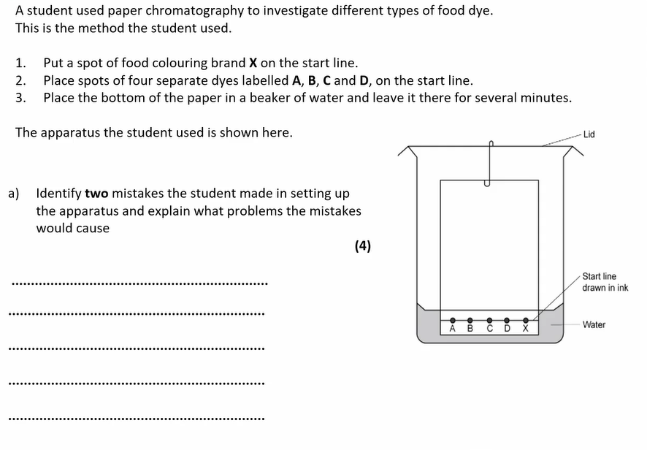
b)
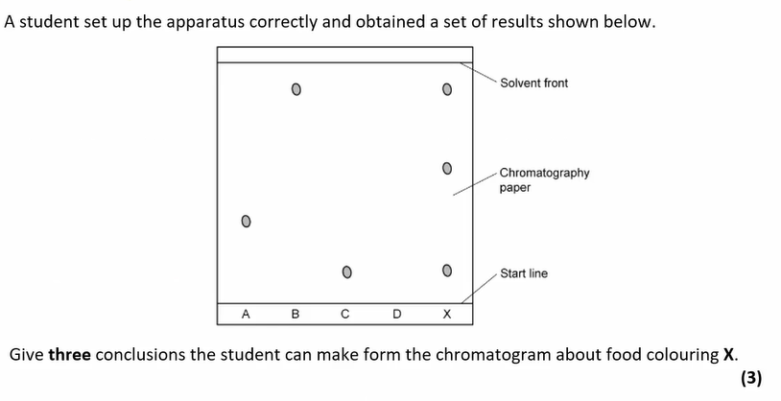
_________________________________________________________________________
_________________________________________________________________________
_________________________________________________________________________
Note: 1.13 practical: Investigate paper chromatography using inks/food colourings.
Refer to pages 19 and 20 in student’s book.

Interpreting chromatograms
We can use a chromatogram to compare the substances present in a mixture to known substances and make assumptions
Identifying mixture:
- Pure substances will produce only one spot on the chromatogram
- Impure substances will produce more than one spot on the chromatogram
- If two or more substances are the same, they will produce identical chromatograms
- If the substance is a mixture, it will separate on the paper to show all the different components as separate spots
- It is common practice to include a known compound as a reference spot

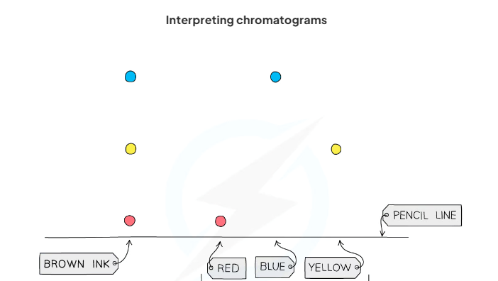
Write your conclusions…
_______________________________________________________________________
_______________________________________________________________________
_______________________________________________________________________

R_{f} Values
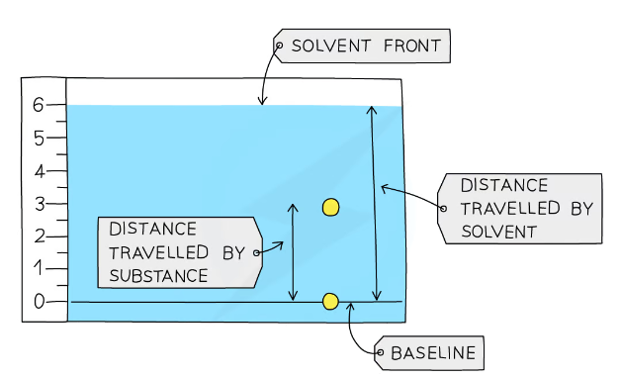
- R_{f} stands for retardation factor
- R_{f} values are used to identify the components of mixtures.
- The R_{f} value of a particular compound is always the same.However, it does depend on the solvent used
- If the solvent is changed then the R_{f} value changes.
- Calculating the R_{f} value allows chemists to identify unknown substances because it can be compared with the R_{f} values of known substances under the same conditions
The retardation factor, R_{f}, is calculated by the equation:
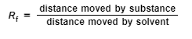
The R_{f} value:
- is a ratio
- has no units
- must be between 0 and 1.

Question seven:
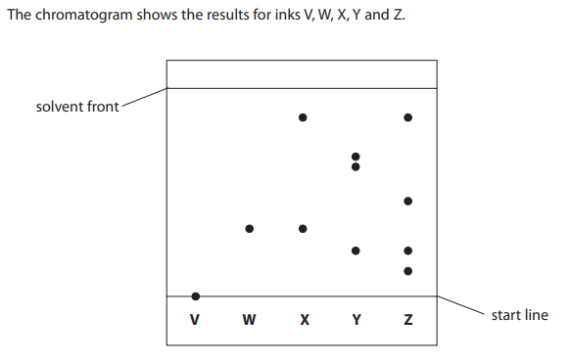
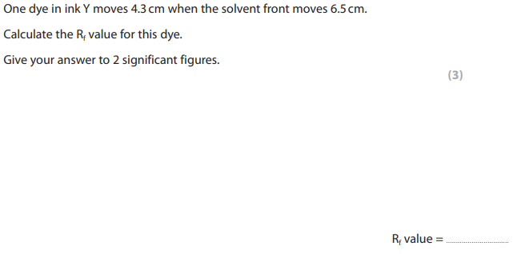
Question eight:
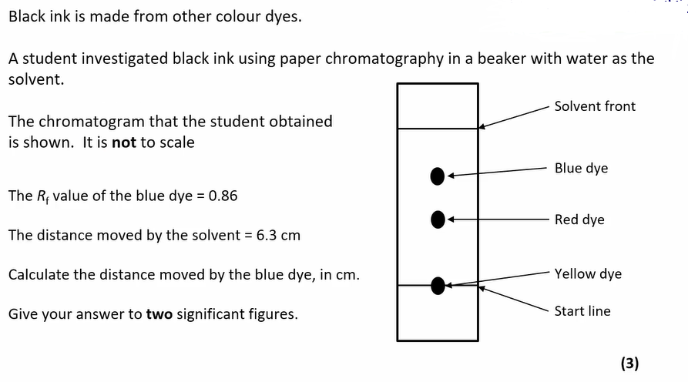

_________________________________________________________________________
_________________________________________________________________________
_________________________________________________________________________
Past paper question:
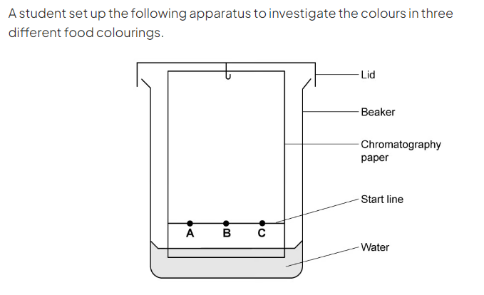
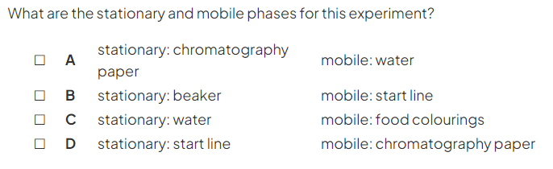
Exam Tip
1) Paper chromatography is the name given to the overall separation technique while a chromatogram is the name given to the visual output of a chromatography run. This is the piece of chromatography paper with the visibly separated components after the run has finished.

2) For the R_{f} calculations, both distances are measured from the baseline.

Homework: Q4 page 22 & Q 6 page 23.

