

Rosary School – Marj Elhamam
Unit 1: Elements , compounds and mixtures
Name: _________________ |  | Date: ____ /____ / 2025
Grade: 9( A,B,C ,D) |  | Paperopp past paper questions
Question one:
A)
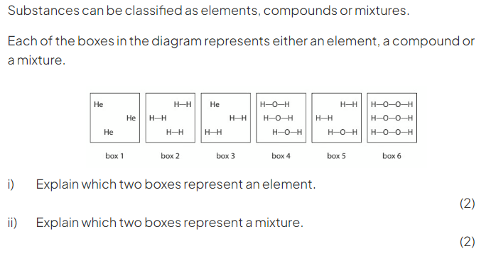B) 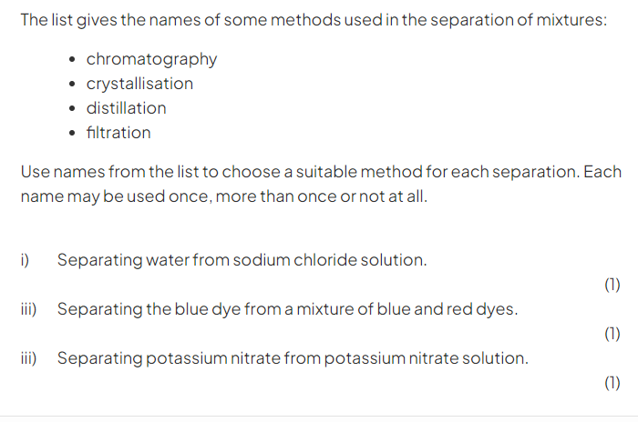
Question two:
A)
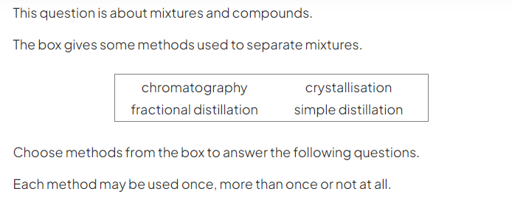
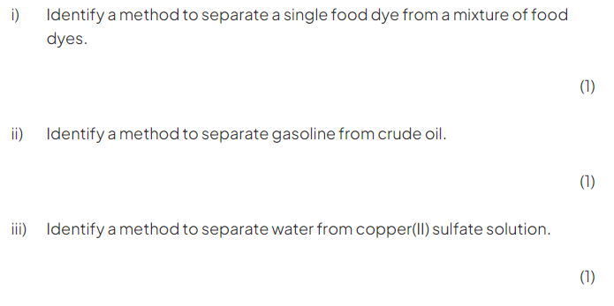B)
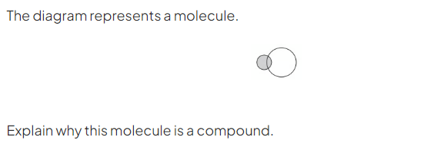
________________________________________________________________________________________________________________________________
(2)
C)
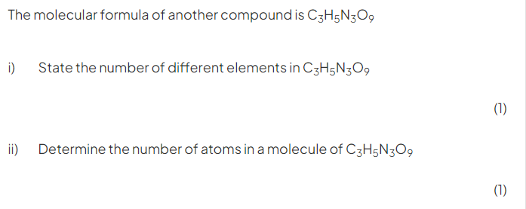Question three:
A)
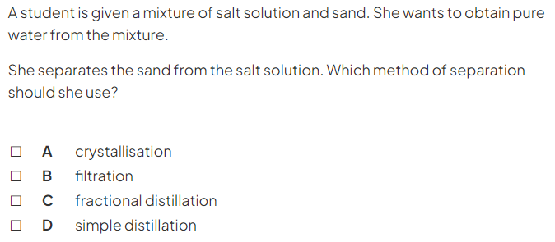(1)
Question four:
A) 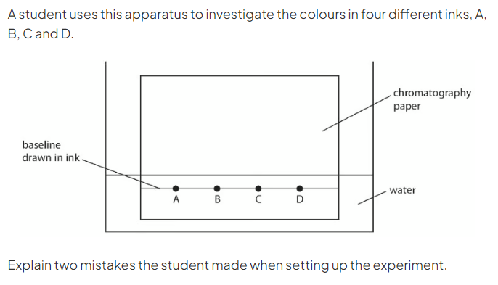
________________________________________________________________________________________________________________________________________________________________________________________________
(4)

B)
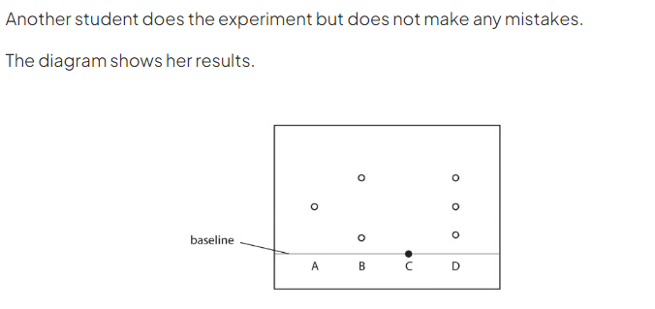
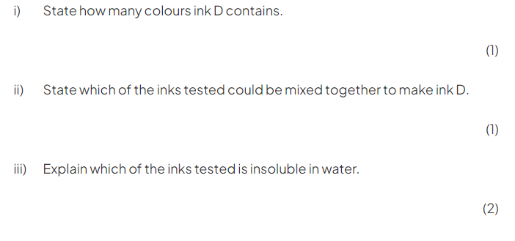Question five:
A)
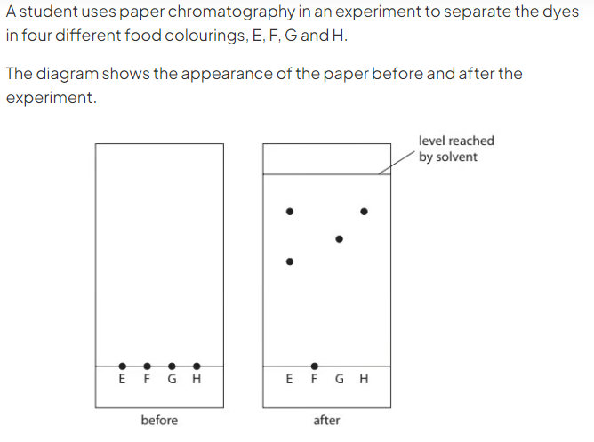
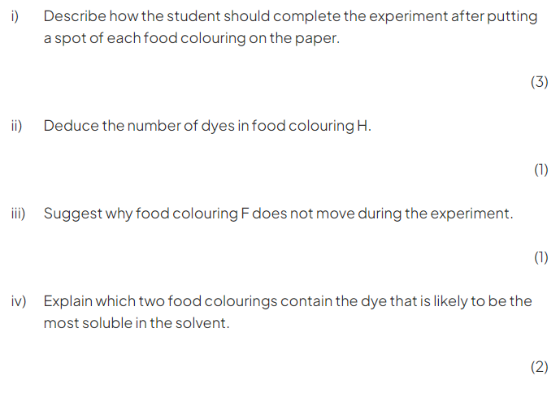

B)
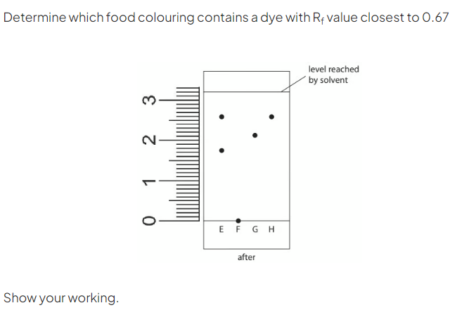

(3)

Question six:
A)
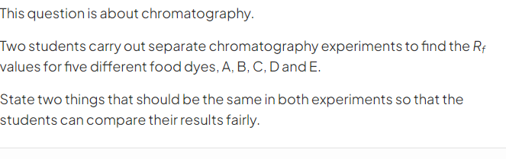(2)
B)
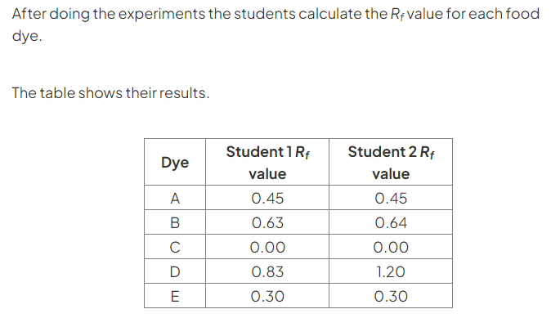
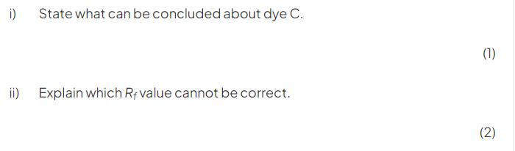

Question seven:
A)
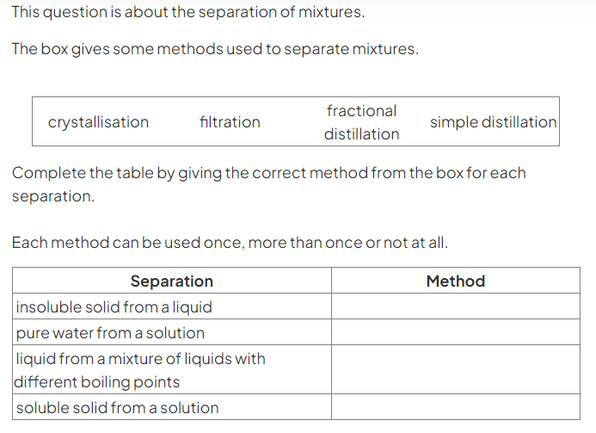
(4)
B)
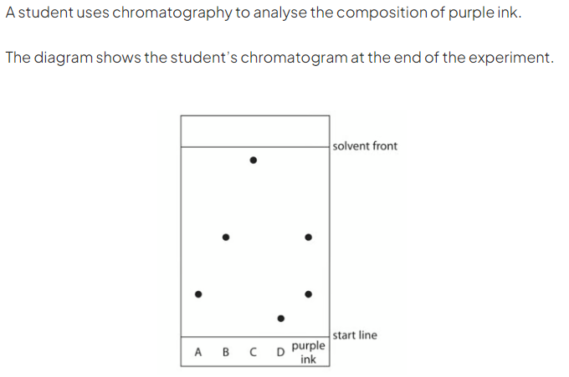
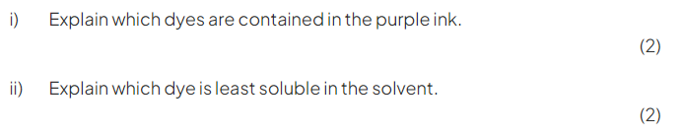
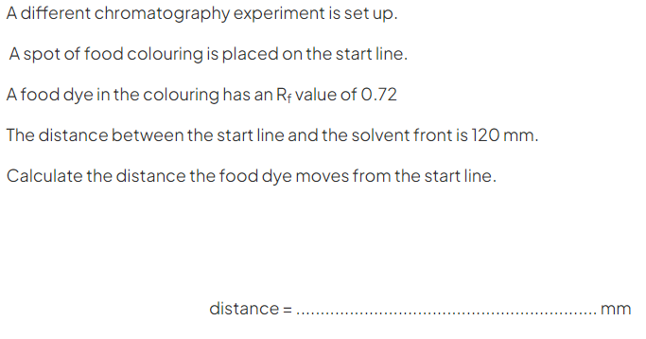
(2)

Question eight:
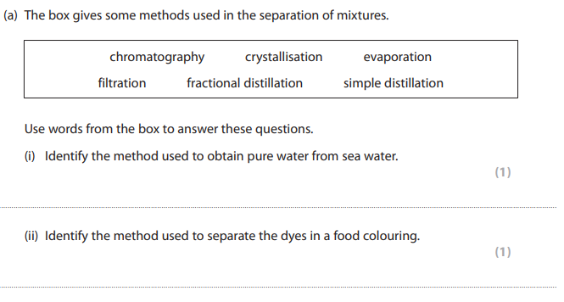
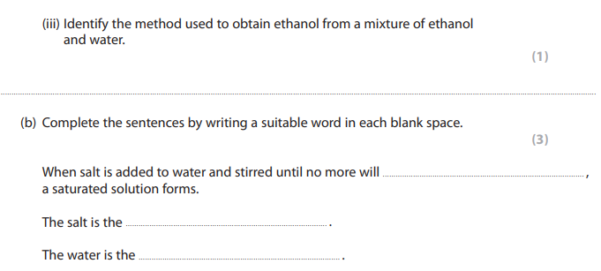
(6)

Question nine:
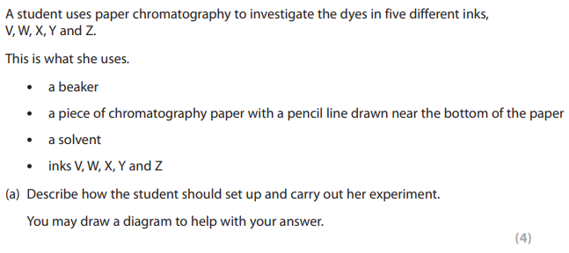
___________________________________________________________
___________________________________________________________
___________________________________________________________
___________________________________________________________
___________________________________________________________
___________________________________________________________
___________________________________________________________
___________________________________________________________
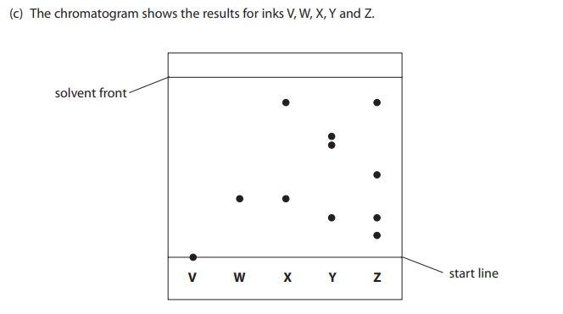
__________________________________________________________
__________________________________________________________
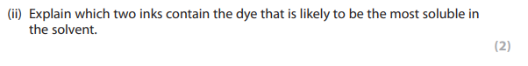
__________________________________________________________
__________________________________________________________

Question ten:
