Topic 2.2: Thermal and electrical conductors
Focus
1 a i All the metal parts: filament, wires, base (screw in)
ii The glass bulb
b Plastic is not an electrical conductor. The plastic protects you from getting an electric shock when you touch the plug.
c i Metals are good conductors of heat. The metal spoon would conduct the heat from the soup to your hand, which could burn your hand.
ii Wood is not a good conductor of heat, so the wooden spoon would not get hot and burn your hand.
Practice
2 a i Silver, copper, aluminium, brass, iron, stainless steel

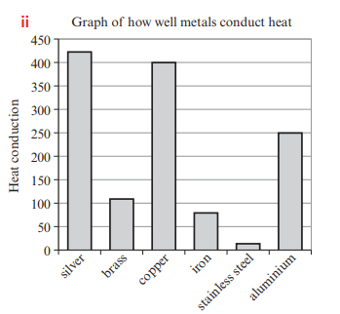
b Copper is a good heat conductor, so it transfers heat from the stove quickly to the food in the pot.
c Silver is much more expensive than copper, and copper is almost as good a heat conductor as sliver.
d Copper and brass are good heat conductors, so they the transfer heat away from the engine quickly to stop it overheating.

