
Rosary School / Marj El Hamam

Name : _____________________ Date :______________
Subject :Grammar Worksheet Class : 6th Grade ( )

Active and Passive Voice
Active Voice vs. Passive Voice
In active voice sentences, the subject does the action (verb) and the object receives the action.
Sentence structure: subject + action (verb) + object.
(subject) + (verb) + (object) + (adverb)
John painted the house last week
________________________________________________________________________
In passive voice sentences, the subject receives the action (verb).
Sentence structure: subject (active verb object) + (verb to be + past participle) + object doing the action.
(subject active verb object) + (verb) + by + (subject) + (adverb)
The house was painted by John last week

Passive Voice usage:
The passive voice is used when:
1. We do not know who did the action:
Example: The documents were stolen.
(We don’t know who stole the documents.)
2. The receiver of the action is more important
Example: The pyramids were built nearly 5,000 years ago by the ancient Egyptians.
(We want to emphasize “pyramids” more than “ancient Egyptians”)

Passive Voice formation:
To change an active voice sentence to a passive voice sentence, … .
1. make the object of the active sentence the subject of the passive sentence.
2. use the verb “to be” in the same tense as the main verb of the active sentence.
3. use the past participle of the main verb of the active sentence.

Here are some examples:
a) Active: Chefs use these machines to mix the ingredients.

Passive: These machines are used by chefs to mix the ingredients.

*** Now draw the lines in the next example to show the connection.
Active: The teachers informed the students that the class had been canceled.

Passive: The students were informed by the teachers that the class had been canceled.

Passive Voice: Present
In the present, the passive voice uses the verbs is/are + past participle of the main verb.
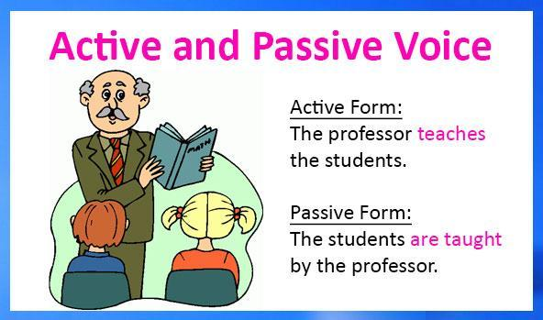
Passive Voice: Past
In the past, the passive voice uses the verbs: was/were + past participle of the main verb



Exercise (1): Choose whether the following sentences are written in active or passive voice.
1- The police showed the victim a picture of the suspect.
a. Active voice. b. Passive voice.
2- The bridge was built five years ago by the government.
a. Active voice. b. Passive voice.
3- The car was found after three days.
a. Active voice. b. Passive voice.
4- The people welcomed the new minister.
a. Active voice. b. Passive voice.
5- After the accident John was taken to the hospital.
a. Active voice. b. Passive voice.

Exercise (2): Change the following sentence from the active voice to the passive voice.

1- The manager locked the door.
______________________________________________________________
2- John built this house in 1991.
______________________________________________________________
3- We all shared the same interest in the game.
______________________________________________________________
4- Alexander plays golf every Sunday morning.
______________________________________________________________
5- He lost all of his money during his vacation.
______________________________________________________________
6- They serve lunch at midday.
______________________________________________________________
7- The police told her that her purse was found.
______________________________________________________________
8- She cleans this bedroom every day.
______________________________________________________________
9-Young people didn’t read the daily newspapers.
______________________________________________________________
10-They treat and cure people at hospitals.
______________________________________________________________

Exercises(3): Present Simple and Past Simple
Select the correct answer.
Question 1
Active: People speak Portuguese in Brazil.
Passive: Portuguese ___________ in Brazil.
A. is speak B. is spoke C. is spoken
Question 2
Active: The staff cleans all the hotel rooms daily.
Passive: The hotel rooms _________ daily.
A. are clean B. are cleaned C. is cleaned
Question 3
Active: We update the company website frequently.
Passive: The company website ___________ frequently.
A. are updated B. is updated C. was updated

Question 4
Active: People see this beach as the most beautiful in the country.
Passive: This beach __________ is the most beautiful in the country.
A. is seen B. is saw C. is see
Question 5
Active: Somebody ships the products via express mail.
Passive: The products ___________ via express mail.
A. are shipped B. is shipped C. were shipped
Question 6
Active: A friend gave me this sweater.
Passive: This sweater ________ to me by a friend.
A. is given B. gave C. was given
Question 7
Active: A famous author wrote these letters.
Passive: These letters _________ by a famous author.
A. were wrote B. was written C. were written
Question 8
Active: The teachers chose her to receive the award.
Passive: She __________ by the teachers to receive the award.
A. was chosen B. was chose C. were chosen

Question 9
Active: A knock at the door woke us all up.
Passive: We _____________ by a knock at the door.
A. was all woke up B. were all woken up C. were all waked up
Question 10
Active: Over 300,000 students took the college entrance exam.
Passive: The college entrance exam _________ by over 300,000 students.
A. was taken B. was took C. is taken



