

Rosary School – Marj Elhamam
Unit 1: Atomic structure
Name: _________________ |  | Date: ____ /____ / 2025
Grade: 9(A, B, C, D) |  | Chemistry summary notes

Objectives:
1.14 Know what is meant by the terms atom and molecule.
1.15 Know the structure of an atom in terms of the positions, relative masses and relative charges of sub-atomic particles.
1.16 Know what is meant by the terms atomic number, mass number, isotopes and relative atomic mass (A_{r}).
1.17 Be able to calculate the relative atomic mass of an element (A_{r}) from isotopic abundances.
___________________________________________________________________
Atoms and molecules
- It is important to understand the terms atoms and molecules when referring to atomic structure, elements and compounds

Term | Definition
Atom | The smallest particle of an element that contains electrons surrounding a nucleus that contains protons and neutrons.( can still be recognized as an element)
Molecule | A group of two or more atoms chemically combined.

Example of an atom:
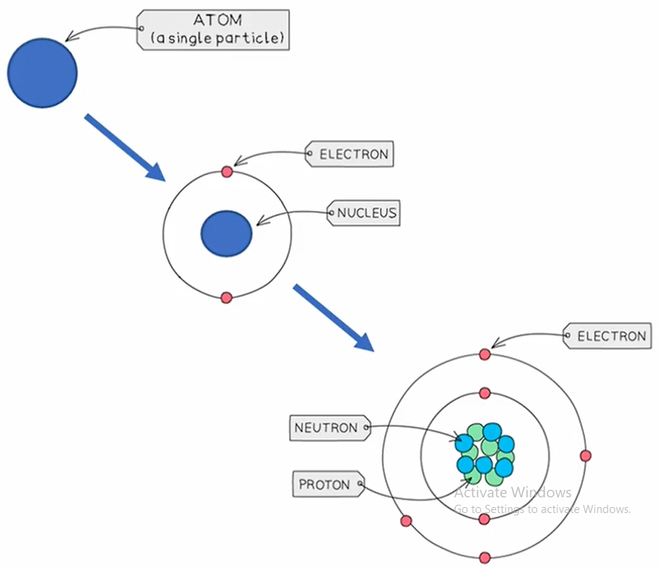
Example of molecules:
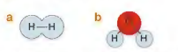
-The atoms that make up a molecule can be made up of the same type of element (H₂) or different type of elements (H₂O)
Atomic structure
- All substances are made of tiny particles of matter called atoms which are the building blocks of all matter.
-Atoms have a nucleus surrounded by shells of electrons.
- Each atom is made of subatomic particles called protons, neutrons, and electrons, because they are smaller than an atom.
- The protons and neutrons are located at the centre of the atom, which is called the nucleus.
- The nucleus is positively charged
-Protons are positive.
-Neutrons are neutral.
-Electrons are negative.
- The mass of the electron is negligible, hence the mass of an atom is contained within the nucleus where the protons and neutrons are located.
P N
eutral
eutron
ositive
roton

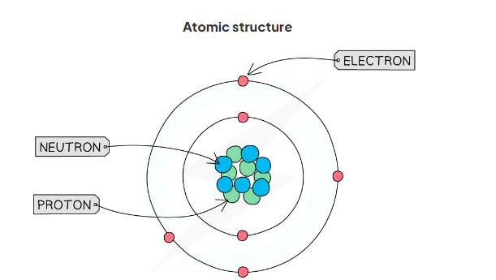
- Subatomic particles are so small that it is not practical to measure their masses and charges using conventional units (such as grams or coulombs).
- Instead, their masses and charges are compared to each other, and so are called ‘relative atomic masses’ and ‘relative atomic charges’
- Protons and neutrons have a very similar mass, so each is assigned a relative mass of 1.
- Electrons are 2000 times smaller than a proton and neutron, and so their mass is often described as being negligible.
- These are not actual charges and masses, but rather charges and masses of particles relative to each other.

Exam Tip

1) You need to know the correct location of each subatomic particle.
2) The mass of an electron can just be stated as 'negligible' or 'very small' in an exam. You do not need to learn the value.

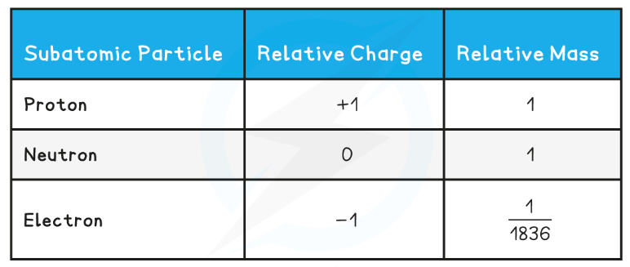

Homework: question 1 page 28

Atomic number and mass number
You need to know the following terms to describe the properties and characteristics of atoms.
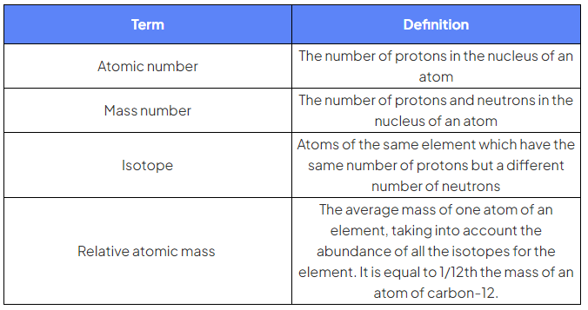
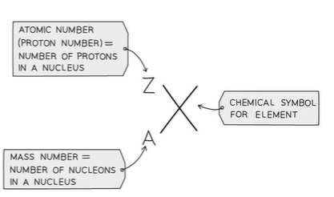
Notes:
a) atomic number = number of protons
b) Mass number = number of protons+ number of neutrons.
c) Number of neutrons = mass number - number of protons
c) Number of electrons is:
1) equal to the number of protons for elements only.
2) less than the number of protons for positive ions.
3) more than the number of protons for negative ions.
d) Atoms are arranged in the Periodic Table in order of increasing atomic
number.
* You should be able to use a chemical symbol to determine the number of protons, neutrons & electrons.
Exam Tip
-Some Periodic tables still have the atomic number at the bottom

* Calculating subatomic particles.
Lithium | 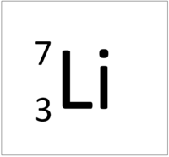
Proton | 3
Electron | 3
Neutron | 4
- The atomic number/ proton number of Lithium is 3.
- The Lithium element has no electronic charge, so
Number of protons = number of electrons
- The mass number of Lithium is 7, so
The number of neutrons = ( mass number- number of protons)=7 - 3 = 4

Example exam question:
1)
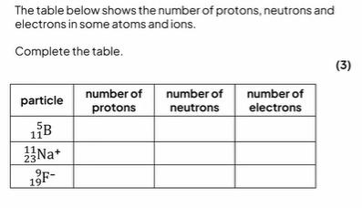

2)
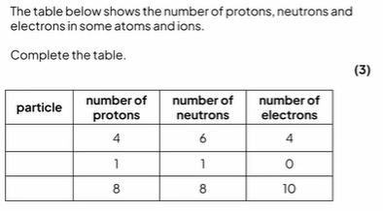

3) Determine the number of protons, electrons and neutrons in an atom of element X with atomic number 29 and mass number 63.

Homework: questions 3 and 4 page 29
Examiner Tips & Tricks
Both the atomic number and the mass number are given on the Periodic Table, but it can be easy to confuse them.
Think Mass=Massive as the mass number is always the bigger of the two numbers, the other smaller one is therefore the atomic number.

Isotopes are atoms (of the same element) which have the same atomic number,but different mass numbers.
-They have the same number of protons but different numbers of neutrons.

* The symbol for an isotope is the chemical symbol (or word) followed by a dash and then the mass numbers.
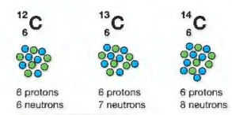
Carbon-12 Carbon-13 Carbon-14

* The isotopes have then same chemical properties because they have the same number of electrons in the outer shell.
* The difference in mass effects the physical properties such as density, boiling point and melting point.
* Isotopes are identical in appearance.
Exam Tip
The key points are the same number of protons and different number of neutrons.

Relative atomic mass (A_{r})
- Relative atomic mass: the average mass of one atom of an element, taking into account the amount of each isotope of an element.
- This Type of average is called weighted average or weighted mean.
- Atoms are so tiny that we can't really compare their masses in conventional units such as (Kg or g), so the unit instead is called "Relative atomic mass".
- The Ar unit is equal to 1/12th the mass of carbon-12 atom.
- All other elements are measured by comparison to the mass of carbon-12 atom and since these are ratios, the relative atomic mass has no units.
For example, hydrogen has Ar= 1, meaning that 12 atoms of hydrogen would have exactly the same mass of 1 atom of carbon.

Calculating relative atomic mass
The relative atomic mass of each element is calculated from the mass number and relative abundance of all the isotopes of a particular element.
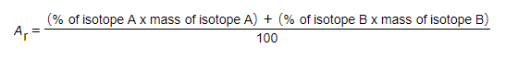

Example:
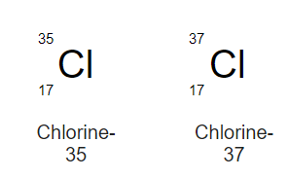

Ar = (75% x 35) + (25% x 37) = 35.5
100

Question:
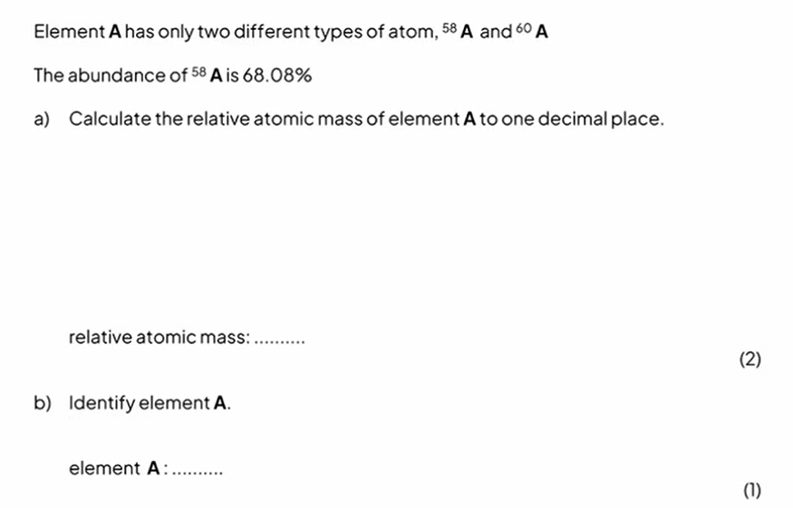
Worked example
The table shows information about the isotopes in a sample of rubidium.
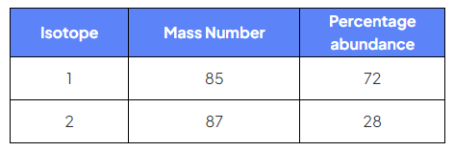
Use information from the table to calculate the relative atomic mass of this sample of Rubidium.
Give your answer to one decimal place.

Exam Style Question:
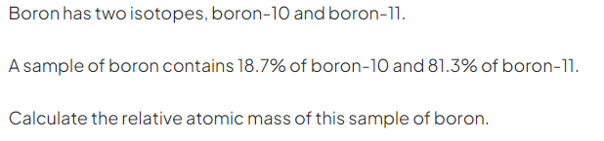

(2)
Homework: questions 5,6,7,8 and 9 page 29.
Refer to the following for extra practice:
* student's book page 27, example 1
* students book page 28, example 2
Exam Tip
- The relative atomic mass should always be between the mass values in the question.
- Isotopes are easy to recognise from their notation as they have the same symbol but different mass numbers. For example, the two stable isotopes of copper are ⁶³Cu and ⁶⁵Cu.

