
Rosary School / Marj El Hamam

Name : __________________ Date :___/___/2024
Grade: 5 ( A,B,C,D,E ) Narrative Writing Study sheet Subject: English

What is “narrative” writing?
Narrative writing is a type of writing that tells a story or gives an account of something that has happened. The story is fiction and it could be told in the first person (I, we, and us) or third person (he, she, it, and they).
-It can be written to persuade, entertain or to inform the reader.
What are the elements of a narrative story?

- Setting: tells us when and where it happened.
- Characters: the people or animals in the story. Who?
- Conflict: makes us want to read on to find out what happened.
- Climax: the most exciting part of the story.

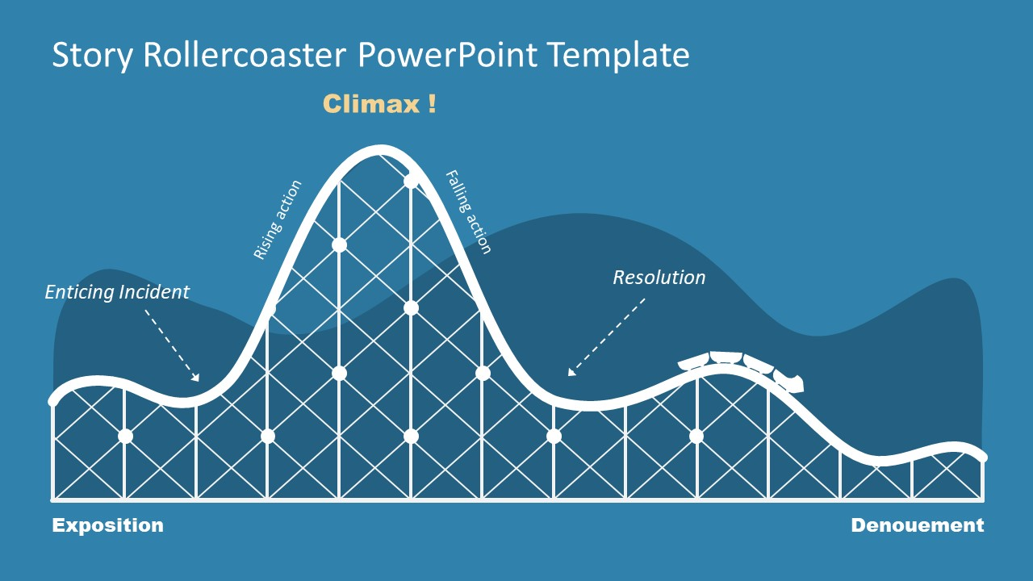

Exposition: the first paragraph or paragraphs in which the characters, setting (time and place) and basic information is introduced.
Enticing incident (rising action): an event that sets the main character on their journey or triggers the central conflict in a story (example: poor man wins the lottery)
Climax: The point in the narrative writing where the tension, excitement reach the highest level, the most important point in a story especially when it happens near the end. The reader wonders what will happen next; will the conflict be resolved or not?
Resolution: is the part of the story's plot where the characters work to solve the main problem or conflict.
Denouement: Conclusion after the climax of a narrative in which the complexities of the plot are unraveled and conflict is finally resolved.

Conflict:
You ask yourself what the main character’s biggest challenge is, what they overcome by the end of the story.

There are four kinds of conflict:
1. Character vs. Character (physical) - The leading character struggles with his physical strength against other men (friends or family). (External)
2. Character vs. Nature - The leading character struggles the forces of nature (natural disasters or animals). (External)
3. Character vs. Society (social) - The leading character struggles against ideas, practices, or customs of other people. (External)
4. Character vs. Self (psychological) - The leading character struggles with himself/herself; with his/her own soul, ideas of right or wrong, physical limitations, choices, etc. (Internal)
External - A struggle with a force outside one's self.
Internal - A struggle within one's self; a person must make some decision, overcome pain, quiet their temper, fear, self-doubt, self-destructiveness, etc.
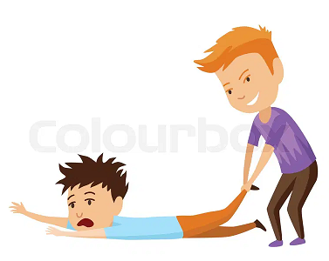


Planning your story/story layout
Title

1St paragraph/Introduction
Setting (Where /when)
Characters (who)
Basic Information

2nd paragraph
Enticing incident
Rising action

3rd paragraph
Climax
Start acting on a solution
Falling action

4th paragraph
Resolution (conflict is solved/solution for all problems)
End of story

Remember... you should use:

- Strong vocabulary
- Descriptive language (adjectives and adverbs + similes and metaphors)
- Dialogues
- Different types of sentences (simple, compound and complex )

The Adventure of the Lost Puppy

One sunny afternoon, Emma and her little brother, Jack, were playing in their backyard. Their house was surrounded by tall trees, and they loved exploring the nearby forest.

Suddenly, they heard a faint whimpering sound coming from the woods.
“Do you hear that?” Jack asked, his eyes wide with excitement.
Emma nodded and, holding Jack's hand, they followed the sound deeper into the forest.

After walking for a while, they found a small, brown puppy hiding under a bush. It looked scared and hungry. Jack knelt down and gently petted the puppy’s soft fur, only to realize that the puppy’s foot was injured and stuck in a metal fence. Jack started thinking and asked Emma to go back home and get him a metal cutter. She ran back home as fast as a rabbit and got him the cutter in no time.

Together, they cut a hole in the fence big enough to release the puppy’s foot, then they took the puppy back home and cleaned his wound. After a few days, the puppy was able to run and play again so Emma and Jack kept him as a pet.



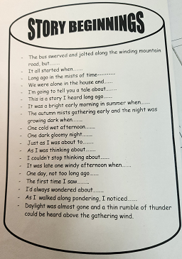
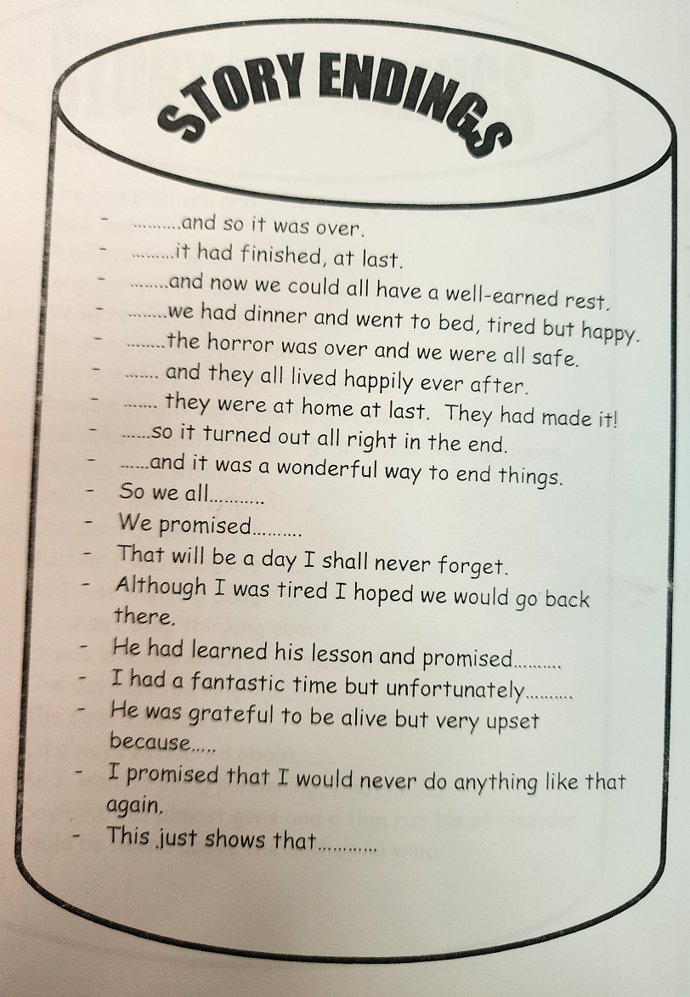

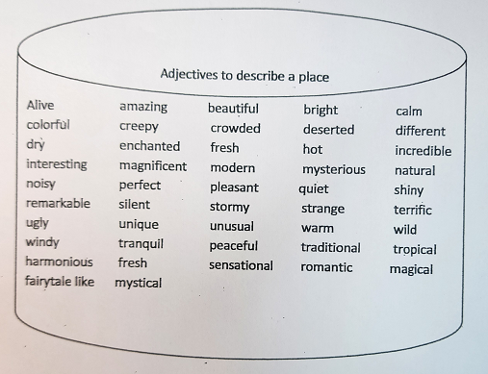

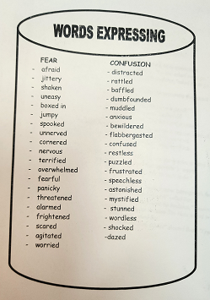
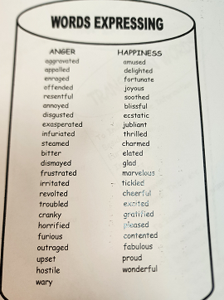

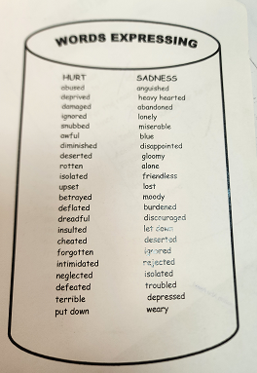
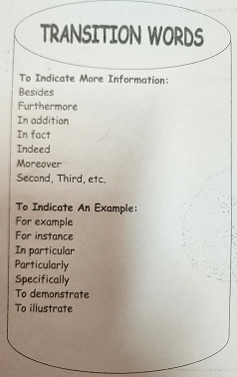

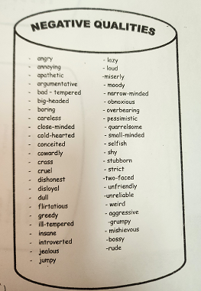
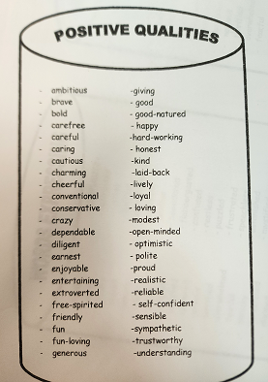

Powerful Verbs
Allow borrow calculate demand escape
Flash grasp hike inform judge
Limit mingle notice order predict
Reject sneak threaten volunteer wonder

Adjectives that can be used to describe the characters:
