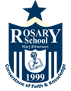

Rosary School – Marj Elhamam
Formative Sheet (1)
Name: _________________ |  | Date: / 8 / 2025
Grade: 7 ( ) |  | Subject: Chemistry
Atoms, elements and molecules
