

Rosary School – Marj Elhamam
Worksheet 4
Name: _________________ |  | Date: / / 2025
Grade: 5 (A, B, C, D, E) |  | Subject: Science
Question 1: Put a tick (✓) next to the processes that are reversible:
Melting Burning
Evaporation Dissolving
Rusting

Question 2: Will a block of ice melt quicker in a plastic dish or in a metal dish of the same size? Say why.
Metal dish, because metal is a better conductor of heat than plastic, so heat energy is transferred more quickly through the metal to the ice.
Question 3:
a. When Marcus pumps air into his football, the ball expands. Say why this happens.
Because air takes up space.
b. What other change to the football could Marcus measure?
The mass, the ball gets heavier.
Question 4: Mike investigates how well materials conduct electricity. He connects different materials to an electrical circuit containing a lamp. He looks at the brightness of the lamp. Here are his results.
Material | Brightness of lamp in circuit
Lead | Lamp is very dim
Brass | Lamp is just brighter than when using lead
Copper | Lamp is bright
Plastic | Lamp does not work
Silver | Lamp is very bright

- Brass conducts electricity. Name one material that is a better conductor of electricity.
Copper, silver.
- Which material is the best conductor of electricity?
Silver.

Question 5:
Rita investigates electrical conductors. She uses different materials in an electrical circuit. She tested each substance three times.
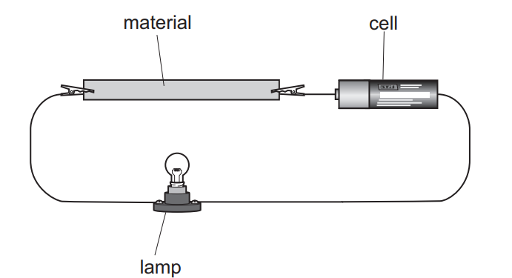
- Explain how she can tell if a material is an electrical conductor.
The lamp turns on.
- Substances have properties. Complete the sentence.
Two different properties are electrical conductivity and thermal conductivity.
- Are her results reliable? Explain your answer?
Yes, because she repeated the test three times.

